Geography ~ Isn’t that SPATIAL?
Grade Level or Special Area: Sixth/Fifth & Kindergarten Social Studies
Written by: Erica Armstrong, Wendy Haggerton, Carey Lindner, Mills Elementary, Hobbs, NM
Length of Unit: Six Lessons (45-60 minutes each)

ABSTRACT
  - Have you ever wanted to incorporate cross-grade level teaching in your geography lessons? Take a trip with us and allow your older students to become the teachers! Within this multi-grade level unit, 5th/6th grade students will become the experts in using geographical tools and terms. By teaching to kindergarten students, they will be sharing their expertise in geography. This will help both 5th/6th grade and kindergarten students strengthen and reinforce their geographical knowledge.

OVERVIEW
  - Concept Objectives
    - Understand the concept of location by using and constructing maps, globes, and other geographic tools to identify and derive information about people, places, and environments (NM Geography Standard I: K-4 Benchmark II-A)
    - Analyze and evaluate the characteristics and purposes of geographic tools, knowledge, skills and perspectives and apply them to explain the past, present, and future in terms of patterns, events, and issues. (NM Geography Standard I: 5-8 Benchmark II-A)
  - Content from the Core Knowledge Sequence
Kindergarten (p. 11)
    - Maps and globes: what they represent, how we use them
    - Rivers, lakes, and mountains: what they are and how they are represented on maps and globes
    - Locate the Atlantic and Pacific Oceans.
    - Locate the North and South Poles.
    - Songs (p. 16)
- “Oh Where, Oh Where, Has My Little Dog Gone”
    - Mother Goose and other Traditional Poems (p. 8)
- Little Bo Peep
    - Measurement (p. 18)
      - Time – Read a clock face and tell time to the hour
Fifth (p. 112)
- Read maps and globes using longitude and latitude, coordinates, degrees.
- Tropic of Cancer and Tropic of Capricorn: relation to seasons and temperature
- Climate zones: Arctic, Tropic, Temperate
- Time zones (review from Grade 4): Prime Meridian (0 degrees): Greenwich, England; 180° Line (International Date Line)
- Arctic Circle (imaginary lines and boundaries) and Antarctic Circle
- From a round globe to a flat map: Mercator projection, conic and plane projections
Sixth (p. 137)
- Continents and majors oceans
- How to read maps and globes using longitude and latitude, coordinates, degrees
- Tropic of Cancer and Tropic of Capricorn: relation to seasons and temperature
- Climate zones: Arctic, Tropic, Temperate
- Time zones (review from Grade 4): Prime Meridian (0 degrees): Greenwich, England; 180° Line (International Date Line)
- Arctic Circle (imaginary lines and boundaries) and Antarctic Circle
  - Skill Objectives
    - Demonstrate prior knowledge of geographic tools that help represent locations (NM Strand: Geography, Content Standard II, K-8 Benchmark II-A)
    - Utilize a globe (NM Strand: Geography, Content Standard II, K-8 Benchmark II-A)
    - Compare and contrast maps and globes (NM Strand: Geography, Content Standard II, K-8 Benchmark II-A)
    - Recognize that Earth is split into four hemispheres (NM Strand: Geography, Content Standard II, 5-8 Benchmark II-A)
    - Identify the location of continents and oceans (NM Strand: Geography, Content Standard II, K-8 Benchmark II-A)
    - Complete a Venn Diagram (NM Strand: Reading and Listening for Comprehension, Content Standard I, Benchmark K-8 IB)
    - Utilize a map (NM Strand: Geography, Content Standard II, K-8 Benchmark II-A)
    - Compare and contrast map projections (NM Strand: Geography, Content Standard II, 5-8 Benchmark II-A)
    - Understand distortion (NM Strand: Geography, Content Standard II, 5-8 Benchmark II-A)
    - Recognize that earth has North and South Poles (Kindergarten) (NM Strand: Geography, Content Standard II, K-4 Benchmark II-A)
    - Learn and sing song, “Oh Where, Oh Where, Has My Little Dog Gone.” (Kindergarten) (NM Strand: Reading and Listening for Comprehension, Content Standard I, K-4 Benchmark I-A)
    - Recognize basic terms of spatial orientation necessary for working with maps. (NM Strand: Geography, Content Standard II, K-8 Benchmark II-A)
    - Understand lines of longitude and latitude (NM Strand: Geography, Content Standard II, K-8 Benchmark II-A)
    - Identify locations of longitude and latitude (NM Strand: Geography, Content Standard II, K-8 Benchmark II-A)
    - Learn and recite poem “Little Bo Peep” (Kindergarten) (NM Strand: Reading and Listening for Comprehension, Content Standard I, K-4 Benchmark I-A)
    - Identify climate zones (NM Strand: Geography, Content Standard II, K-8 Benchmark II-A)
    - Locate Tropic of Cancer and Tropic of Capricorn (NM Strand: Geography, Content Standard II, K-8 Benchmark II-A)
    - Understand boundaries of the Arctic Circle and the Antarctic Circle (NM Strand: Geography, Content Standard II, K-8 Benchmark II-A)
    - Utilize a time zone map (NM Strand: Geography, Content Standard II, K-8 Benchmark II-A)
    - Understand time zone (NM Strand: Geography, Content Standard II, K-8 Benchmark II-A)
    - Tell time to the hour (Kindergarten) (NM Strand: Measurement, Benchmark K-4 M.1)
    - Conduct research using multiple sources (NM Strand: Reading and Listening for Comprehension, Content Standard I, Benchmark 5-8 IB)
    - Create a brochure (NM Strand: Reading and Listening for Comprehension, Content Standard I, Benchmark 5-8 IB)

BACKGROUND KNOWLEDGE
  - For Teachers
    - Kids’ Stuff People, US Social Studies Yellow Pages for Students and Teachers
    - Core Knowledge Foundation, Teacher Handbook Series Grade 5
    - Core Knowledge Foundation, Teacher Handbook Series Grade K
  - For Students
    - K-5 Spatial Sense
    - K-5 Geographical Terms and Features

RESOURCES
  - Chapman, J., & Wilson, K., Where Is Home, Little Pip? (Lesson 5)
  - Core Knowledge Foundation, Teacher Handbook Series Grade K (Lessons 1-6)
  - Core Knowledge Foundation, Teacher Handbook Series Grade 5 (Lessons 1-6)
  - Core Knowledge Text Resources, Kindergarten (Lessons 1-6)
  - Core Knowledge Text Resources, Fifth Grade (Lessons 1-6)
  - Disney’s Small World Library, Donald’s Fantastic Fiesta: An Adventure in Mexico
(Lesson 5)
  - Disney’s Small World Library, Lapland Friends: An Adventure in Sweden (Lesson 5)
  - Disney’s Small World Library, Mickey and Goofy Down Under: An Adventure in Australia (Lesson 5)
  - Hirsch, E.D., What Your Kindergartener Needs to Know (Lessons 1-6)
  - Hirsch E.D., What Your Fifth Grader Needs to Know (Lessons1-6)
  - Hirsch, E.D., What Your Sixth Grader Needs to Know (Lessons 1-6)
  - Scott Foresman, Social Studies: The World (Lessons 1-4, 6)
  - Scholastic, Great Map Games (Lessons 4-6)
  - http://www.nationalgeographic.com/xpeditions/activities/01/crackcode.html (Lesson 4)
  - http://www.proteacher.org/c/326_Latitude_and_Longitude.html (Lesson 3)
  - http://www.enchantedlearning.com/crafts/clocks/clock/ (Lesson 6)
  - http://www.worldatlas.com/aatlas/inforpage/oceans.html (Lesson 2)
  - http://www.clipsahoy.com/animals/sheep/sheep1.htm (Lesson 4)

- LESSONS
Lesson One: What Do We Know? (45-60 minutes)
  - Daily Objectives
    - Concept Objective(s)
      - Understand the concept of location by using and constructing maps, globes, and other geographic tools to identify and derive information about people, places, and environments (NM Geography Standard I: K-4 Benchmark II-A)
      - Analyze and evaluate the characteristics and purposes of geographic tools, knowledge, skills and perspectives and apply them to explain the past, present, and future in terms of patterns, events, and issues. (NM Geography Standard I: 5-8 Benchmark II-A)
2. Lesson Content (Preview of the following)
Kindergarten (p. 11)
- Maps and globes: what they represent, how we use them
- Rivers, lakes, and mountains: what they are and how they are represented on maps and globes
- Locate the Atlantic and Pacific Oceans.
- Locate the North and South Poles.
- Songs (p. 16)
- “Oh Where, Oh Where, Has My Little Dog Gone”
- Mother Goose and other Traditional Poems (p. 8)
- Little Bo Peep
- Measurement (p. 18)
- Time – Read a clock face and tell time to the hour
Fifth (p. 112)
- Read maps and globes using longitude and latitude, coordinates, degrees.
- Tropic of Cancer and Tropic of Capricorn: relation to seasons and temperature
- Climate zones: Arctic, Tropic, Temperate
- Time zones (review from Grade 4): Prime Meridian (0 degrees): Greenwich, England; 180° Line (International Date Line)
- Arctic Circle (imaginary lines and boundaries) and Antarctic Circle
- From a round globe to a flat map: Mercator projection, conic and plane projections
Sixth (p. 137)
- Continents and majors oceans
- How to read maps and globes using longitude and latitude, coordinates, degrees
- Tropic of Cancer and Tropic of Capricorn: relation to seasons and temperature
- Climate zones: Arctic, Tropic, Temperate
- Time zones (review from Grade 4): Prime Meridian (0 degrees): Greenwich, England; 180° Line (International Date Line)
- Arctic Circle (imaginary lines and boundaries) and Antarctic Circle
3. Skill Objective(s)
    - Demonstrate prior knowledge of geographic tools that help represent locations. globes (NM Strand: Geography Content Standard II K-8 Benchmark II-A)
  - Materials
    - Maps and Globes displayed throughout the classroom
    - Appendix A: KWL Chart
    - Appendix B: Venn Diagram (Kindergarten)
    - Core Knowledge Instructional Masters Kindergarten, KWL chart, pg. 35
    - Pen/Pencil (for each student)
    - Crayons/map pencils (for each student)
    - Notebook paper (10 sheets for each student)
    - 11 x 14 large construction paper (1 per student, any color)
    - Stapler
  - Key Vocabulary
    - KWL Chart is visual representations of what students already know, what they want to know, and what they learned at the end of a lesson.
    - Cardinal directions are the four principal directions outwards from any defined spot: north, south, east, and west.
    - Geography is the study of the surface of Earth, its people, its climates, and its resources.
    - Globe is a model of the Earth.
    - Map is a representation or drawing, usually on paper, of the whole or part of an area of land.
  - Procedures/Activities
    - Tell the students, “Look around the room. Do you see any tools that represent geographic locations?” (Teachers Note: Have out visible maps, globes, cardinal directions, etc.)
    - Write their responses on the board.
    - Tell the students that as a class we will be discussing the various characteristics and purposes of geographic tools and how to apply them.
    - Pass out Appendix A: KWL Chart (Kindergarten should use Core Knowledge Instructional Master, KWL chart, pg. 35)
    - Explain to the students what a KWL chart is and how to use it to pre-assess their knowledge.
    - Have the students brainstorm in a group the “What Do I know?” section. Ask the students for 10 things (5th-6th) 5 things (Kindergarten teacher will need to write down the ideas on the board for the students to copy) that they need to write down on their KWL chart for this section.
    - Instruct the students to come up with 5 more things (5th-6th)
    - Repeat steps 6 and 7 for the “What Do I Want to Know?” section.
    - Ask the students, “Can we complete the What I Learned? section ?” Answers should be no, because they have not learned the content yet. Explain that they will be filling out this section as new concepts are learned.
    - Pass out a sheet of construction paper to each student. (Kindergarten teachers may want to have steps 10-14 prepared for their students before hand. Include Appendix B: Venn Diagram for Lesson 2)
    - Fold the construction paper in half. This will be the cover for the “Geography” journal.
    - Have the students design and decorate the cover with geography tools and terms.
    - Have the students get 10 sheets of notebook paper.
    - Instruct the students to put Appendix A: KWL Chart on top of the 10 sheets of notebook paper.
    - Take Appendix A: KWL chart and the 10 sheets of paper and place inside the folded construction paper. Staple along the folded edge to secure the Appendix A: KWL chart and 10 sheets of notebook paper to the construction paper.
    - Once the journal is created, students will then complete the first entry in their journal.
    - Journal Entry 1: Students will write about the things they think we will discuss or what they would like us to discover during this unit (teacher can specify length of journal entries). Kindergarten: Students can copy definitions off the board or teacher can chose to have the students draw representations of geographic tools.
    - Extension: To extend the learning of this unit, you can choose to add a fourth section to the KWL chart. This section can either be titled, “What I Can Still Learn” or “How Does This Unit Apply to My Life?”
  - Assessment/Evaluation
    - Teacher will collect journals and assess both the KWL chart for completion of the first two sections and assess that the journal topic was followed.

Lesson Two: Globe-Trotting (45-60 minutes)
- Daily Objectives
- Concept Objective(s)
      - Understand the concept of location by using and constructing maps, globes, and other geographic tools to identify and derive information about people, places, and environments (NM Geography Standard I: K-4 Benchmark II-A)
      - Analyze and evaluate the characteristics and purposes of geographic tools, knowledge, skills and perspectives and apply them to explain the past, present, and future in terms of patterns, events, and issues. (NM Geography Standard I: 5-8 Benchmark II-A)
2. Lesson Content
Kindergarten:
- Maps and globes: what they represent and how we use them (p. 11)
- Rivers, lakes, and mountains: what they are and how they are represented on maps and globes (p. 11)
- Locate the Atlantic and Pacific Oceans (p. 11)
Fifth and Sixth:
a. Continents and major oceans (p. 137)
3. Skill Objective(s)
- Utilize a globe (NM Strand: Geography Content Standard II K-8 Benchmark II-A)
- Compare and contrast maps and globes (NM Strand: Geography Content Standard II K-8 Benchmark II-A)
- Recognize that Earth is split into four hemispheres (NM Strand: Geography Content Standard II 5-8 Benchmark II-A)
- Identify the location of continents and oceans (NM Strand: Geography Content Standard II K-8 Benchmark II-A)
- Complete a Venn Diagram (NM Strand: Reading and Listening for Comprehension: Content Standard I Benchmark K-8 IB)
- Materials
- Blow up globes (1 per group of four students, 5th-6th)
- Maps
- Globe
- Large Venn Diagram on poster or butcher Paper (Kindergarten)
- Appendix C: Venn Diagram Answer Key (Kindergarten)
- Appendix D: Continents, Oceans & Latitude Longitude Songs (Kindergarten)
- Appendix E: Venn Diagram (3 copies per student or group of 4)(5th-6th)
- Appendix F: Venn Diagram Answer Key (5th-6th)
- Appendix G: Mastery Checklist – Globe Trotting (Kindergarten)
- Journals (from Lesson 1)
- Key Vocabulary
- Globe is a model of the Earth.
- Ocean is the large body of water between continents.
- Continent a large land area.
- Hemisphere refers to half of the Earth.
- Venn Diagram is a diagram using circles to represent sets, with the position and overlap of the circles indicating the relationships between the sets.
- Equator is the imaginary East-West line that divides the Northern and Southern Hemisphere.
- Prime Meridian is the imaginary North-South line that divides the Eastern and Western Hemisphere.
D. Procedures/Activities
Kindergarten
- Before beginning the lesson, affix a large Venn diagram on poster or butcher paper in a visible place in the classroom. (Teacher Note: This is best done at a circle teaching time).
- Begin the lesson by showing students examples of maps and globes. First hold up the map. Ask the students “What is this object?” Students should respond appropriately. Then ask the students “Can you describe this map for me?” Allow students to give answers such as it is paper, it is flat, is has pictures on it, etc. Next hold up the globe. Ask the students “Can anyone name this object?” Allow students to respond. Tell the students “This is a globe. It is round and shows the whole planet Earth.”
- At this time teacher should lead a discussion which compares and contrasts a globe and a map. Record on the large Venn diagram answers to characteristics of maps, globes, and maps and globes. Students should describe maps as flat and globes as round. A flat map can show the Earth all at once. With a round globe you must spin it, therefore allowing the user to only see one section of the Earth at a time. Flat maps are used by individuals, while globes are usually used in schools. Both maps and globes show bodies of water and land, and both show the world. (Teacher Note: See Appendix C: Venn Diagram Answer Key)
- On the globe point to blue areas and ask the students “What do you think these blue areas are?” Students should answer water or oceans. Tell them “They are oceans which are made of water. Let’s learn the five oceans of the world!” Point to each ocean and say its’ name. Have students repeat the name after you say and point to each one. Introduce “The Five Ocean of the World” song. Appendix D: Continents, Oceans & Latitude Longitude Songs (Teacher Note: For many years only (4) four oceans were officially recognized, and then in the spring of 2000, the International Hydrographic Organization established the Southern Ocean, and determined its limits. Those limits include all water below 60 degrees south, and some of it, like the Arctic Ocean, is frozen. http://www.worldatlas.com/aatlas/inforpage/oceans.html)
- On a map point to the blue areas again and review “What are these blue areas?” At this point students should understand that although on a map and not a globe these blue areas still represent oceans. Now ask “If the blue areas are oceans, what are these colored areas?” Students should answer land. Tell the students “It is land. Land on Earth is divided into seven big pieces called continents.” Point to each continent beginning with the continent you live on. Have students repeat the name after you say and point to each one. Introduce “The Seven Major Continents” song. Appendix D: Continents, Oceans & Latitude Longitude Songs
- Have students practice pointing to the five oceans and seven continents on both maps and globes.
- Using a map of a continent or country once again point out the blue oceans. Ask the students “What are these large blue areas?” Allow time for the students to answer ocean. Then ask the students “Do you see anything else on this map that is blue?” If students to not see long lines which represent a river, and blue shapes which represent lakes point them out. Choose a river and tell students “This is the _______ River. Water flows or moves in a river from one place to another. This is why it is a long line.” At this time you can allow student to come up one or two at a time and trace rivers with their finger on the map. Then choose a lake and tell students, “This is Lake _________. Water in a lake stays in one place. It does not flow like a river and it has land all around it.” Allow students to come up one or two at a time and trace lakes with their finger on the map.
- Tell the students to return to their seats and get out their journals. Tell them “In your journal is a picture of a Venn diagram that is just like the one we filled out together. You will copy our class diagram into your individual journals.”
Fifth and Sixth
- Hold a globe in your hands and ask the students “What is this object?” Students will respond appropriately. Then ask the students, “What reasons can you give me for using a globe?” Students will respond appropriately.
- Discuss the reasons and write them on the board.
- Assign students into groups of 4.
- Pass out a blow up globe to each group. (Teacher Note: Blow up globes before the activity).
- Have each group look at the globe and find continents and oceans.
- Create a T-Chart on the board with the headings Continents and Oceans.
- Have the students come up to the board when they find a continent or an ocean and write the name under the appropriate heading. Make sure each group has the opportunity to write at least one continent or ocean on the board.
- Introduce the vocabulary terms: Hemisphere, Equator, and Prime Meridian.
- Ask the students, “Identify what divides the Northern and Southern Hemisphere.” Response should be Equator.
- Ask the students, “Identify what divides the Eastern and Western Hemisphere.” Response should be Prime Meridian.
- Discuss the different hemispheres and the continents and oceans located in each hemisphere.
- Ask the students, “Can you find any ocean or continent that is in more than one hemisphere?” Response should be yes. (Teacher Note: Discussion is not necessary at this time. Students will demonstrate the knowledge in the assessment.)
- Globe Toss Activity: Have the students lightly toss the globe in their group to one another.
- As a student catches the globe with both hands, their thumbs will be their focus points.
- Students will identify the continent or ocean that their thumbs land on and also identify the hemisphere(s). Group members will verify that the answers given are correct.
- After 10 minutes of practice, the teacher will ask “Find me a continent in the Western Hemisphere.” Allow time for students to toss the globe and have one person find the requested continent.
- Have students respond with correct answers.
- Continue asking questions on continents and oceans, choosing each hemisphere.
- Teacher will pass out Appendix E: Venn Diagram. Explain how to complete a Venn Diagram if needed. Students will need 3 copies of this appendix to complete this activity.
- Complete the first Venn Diagram (North/South Hemispheres) with the class as an example. Have students label the diagrams North/South, East/West, North/West, North/East, South/West, and South/East.
- Students will independently complete Appendix E: Venn Diagram by placing continents and oceans in the correct hemisphere(s).
- Journal Entry 2: Students will answer the questions, “What is the imaginary North-South line that divides the Eastern from the Western Hemisphere?” and “What is the imaginary East-West line that divides the Northern from the Southern Hemisphere?” Students will also create a new continent, determine in which hemisphere it will be, and draw it in their journal.
- Extension: To collaborate with Kindergarten, 5th-6th grade students can teach the Globe Toss Activity (beginning at Procedure 13) with the younger students. Students will cover continents and oceans only (Can take place several days after initial Kindergarten lesson).
E. Assessment/Evaluation
      - Teacher will collect journals and assess that the journal topic was followed (5th-6th).
      - Teacher will collect and assess Appendix E: Venn Diagrams for correct placement using Appendix F: Venn Diagram Answer Key (5th-6th).
      - Teacher will collect journals and assess that the journals were filled out correctly (Kindergarten)
      - Teacher will assess each student individually using a Mastery Checklist to check-off skills which should have been mastered in this lesson (Appendix G: Mastery Checklist- Globe Trotting) (Kindergarten).
Lesson Three: Maps, Maps, and more Maps (45-60 minutes)
- Daily Objectives
- Concept Objective(s)
- Understand the concept of location by using and constructing maps, globes, and other geographic tools to identify and derive information about people, places, and environments (NM Geography Standard I: K-4 Benchmark II-A)
- Analyze and evaluate the characteristics and purposes of geographic tools, knowledge, skills and perspectives and apply them to explain the past, present, and future in terms of patterns, events, and issues. (NM Geography Standard I: 5-8 Benchmark II-A)
- Lesson Content
Kindergarten:
  - Maps and globes; what they represent and how we use them (p. 11)
  - Locate North and South Poles (p. 11)
  - Songs (p. 16)
    - “Oh Where, Oh Where, Has My Little Dog Gone”
Fifth and Sixth:
a. From a round globe to a flat map: Mercator projection, conic and plane
projections (p. 112)
3. Skill Objective(s)
- Utilize a map (NM Strand: Geography Content Standard II K-8 Benchmark II-A)
- Compare and contrast map projections (NM Strand: Geography Content Standard II 5-8 Benchmark II-A)
- Understand distortion (NM Strand: Geography Content Standard II 5-8 Benchmark II-A)
- Recognize that earth has North and South Poles (Kindergarten) (NM Strand: Geography Content Standard II K-4 Benchmark II-A)
- Learn and sing song, “Oh Where, Oh Where, Has My Little Dog Gone”(Kindergarten) (NM Strand: Reading and Listening for Comprehension, Content Standard I, K-4 Benchmark I-A)
- Recognize basic terms of spatial orientation necessary for working with maps. (NM Strand: Geography Content Standard II K-8 Benchmark II-A)
- Materials
- Mercator Projection map
- conic Projection map
- Robinson projection map
- plane projection map
- globe (Kindergarten)
- Appendix H: Types of Maps (5th-6th)
- Appendix I: Map Match-Up(5th-6th)
- Appendix J: Map Match-Up Answer Key(5th-6th)
- Appendix K: Different Map Projections (Kindergarten)
- Appendix L: Sheep Markers and Little Dog (Kindergarten)
- Oranges (1 per group of four + example orange) (5th-6th)
- plastic orange peeler (1 per group of four) (5th-6th)
- napkins (5th-6th)
- 11 x 17 sheet of construction paper (1 per group, any color) (5th-6th)
- Core Knowledge Text Resources, Kindergarten, p. 261 (“Oh Where, Oh Where Has My Little Dog Gone”)
- Journals (from Lesson 1)
- Key Vocabulary
- Conic projection is a type of map in which features on a globe are projected onto a map using a cone-shaped projection.
- Mercator projection is a type of map in which features on globe are projected onto a map using a cylinder-shaped projection, which results in a map which the meridians and parallels of latitude appear as lines crossing at right angles.
- Plane projection is a type of map projection in which the surface of the globe is transferred to a plane.
- Robinson projection is a map projection showing the poles as lines rather than points and more accurately portraying high latitude lines.
- Cardinal directions are the four principal directions outwards from any defined spot: north, south, east and west.
- Compass Rose is an instrument for determining direction, esp. one with a horizontal magnetic needle that rotates freely until it points to the magnetic north.
- Sphere is a round, solid figure in which every point on the surface is an equal distance from the center.
- Distortion is to twist out of shape; deform the appearance or functioning of.
- North Pole is the point on the earth's surface that is farthest north.
- South Pole is the point on the earth's surface that is farthest south.
D. Procedures/Activities
Kindergarten
- Begin the lesson by showing students examples of Mercator, conic, plane (These should be North and South Pole projections) and Robinson maps. Ask the students “Do you remember what these objects are?” Students should respond appropriately. Tell the students “These are different types of maps. We will be using them to pretend we are going on a trip.”
- At this time the teacher should choose one type of map to lead a discussion of the terms of cardinal directions. Put your finger on the compass rose. Say “If we are going on a trip we must know where we are, where we are going, and in what direction we need to travel. This symbol is a compass rose, and it stands for the four directions. N stands for North, or usually the top of the map. E stands for East, usually the right side of the map. S stands for South, which is the bottom of the map, and W stands for West or the left side of the map.” Now choose an area on the map at which you would like to begin. This can be your town, a lake or river, or even a continent. Put your finger on the area you have picked, and say “To get from ____________to ____________ in what direction will we need to go?” Allow students to answer and guide them if needed. Take several “trips” so that all four directions are used at least once.
- At this time get a globe. On the globe point to the compass rose and ask “Do you remember what this symbol is called?” If they do not answer correctly remind them that it is a compass rose. Then ask the students “What does the compass stand for?” Allow time for the correct answer and review N,S,E,W. Remind the students that North would be up the globe, and South would be down the globe. Tell the students “If we go North up, up, up the globe we would travel to a part of the world called the North Pole.” With your finger trace the route from your continent to the North Pole. Tell the students “If we go South down, down, down the globe we would travel to the South Pole. It is Antarctica.” With your finger trace the route from your continent to the South Pole. Tell the students “The North Pole is always at the top of the globe, and the South Pole is always at the bottom of the globe. Both are so cold that the land and the oceans are covered with ice and snow!”
- Have students practice tracing routes on both maps and globes.
- Using Core Knowledge Kindergarten Text Resources introduce the Core Knowledge Song “Oh Where, Oh Where Has My Little Dog Gone?”(pg. 261). Teach and sing the song, and then discuss with the students that if the child in this song had a map, he or she could use it to find where the little dog might have gone.
- Have students cut out examples of the different map projections (Mercator, Conic, and Plane) and glue them in their journals Appendix K: Different Map Projections.
Fifth and Sixth
- Ask the students, “If we needed directions to get to (insert place) what would we use?” Response should be a map.
- Ask the students, “What are the names of some different types of maps?” Responses will probably be unknown. At this time show them different examples of maps (Mercator, Robinson, conic, and plane).
- Tell the students, “When you map a round object on a flat sheet of paper, it causes distortion because cracks and gaps appear when a sphere is flattened. There are many different ways to project the details of a globe onto a flat surface, but no one map can accurately show the size, shape, distance, and direction of its subjects all at once.”
- Put each student into groups of 4.
- Give each group an orange, napkins, and a large sheet of paper (Make sure you don’t have anyone allergic to oranges).
- Students should attempt to peel the orange, so that the peel remains in one large piece (You may want to have one already peeled to show as an example).
- Students will attempt to lay the peel flat on the sheet of paper.
- Allow time to discover the problems with this process and develop possible solutions on their own.
- As a whole group, discuss the solutions and write them on the board.
- Using Appendix H: Types of Maps (you can use these as handouts to the students, on the overhead, Elmo, etc.) students will review each type of map. Hold class discussion as you are reading the notes.
- Pass out Appendix I: Map Match-Up
- Journal Entry 3: Students will need to write down their group problems and solutions about their orange activity. Students will also need to answer the question, “Which type of projection most accurately shows both size and shape?”
E. Assessment/Evaluation
- Teacher will collect journals and assess that the journal topic was followed (5th-6th).
- Teacher will collect and assess Appendix I: Map Match-Up for correctly identifying the maps with their names and definitions. Teacher will use Appendix J: Map Match-Up Answer Key (5th-6th).
- Teacher will collect journals and assess that the journals now include map projections. (Kindergarten)
- Teacher will assess each student individually using a map and picture of a little dog (Appendix K: Sheep Markers and Little Dog). The teacher will place the dog on the map, and ask “Do you see the little dog?” Wait for answer. Teacher will then ask “If you begin here, (place your finger on whatever beginning point you choose), in what direction do you need to travel to find the little dog?” Allow students to trace the direction with their finger if needed and answer orally the correct direction. Guide them to use the compass rose if needed. You can move the little dog to several locations to insure the student understands all four directions, and can identify the North and South Poles (Kindergarten).

Lesson Four: Follow Those Lines (45-60 minutes)
- Daily Objectives
- Concept Objective(s)
- Understand the concept of location by using and constructing maps, globes, and other geographic tools to identify and derive information about people, places, and environments (NM Geography Standard I: K-4 Benchmark II-A)
- Analyze and evaluate the characteristics and purposes of geographic tools, knowledge, skills and perspectives and apply them to explain the past, present, and future in terms of patterns, events, and issues. (NM Geography Standard I: 5-8 Benchmark II-A)
- Lesson Content
Kindergarten:
  - Maps and globes; what they represent and how we use them (p. 11)
  - Mother Goose and other Traditional Poems (p. 8)
    - Little Bo Peep
Fifth and Sixth:
a. How to read maps and globes using longitude and latitude, coordinates,
degrees ( 5th p.112 & 6th p. 137)
3. Skill Objective(s)
- Utilize a globe and a map (NM Strand: Geography Content Standard II K-8 Benchmark II-A)
- Understand lines of longitude and latitude (NM Strand: Geography Content Standard II K-8 Benchmark II-A)
- Identify locations of longitude and latitude (NM Strand: Geography Content Standard II K-8 Benchmark II-A)
- Learn and recite poem “Little Bo Peep” (Kindergarten) (NM Strand: Reading and Listening for Comprehension, Content Standard I, K-4 Benchmark I-A)
- Materials
- Appendix D: Continents, Oceans & Latitude Longitude Songs (Kindergarten)
- Appendix L: Sheep Markers and Little Dog (Kindergarten)
- Appendix M: Longitude and Latitude Teacher Background (5th-6th)
- Appendix N: Map of the World
- Appendix O: Finding Locations (5th-6th)
- Appendix P: Identifying Locations and Coordinates (5th-6th)
- Appendix Q: Identifying Locations and Coordinates Answer Key (5th-6th)
- Appendix R: Mastery Checklist – Follow These Lines (Kindergarten)
- String (5th-6th)
- Blow up globes (5th/6th)
- Globe/Maps
- Journals (from Lesson 1)
- Key Vocabulary
- Latitude is a measurement of location north or south of the Equator measured in degrees.
- Longitude is a measurement of location east or west of the Prime Meridian measure in degrees.
- Coordinates is a set of numbers used to specify the location of a point on a plane, map, or a globe.
- Degrees are units of measurement used to describe latitude and longitude.
- Prime Meridian is the imaginary North-South line that divides the Eastern and Western Hemisphere at zero degrees longitude that runs through Greenwich, England.
- Equator is the imaginary East-West line that divides the Northern and Southern Hemisphere at zero degrees latitude.
D. Procedures/Activities
Kindergarten
- Begin the lesson by showing students examples of maps and globes which are labeled with latitude and longitude. Tell the students “These maps show imaginary lines called latitude and longitude”. Introduce and sing the latitude and longitude song Appendix D: Continents, Oceans & Latitude Longitude Songs. You can trace the globe with your finger while singing the song as a visual aide.
- At this time the teacher should give each child the world map of latitude and longitude lines (Appendix N: Map of the World).
- Tell the students “Put your finger on the latitude 0° line on your map.” Walk around the room and insure that all students are identifying the correct line. Tell the students “This is also called the equator, and it is the imaginary circle around the earth that is halfway between the North and South Poles”. Then tell the students “Please place your finger on 15º North. This line will be above the 0º latitude line, moving toward the North Pole.” Again, walk around the room and insure that all students are identifying the correct line. Continue this process up to the 90º North latitude line. Tell the students “These are the North latitudes.” Repeat this process working from the equator South. Tell the students “These are the South latitudes.”
- Using the same map Tell the students “Put your finger on the longitude 0° line on your map.” Walk around the room and insure that all students are identifying the correct line. Tell the students “This is also called the Prime Meridian, and it is the imaginary circle around the earth that is halfway between the West and South sides of the map or globe.” Then tell the students “Please place your finger on 15º East. This line will be to the right of the 0º longitude line.” Again, walk around the room and insure that all students are identifying the correct line. Continue this process across to the 90º East longitude line. Tell the students “These are the East longitudes.” Repeat this process working from the prime meridian West. Tell the students “These are the West longitudes.”
- Model how to find the latitude and longitude of your continent. Call out different lines of latitude and longitude and have students identify which continent is located at those coordinates.
- Using Core Knowledge Kindergarten Text Resources introduce the Core Knowledge Mother Goose poem “Little Bo Peep” (pg. 6). Discuss with the students that if Little Bo Peep had a map of latitude and longitude lines she could use it to find out at which coordinates the sheep were hiding.
- Have students cut out an example of the map of latitude and longitude lines and glue them in their journals Appendix N: Map of the World.
Fifth and Sixth
- Ask the students, “Can you give me a set of numbers that represents where (city) is?” Response should be a longitude/latitude coordinate. If students do not know the answer, point out the latitude and longitude lines on a map/globe.
- Using Appendix M: Longitude and Latitude Teacher Background, discuss longitude and latitude and how together they create coordinates that represent the most exact way to locate places on Earth.
- Ahead of time, attach one string to Appendix N: Map of the World to create a line of latitude. Wrap the string once around the map and tie it securely. The string should move freely from side to side along the map (See Appendix M: Longitude and Latitude Teacher Background for picture).
- Attach another string to Appendix N: Map of the World to create a line of longitude. Wrap the string once around the map and tie it securely. The string should move freely up and down along the map (See Appendix M: Longitude and Latitude Teacher Background for picture).
- Procedures 3-4 should be prepared for each student.
- Pass out Appendix N: Map of the World with strings to each student.
- Using Appendix O: Finding Locations, call out the coordinates or the location and have the students move the strings accordingly. Where the strings cross, should be the exact coordinate lines of longitude and latitude. For example, call out 38°N, 120°W and the students should move each string to those coordinates. They should cross at Yosemite National Park.
- Continue practicing finding coordinates and locations using the blow up globes. This gives students the opportunity to use different geographic tools and practice without the use of the string.
- Pass out Appendix P: Identifying Locations and Coordinates. Students will complete individually using any available geographic tools.
- Journal Entry 4: Students will need to identify the coordinates for their city, state, country, and continent.
- Extension 1: To collaborate with Kindergarten, 5th-6th grade students can teach longitude and latitude by playing “Little Bo Peep Bingo” with the younger students. Older students will have prepared coordinates to use along with Appendix N: Map of the World. As coordinates are called out, Kindergarten students will place a “sheep” marker (Appendix L: Sheep Markers and Little Dog) on the correct continent. Once all continents are covered, a student will shout “BAAAA” indicating they have a “bingo.”
Extension 2: The following website can be used for further demonstration of understanding of longitude and latitude coordinates.
http://www.nationalgeographic.com/xpeditions/activities/01/crackcode.html
Extension 3: These activities are hands-on games that have students use coordinates and longitude and latitude to locate positions. “Ant Attack” pages 32-34 and “Message in a Bottle” pages 35-37 from Great Map Games.
E. Assessment/Evaluation
- Teacher will collect journals and assess that the journal topic was followed (5th-6th).
- Teacher will collect and assess Appendix P: Identifying Locations and Coordinates for correctly identifying the locations and coordinates. Teacher will use Appendix: Q Identifying Locations and Coordinates Answer Key (5th-6th).
- Teacher will collect journals and assess that the journals now include map of latitude longitude lines. (Kindergarten)
- Teacher will assess each student during the Fifth/Sixth grade extension “Little Bo Peep Bingo” using a Mastery Checklist which check-off skills which should have been mastered in this lesson. Appendix R: Mastery Checklist – Follow Those Lines (Kindergarten)

Lesson Five: If You Can’t Stand the Climate, Get Out of the ZONE! (45-60 minutes)
- Daily Objectives
- Concept Objective(s)
- Understand the concept of location by using and constructing maps, globes, and other geographic tools to identify and derive information about people, places, and environments (NM Geography Standard I: K-4 Benchmark II-A)
- Analyze and evaluate the characteristics and purposes of geographic tools, knowledge, skills and perspectives and apply them to explain the past, present, and future in terms of patterns, events, and issues. (NM Geography Standard I: 5-8 Benchmark II-A)
- Lesson Content
Kindergarten:
- Maps and globes; what they represent and how we use them (p. 11)
Fifth and Sixth:
a. Tropic of Cancer and Tropic of Capricorn: relation to seasons and temperature (5th p.112 & 6th p. 137)
- Climate zones: Arctic, Tropic, Temperate (5th p.112 & 6th p. 137)
- Arctic Circle (imaginary lines and boundaries) and Antarctic Circle (5th p.112 & 6th p. 137)
3. Skill Objective(s)
- Utilize a globe and a map (NM Strand: Geography Content Standard II K-8 Benchmark II-A)
- Identify climate zones (NM Strand: Geography Content Standard II 5-8 Benchmark II-A)
- Locate Tropic of Cancer and Tropic of Capricorn (NM Strand: Geography Content Standard II 5-8 Benchmark II-A)
- Understand boundaries of the Arctic Circle and the Antarctic Circle (NM Strand: Geography Content Standard II 5-8 Benchmark II-A)
- Materials
- Appendix S: Climate Zones (5th-6th)
- Appendix T: Climate Zones Teacher Notes (5th-6th)
- Appendix U: Map of Climate Zones (Kindergarten)
- Mickey and Goofy Down Under: An Adventure in Australia (Kindergarten)
- Lapland Friends: An Adventure in Sweden (Kindergarten)
- Donald’s Fantastic Fiesta: An Adventure in Mexico (Kindergarten)
- Where Is Home, Little Pip? (Kindergarten)
- paper plates (1 per student)
- map pencils/colors (orange, green, purple)
- pencil
- Journal (from Lesson 1)
- Key Vocabulary
- Antarctic Circle is a parallel of latitude approximately 67 degrees south of the Equator that defines the southern Frigid Zone.
- Arctic Circle is a parallel of latitude approximately 67 degrees north of the Equator that defines the northern Frigid Zone.
- Arctic is the region between the North Pole and the Arctic Circle that is geographically bordered by the northern timberlines of North America and Eurasia; characterized by extremely cold weather.
- Climate is a summary of weather conditions; the general weather patterns as opposed to the specific conditions on any particular day.
- Temperature is the degree of hotness or coldness in an atmosphere, body, or environment.
- Temperate Zone is the area between the Tropic of Cancer and the Artic Circle and between the Tropic of Capricorn and the Antarctic Circle.
- Tropic of Cancer is the latitude that is approximately 23.5 degrees north of the Equator and that is the northernmost latitude reached by the overhead sun.
- Tropic of Capricorn is the latitude that is approximately 23.5 degrees south of the Equator and that is the southernmost latitude reached by the overhead sun.
- Tropics are the regions of Earth’s surface lying between the Tropic of Cancer and the Tropic of Capricorn.
D. Procedures/Activities
Kindergarten
- Begin the lesson by reading Disney’s Small World Library – Lapland Friends: An Adventure In Sweden, (or any other grade level appropriate book which references the Arctic Circle). Be sure to point out the reference to the Arctic Circle on pg. 7. On a map or globe show the students where Sweden is located. Tell the students, “As you can see, Sweden is very close to an imaginary line called the Arctic Circle. This line marks where the Earth’s weather is Artic or freezing and very cold.” Make reference to such items as pg. 10, Reindeer in the snow, pg. 11 & 12, Carl and Lapp’s clothing, and any other pages you would like to point out and share with your students. Further discuss weather patterns around the Arctic Circle as needed.
- Read Where is Home, Little Pip? (or any other grade level appropriate book which references Antarctica or the Antarctic Circle). Be sure to point out the Antarctic features throughout the book. On a map or globe show the students where Antarctica is located. Tell the students “As you can see, Antarctica is very close to an imaginary line called the Antarctic Circle. This line is drawn around the earth parallel to the equator and north of the South Pole. Further discuss weather patterns around the Antarctic Circle as needed.
- Read Disney’s Small World Library – Mickey and Goofy Down Under: An Adventure in Australia (or any other grade level appropriate book which references the Australia – A continent/country that the Tropic of Capricorn crosses). Be sure to point out the reference to Sydney, Australia on pg. 5 which is a temperate zone or an area which has neither very hot or very cold temperatures. On pg. 7, point out the map the Mr. Greene is showing Mickey and Goofy. Tell the students, “If you look at the star that Mr. Greene is pointing to, you will see that Mickey and Goofy will need to travel North in Australia to the Northern Territory. This area of Australia is Tropical or Torrid and has a hot climate.” On a map or globe show the students where Australia is located. Tell the students “As you can see, Sydney Australia is below an imaginary line called the Tropic of Capricorn. This line marks where the Earth’s weather is temperate South down to the Antarctic Circle. Alice Springs, Australia is at or a little above the Tropic of Capricorn line where the Earth’s weather is tropic North up to the Tropic of Cancer.” Make reference to any other pages you would like to point out and share with your students. Further discuss weather patterns around the Tropic of Capricorn as needed.
- Read Disney’s Small World Library – Donald’s Fantastic Fiesta: An Adventure in Mexico (or any other grade level appropriate book which references Mexico – A country that the Tropic of Cancer crosses). Be sure to point out the reference to Mexico City, Mexico on pg. 11 which is a Tropical or Torrid zone which has a hot climate. On a map or globe show the students where Mexico is located. Tell the students “As you can see, Mexico City, Mexico is below an imaginary line called the Tropic of Cancer. This line marks where the Earth’s weather is Tropical or Torrid. Juarez Mexico is above the Tropic of Cancer line where the Earth’s weather if temperate North up to the Arctic Circle.” Make reference to any other pages you would like to point out and share with your students. Further discuss weather patterns around the Tropic of Cancer as needed.
- Have students cut out an examples of the maps of Sweden/Arctic Circle, Antarctica/ Antarctic Circle, Australia/ Tropic of Capricorn, Mexico / Tropic of Cancer, and glue them in their journals (Appendix U: Map of Climate Zones).
- Extension: Discuss with students in what climate zone your continent is located.
Fifth and Sixth
- Ask the students, “How is the climate of our area different than the climate of Antarctica?” Response should be the climate of Antarctica is colder.
- Ask the students, “How is the climate of Antarctica different from the climate around the Equator?” Response should be the Equator is hotter and Antarctica is colder.
- Tell the students, “In this lesson we are going to discuss different climate zones of the world. We will also be discussing the imaginary lines that divide these climate zones.”
- Pass out Appendix S: Climate Zones.
- Using Appendix T: Climate Zones Teacher Notes go over Appendix S: Climate Zones with the students as a whole group.
- Discuss with the students each of the Key Vocabulary terms and where they are located on the Appendix S: Climate Zones. Have the students label each of the key vocabulary on Appendix S: Climate Zones.
- Pass out one paper plate to each student.
- Tell the students, “We are going to recreate the Climate Zones on this paper plate. I want you to draw the continents and create each of the Climate Zones and label them. On one side you will draw North America, South America, part of Antarctica, and Greenland. On the other side you will draw Europe, Asia, Africa, Australia, and the other part of Antarctica.”
- Once the students have the continents drawn on both sides of the paper plate, they need to label each continent, draw dotted lines to indicate the climate zones, and label the climate zones appropriately.
- Students will need to create a key labeling the low latitude (Torrid/Hot Zone) and color it orange, label the middle latitude (Temperate/Warm Zone) and color it green, and label the high latitude (Frigid/Cold Zone) and color it purple.
- Students will then lightly color their paper plate according to the key.
- Journal Entry 5: Students will need to answer the following questions. The temperate zone is also known as which zone? (Answer: Warm Zone) Which two latitudes is Australia divided between? (Answer: low and middle) Which three continents does the Tropic of Capricorn pass through? (Answer: South America, Africa, and Australia) In which zone is Antarctica almost entirely located? (Answer: Frigid or Cold Zone) Which three continents does the Tropic of Cancer pass through? (Answer: North America, Africa, and Asia)
- Extension 1: To collaborate with Kindergarten, 5th-6th grade students can teach the climate zones with the younger students. Older students will take their paper plate activity and recreate one with the younger students (Teacher Note: have the continents pre-copied on paper for the kindergarten students to cut out). The older students will teach the younger students about the climate zones, where they are located and have them draw the dotted lines to represent each boundary. They will also color each zone according to the key.
Extension 2: This activity is a hands-on game that has students identify climates. “Around the World” pages 42-45 from Great Map Games.
E. Assessment/Evaluation
- Teacher will collect journals and assess that the journal topic was followed (5th-6th).
- Teacher will collect and assess paper plates for accuracy (5th-6th).
- Teacher will collect journals and assess that the journals now include map of climate zones (Kindergarten).
- Teacher will assess each student’s climate zone project that will be completed as an extension with 5th/6th grade students (Kindergarten).

Lesson Six: Traveling through the Time Zones (45-60 minutes)
- Daily Objectives
- Concept Objective(s)
- Understand the concept of location by using and constructing maps, globes, and other geographic tools to identify and derive information about people, places, and environments (NM Geography Standard I: K-4 Benchmark II-A)
- Analyze and evaluate the characteristics and purposes of geographic tools, knowledge, skills and perspectives and apply them to explain the past, present, and future in terms of patterns, events, and issues. (NM Geography Standard I: 5-8 Benchmark II-A)
- Lesson Content
Kindergarten:
- Maps and globes; what they represent and how we use them (p. 11)
- Measurement (p. 18)
      - Time – Read a clock face and tell time to the hour.
Fifth and Sixth:
a. Time zones (review from Grade 4): Prime Meridian (0 degrees): Greenwich, England; 180° Line (International Date Line) (5th p.112 & 6th p. 137)
3. Skill Objective(s)
- Tell time to the hour (Kindergarten) (NM Strand: Measurement, Benchmark K-4 M.1)
- Utilize a time zone map (NM Strand: Geography Content Standard II K-8 Benchmark II-A)
- Understand time zone (NM Strand: Geography Content Standard II K-8 Benchmark II-A)
- Conduct research using multiple sources (NM Strand: Reading and Listening for Comprehension: Content Standard I Benchmark 5-8 IB)
- Create a brochure (NM Strand: Reading and Listening for Comprehension: Content Standard I Benchmark 5-8 IB)
- Materials
- Appendix V: Map of Time Zones (Kindergarten)
- Appendix W: Traveling Through the Time Zones (5th-6th)
- Appendix X: Brochure Rubric (5th-6th)
- Core Knowledge Grade 5 Teacher Handbook
- What Your 5th/6th Grader Needs to Know
- Maps with Time Zones (Kindergarten)
- Globe (Kindergarten)
- Flashlight (Kindergarten)
- Stickers/Post-It Notes (Kindergarten)
- Analog Clock (Kindergarten)
- Internet access (brochure) (5th-6th)
- Publishing program (brochure) (5th-6th)
- 11x17 construction paper -any color (brochure) (5th-6th)
- pencil
- Journal (from Lesson 1)
- Key Vocabulary
- Greenwich, England is the location of the Prime Meridian which is 0 degrees longitude.
- International Date Line is a line that marks the difference in time between East and West largely corresponding to 180 degrees longitude.
- Prime Meridian is the meridian of 0 degrees longitude that runs through Greenwich, England and from which other longitudes are determined.
- Time Zone is the geographic area within which the same standard of time is used.
D. Procedures/Activities
Kindergarten
- Begin the lesson by showing students a globe. Hold up the globe and ask the students “What shape is this globe, and the Earth?” Students should remember that the Earth is round. Tell the students “The Earth is always rotating, so half of the time the Earth faces the Sun, while the other half of the Earth faces away from the Sun. Today we will be using this globe and a flashlight to show you how this works.” Ask one student to hold the globe, and ask another student to hold a flashlight about 2 to 3 feet away. Tell the students “The globe is a model of the Earth, and today our flashlight is a model of the Sun.” Darken the room. Tell the students “We live right here on the globe.” Point to your continent and place a sticker or post it on your continent. Make sure the flashlight is shining directly on you sticker or post it. Tell your students “Right now the Sun is shining on our continent so it is daytime. Watch what happens as the Earth begins to rotate.” Move the globe slowly a 180° turn. Tell the students, “Now our continent is not facing the Sun, so it is nighttime. When we rotate back to the Sun, it is once again daytime. It takes one day for the Earth to rotate fully.”
- Show students examples of maps and globes which are labeled with Time Zones. Tell the students, “These maps show imaginary lines called Time Zones. When it is daytime on our continent, it is nighttime at another continent on the other side of the Earth.” At this time the teacher should give each child the world map of time zones (Appendix V: Map of Time Zones). Tell the students “Put your finger our continent.” Walk around the room and insure that all students are identifying the area. Tell the students, “The time zone we live in is the ___________time zone.” Then tell the students, “If you move your finger to the East the hours will be ahead of our time zone.” Again, walk around the room and insure that all students are moving their fingers to the East (right). Then tell the students, “Please put your finger back on our continent.” Walk around the room and check to make sure that students are identifying the correct continent. Tell the students, “If you move your finger to the West of our continent the hours will be behind that of our time zone.”
- Show students a clock. Tell the student, “Now that we have know what time zone we live in, let’s learn how to tell time!” Ask the students, “Do you know what this object is?” Students should be able it identify it as a clock. Tell the students, “This is an analog clock that displays the time using time hands.” Point to the hands. Point to the longer hand and tell the students, “This longer hand is called the minute hand. It tells you how many minutes past the hour it is. We are learning to tell time to the hour, so for now the minute hand will be pointing to the 12. We the minute hand is pointing to 12, we say the minute is o-clock.” Point to the hour hand and tell the students, “This shorter hand is called the hour hand. It tells us what hour it is.” Move the hands on the clock to 1:00. Tell the students, “If the minute is on the 12, and the hour hand is on the 1, the time would be one o’clock. What time does the clock say?” Allow time for the students to answer. Repeat this step moving around the clock.
- Have students cut out the Map of Time Zones and glue it in their journals. (Appendix V: Map of Time Zones)
- Extension: Create a clock template which includes the clock face and hands. Allow the students to cut out the template, attach the hands with a brass paper fastener, and practice telling time (Teachers Note: An excellent source for this activity is http://www.enchantedlearning.com/crafts/clocks/clock/).
Fifth and Sixth
- Ask the students, “Have you ever thought about where the starting point for all the world’s time zones are?” (Answer: Greenwich, England the location of the Prime Meridian).
- Ask the students, “At what hour do you think the starting time is set?” (Answer: zero hour).
- Ask the students, “How many time zones do you think there are in the world?” (Answer: 24, because there are 24 hours in a day). “What are the four major time zones in the United States?” (Answer: Pacific, Mountain, Central, Eastern).
- Ask the students, “Has anyone ever heard of the International Date Line?” Discuss the term and how it relates to time zones and the rotation of Earth. (See Core Knowledge Grade 5 Teacher Handbook or What Your 5th/6th Grader Needs to Know for reference).
- Tell the students they are going to create a brochure that will research and explain the time zones across the world.
- Students will use Appendix W: Traveling Through the Time Zones to create their brochure (Teacher note: all student directions for brochure are on this appendix).
- Journal Entry 6: Students need to summarize the lesson in their own words making sure to use all of the vocabulary terms.
- Extension: This activity is a hands-on game that have students use a map key to compute differences in time zones. “Got the Time?” pages 49-52 from Great Map Games.
E. Assessment/Evaluation
- Teacher will collect journals and assess that the journal topic was followed (5th-6th).
- Teacher will collect and assess brochure using Appendix X: Brochure Rubric for accuracy (5th -6th).
- Teacher will collect journals and assess that the journals now include map of Time Zones (Kindergarten).

CULMINATING ACTIVITY
  - At the end of the unit, 5th/6th grade students will create a life size longitude/latitude grid. This grid can be created outside or in a large room (wherever adequate space is available). 5th/6th grade students will create labeled cards with coordinates corresponding to the life size longitude/latitude grid that the kindergarteners will have to map with their bodies. They will also have kindergarten concepts to quiz the kindergartners with as they find their location. 5th/6th grade students will partner up with two or three kindergarteners. The 5th/6th grade student will have the pre-made card labeled with a coordinate to hand to their kindergarteners. The kindergarteners (with 5th/6th grader help) will attempt to find the location. When the location is found, the 5th/6th grader will quiz the younger students on kindergarten concepts that were presented throughout the unit. When all questions have been completed, the kindergarteners will receive a prize (teacher’s choice on prizes).

HANDOUTS/WORKSHEETS

Appendix A: KWL Chart (5th-6th)
- Appendix B: Venn Diagram (Kindergarten)
- Appendix C: Venn Diagram Answer Key (Kindergarten)
- Appendix D: Continents, Oceans & Latitude Longitude Songs (Kindergarten)
- Appendix E: Venn Diagram (5th-6th)
- Appendix F: Venn Diagram Answer Key (5th-6th)
- Appendix G: Mastery Checklist Globe Trotting (Kindergarten)
- Appendix H: Types of Maps (5th-6th)
- Appendix I: Map Match-Up (5th-6th)
- Appendix J: Map Match-Up Answer Key (5th-6th)
- Appendix K: Different Map Projections (Kindergarten)
- Appendix L: Sheep Markers and Little Dog (Kindergarten)
- Appendix M: Longitude and Latitude Teacher Background (5th-6th)
- Appendix N: Map of the World (5th-6th)
- Appendix O: Finding Locations (5th-6th)
- Appendix P: Identifying Locations and Coordinates (5th-6th)
- Appendix Q: Identifying Locations and Coordinates Answer Key (5th-6th)
- Appendix R: Mastery Checklist – Follow Those Lines (Kindergarten)
- Appendix S: Climate Zones (5th-6th)
- Appendix T: Climate Zones Teacher Notes (5th-6th)
- Appendix U: Map of Climate Zones (Kindergarten)
- Appendix V: Map of Time Zones (Kindergarten)
- Appendix W: Traveling Through the Time Zones (5th-6th)
- Appendix X: Brochure Rubric (5th-6th)

BIBLIOGRAPHY
  - Chapman, J., & Wilson, K., Where Is Home, Little Pip? New York: Simon & Schuster Children’s Publishing Division, 2008, ISBN 978-0-689-85983-0
  - Core Knowledge Foundation, Teacher Handbook Series Grade K. China: Core Knowledge Foundation, 2004, ISBN 1-890517-69-0
  - Core Knowledge Foundation, Teacher Handbook Series Grade 5. China: Core Knowledge Foundation, 2006, ISBN 1-890517-80-1
  - Core Knowledge Text Resources, Kindergarten. Virginia: Core Knowledge Foundation, 2004, ISBN 1-890517-53-4
  - Disney’s Small World Library, Donald’s Fantastic Fiesta: An Adventure in Mexico. Connecticut: Grolier Enterprises, Inc., ISBN 0-7172-8216-3
  - Disney’s Small World Library, Lapland Friends: An Adventure in Sweden. Connecticut: Grolier Enterprises, Inc., ISBN 0-7172-8218-x
  - Disney’s Small World Library, Mickey and Goofy Down Under: An Adventure in Australia. Connecticut: Grolier Enterprises, Inc., ISBN 0-7172-8212-0
  - Hirsch, E.D., What Your Kindergartener Needs to Know. New York: Dell Publishing, 1996, ISBN 0-385-31841-3
  - Hirsch E.D., What Your Fifth Grader Needs to Know. New York: Doubleday, 2005, ISBN 0-385-49721-0
  - Hirsch, E.D., What Your Sixth Grader Needs to Know. Doubleday: Dell Publishing, 2006, ISBN 0-385-49722-9
  - Scott Foresman, Social Studies: The World. Illinois: Pearson Education, 2003, ISBN 0-328-01892-9
  - Scholastic, Great Map Games. New York: Scholastic Professional Books, 2000, ISBN 0-439-07753-2
  - http://www.nationalgeographic.com/xpeditions/activities/01/crackcode.html
  - http://www.proteacher.org/c/326_Latitude_and_Longitude.html
  - http://www.enchantedlearning.com/crafts/clocks/clock/
  - http://www.worldatlas.com/aatlas/inforpage/oceans.html
  - http://www.clipsahoy.com/animals/sheep/sheep1.htm

Appendix A: KWL Chart

GEOGRAPHY
KWL CHART
What do I know? | What do I want to Know? | What did I learn? | How does Geography affect my life?

Appendix B: Venn Diagram (Kindergarten)

Appendix C: Venn Diagram Answer Key (Kindergarten)

Students should describe maps as flat and able to show the Earth all at once. Maps show bodies of water and land. Most individuals buy and use maps.
Students should describe globes as round, which an individual must spin allowing the user to only see one section of the Earth at a time. Globes show bodies of water and land. Globes are usually used in schools.
Both show bodies of water, land, and the world.
Teacher note: allow for other appropriate responses.

Appendix D: Continents, Oceans & Latitude Longitude Songs
The Seven Major Continents
Tune: “Twinkle, Twinkle, Little Star”
Created for Core Knowledge by Erica Armstrong
Continents, continents, areas of land
Seven major continents, together we stand
Asia, Africa and Australia
Antarctica, North and South America
Europe is the final one
Seven major continents, under the Sun.

The Five Oceans of the World

Tune: “Wheels on the Bus”

Created for Core Knowledge by Erica Armstrong

Five bodies of water are Earth’s oceans, Earth’s oceans, Earth’s oceans
Five bodies of water are Earth’s oceans, all around the globe.

The largest ocean is the Pacific, the Pacific, the Pacific
The largest ocean is the Pacific, it covers 28 % of the world!

The second largest ocean is the Atlantic, the Atlantic, the Atlantic,
The second largest ocean is the Atlantic, it has 29 ports and harbors!

The third largest ocean is the Indian Ocean, Indian Ocean, Indian Ocean,
The third largest ocean is the Indian Ocean, it is the warmest ocean in the world!

The forth largest ocean is the Southern Ocean, the Southern Ocean, the Southern Ocean
The fourth largest ocean is the Southern Ocean, it is in the Antarctic Region!

The smallest ocean is the Arctic Ocean, the Arctic Ocean, the Arctic Ocean
The smallest ocean is the Artic Ocean, it is mostly north of the Arctic Circle!

Five bodies of water are Earth’s oceans, Earth’s oceans, Earth’s oceans
Five bodies of water are Earth’s oceans, all around the globe.

For many years only (4) four oceans were officially recognized, and then in the spring of 2000, the International Hydrographic Organization established the Southern Ocean, and determined its limits. Those limits include all water below 60 degrees south, and some of it, like the Arctic Ocean, is frozen. http://www.worldatlas.com/aatlas/infopage/oceans.htm

(Sung to the tune: Jingle Bells
Latitude, latitude Then:
Lines go round and round Longitude, longitude
Measuring north Lines go up and down
Measuring south Measuring east,
From the equator Measuring west
Latitude, latitude, From the prime meridian
Lines go round and round Longitude, longitude,
Measuring north, Lines go up and down
Measuring south Measuring east,
Those lines of latitude. measuring west
Those lines of longitude.

http://www.proteacher.org/c/326_Latitude_and_Longitude.html

Appendix E: Venn Diagram
Names: ________________________________________ Teacher: _________________ Date:___________

________________ __________________

____________________ ___________________

Appendix F: Venn Diagram Answer Key

North/South:
North only: North America, Europe, Artic
South only: Antarctica, Australia, Southern Ocean
Same: Asia, Africa, South America, Pacific Ocean, Atlantic Ocean, Indian Ocean

East/West:
East only: Australia, Indian Ocean
West only: North America, South America
Same: Africa, Europe, Asia, Antarctica, Artic Ocean, Pacific Ocean, Atlantic Ocean, Southern Ocean

North/West:
North only: Indian Ocean
West only: Antarctica, Southern Ocean
Same: North America, Africa, Europe, Asia, South America, Artic, Pacific Ocean, Atlantic Ocean

North/East:
North only: North America, South America
East only: Australia, Antarctica, Southern Ocean
Same: Africa, Europe, Asia, Pacific Ocean, Atlantic Ocean, Indian Ocean, Artic Ocean

South/West:
South only: Australia, Indian Ocean
West only: Europe, North America, Artic
Same: Africa, Asia, South America, Antarctica, Pacific Ocean, Atlantic Ocean, Southern Ocean

South/East:
South only: South America
East only: Europe, Artic
Same: Antarctica, Asia, Africa, Australia, Pacific Ocean, Indian Ocean, Atlantic Ocean, Southern Ocean

Appendix G: Mastery Checklist Globe-Trotting

Check-off each skill as mastery is achieved.
Skills

Student Name___________________________________________________________

Locate and Name Continents: | North America | South America | Europe | Africa | Antarctica | Asia | Australia
Locate and Name Oceans: | Pacific | Atlantic | Indian Ocean | Southern Ocean | Arctic Ocean
Locate river(s):
Locate lake(s):
Notes:

Skills

Student Name___________________________________________________________

Locate and Name Continents: | North America | South America | Europe | Africa | Antarctica | Asia | Australia
Locate and Name Oceans: | Pacific | Atlantic | Indian Ocean | Southern Ocean | Arctic Ocean
Locate river(s):
Locate lake(s):
Notes:
Appendix H: Types of Maps

The Robinson projection reduces overall distortion as much as possible by accurately showing both the size and shape of land masses. It has been widely used since 1988. It is closest in appearance to the Equal Area projection.
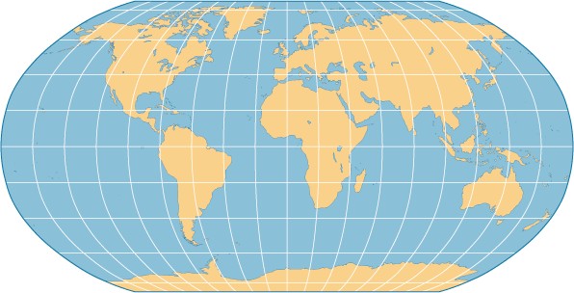

The Mercator projection shows land masses with their true shapes, but their sizes are distorted. It was developed in the 1500’s and was especially useful for sailing ships. The lines of longitude and latitude are drawn as though they do not meet at the poles. The Mercator projection is still used by navigators at sea because a line connecting any two points on this kind of map gives the compass direction between them.

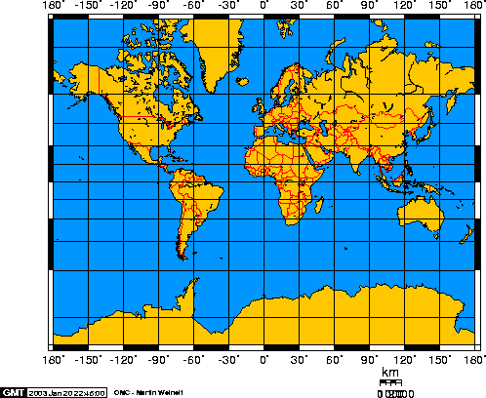

The Conic projection is a rectangular map with curved parallels and meridians. This is most accurate for the areas on the globe that touch the cone. They are good for showing smaller areas, especially areas in the middle latitudes. Direction and distance are also relatively accurate. To create a conic projection, a piece of paper is twisted into a cone and placed over the globe so that the circular “top” of the cone touches the globe.
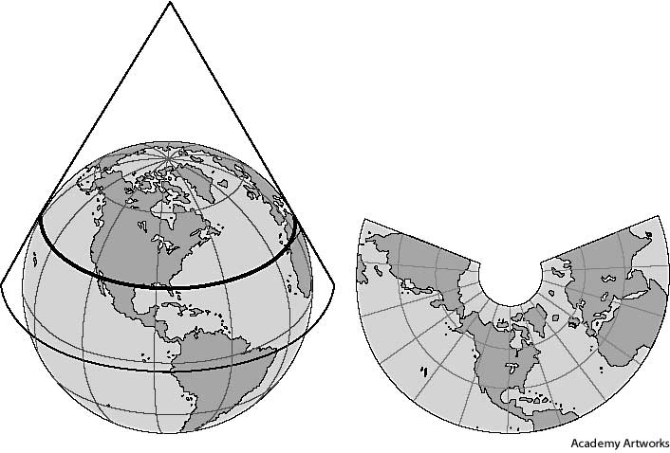

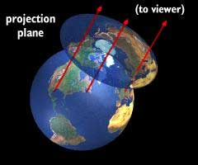
A plane projection is created by placing an imaginary screen directly above, or below a globe. The image that would result is called a plane projection. This type of map projection is not commonly used.

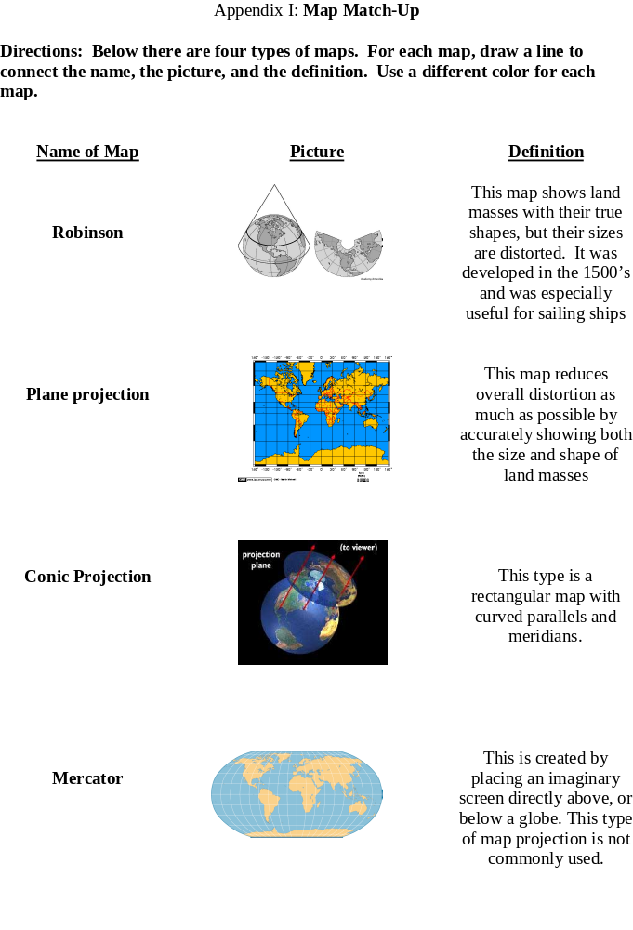
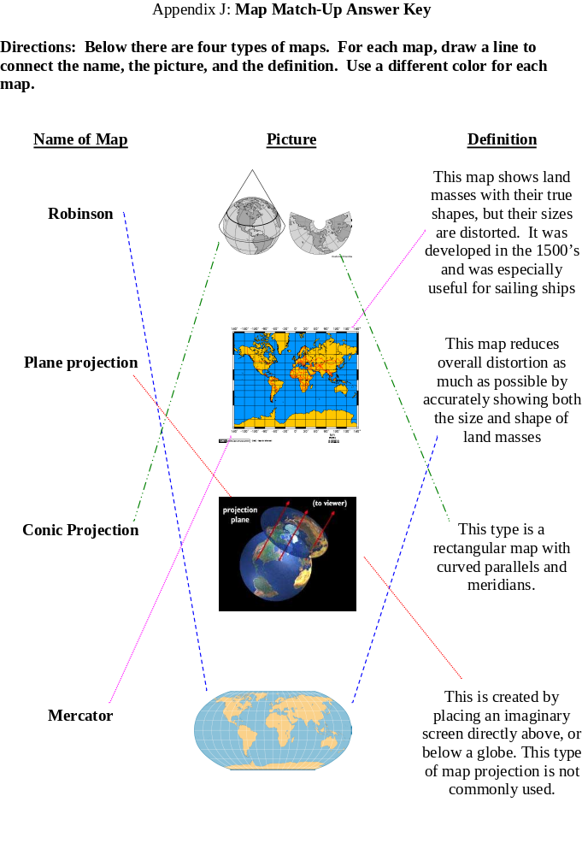

Appendix K: Different Map Projections

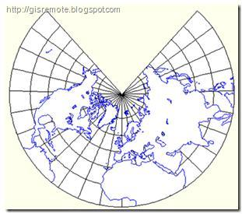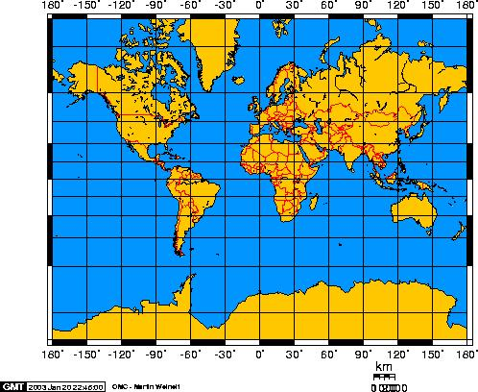

Conic Mercator

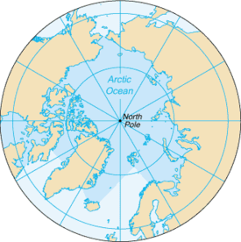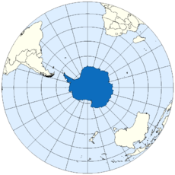

North Pole Plane Projection South Pole Plane Projection

Appendix L: Sheep Markers and Little Dog

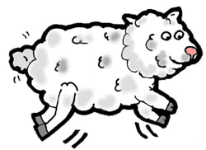
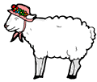
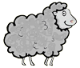
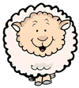
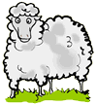
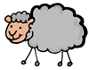
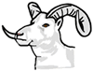

http://www.clipsahoy.com/animals/sheep/sheep1.htm

Appendix M: Longitude and Latitude Teacher Background

- Lines of Latitude run east and west around Earth. They are also called parallels because the lines are always parallel, or the same distance apart. The Equator is the longest latitude line, halfway between the poles, and is 0° latitude. All the other latitude lines are up to 90°, and are either north or south of the equator. The Equator divides Earth into Northern and Southern Hemispheres. The North Pole is at 90° N and the South Pole is at 90° S.

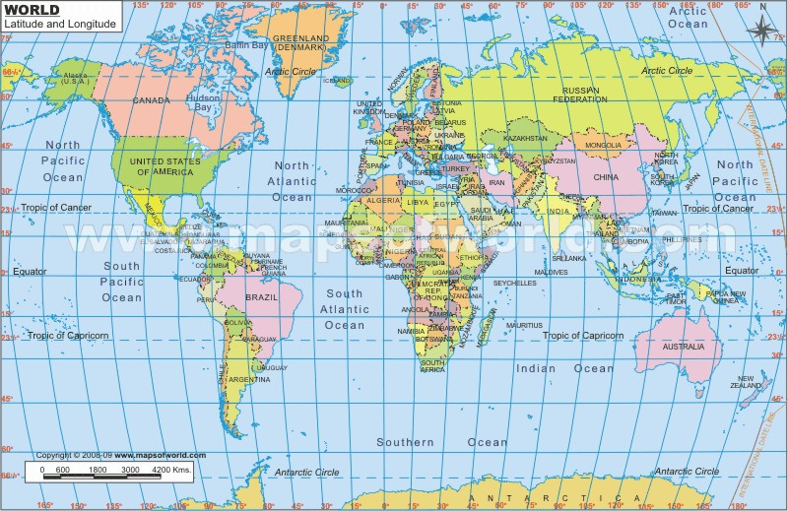
- Lines of Longitude run north and south around Earth. They are also called meridians. Lines of longitude are the same size, but they are not parallel because the Earth is a sphere. The widest distance between lines measuring degrees of longitude is at the Equator, and they converge as they approach the poles. The Prime Meridian 0° longitude. All the other longitude lines are up to 180°, either east or west of it. The Prime Meridian divides Earth into Eastern and Western Hemispheres.

Example of map showing latitude and longitude
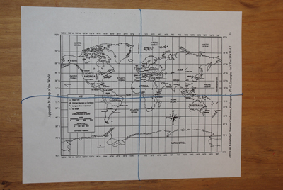

Appendix N: Map of the World
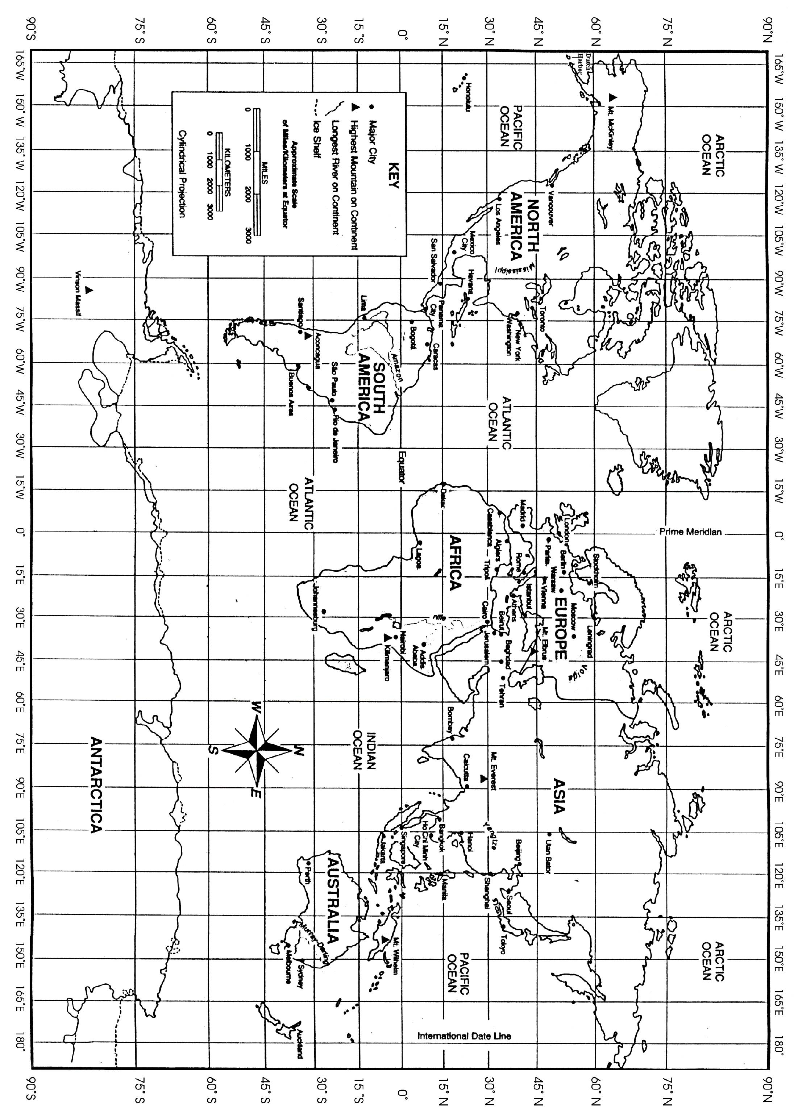

Appendix O: Finding Locations

Coordinates Location

59° N 18° E Stockholm
29° N 31° E Cairo
27° N 86° E Mt. Everest
39° N 116° E Beijing
31° N 121 ° E Shanghai
33° S 151° E Sydney
34° S 58° W Buenos Aires
13° N 89° W San Salvador
49° N 123° W Vancouver
40° N 73° W New York
8° N 79° W Panama City
51° N 0° W London
12° S 77° W Lima
22° S 43° W Rio De Janeiro

Appendix P: Identifying Locations and Coordinates

Find the location or the coordinate. The location can be a city, a state, or a continent.

Coordinate Location

56° N 37° E ____________________________________

35° N 93° W ____________________________________

31°S 25° E ____________________________________

43° N 122° W ____________________________________

80° S 117° E ____________________________________

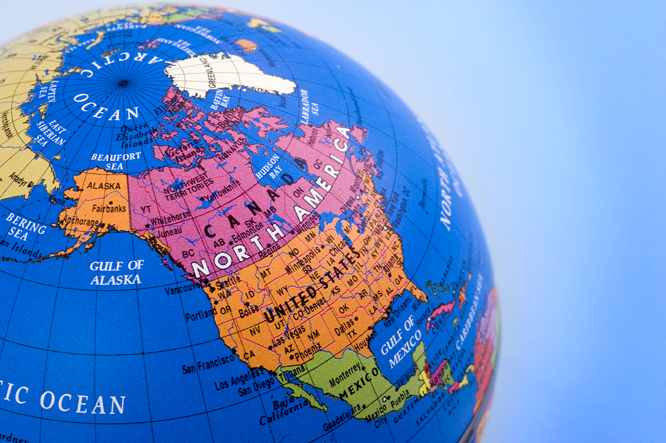

__________________ Madagascar

__________________ Caspian Sea

__________________ Washington DC

__________________ Sahara Desert

__________________ Mexico City
Appendix Q: Identifying Locations and Coordinates Answer Key

Coordinate Location

56° N 37° E Moscow

35° N 93° W Arkansas

31°S 25° E South Africa

43° N 122° W Oregon

80° S 117° E Australia

20° S 44° E Madagascar

45° N 50° E Caspian Sea

38° N 77° W Washington DC

18° N 77° W Montego Bay

19° N 99° W Mexico City

Appendix R: Mastery Checklist – Follow Those Lines

Observe Little Bo Peep Bingo and check-off each skill as it is achieved.

Skills
Student Name______________________ Student Name______________________

Listens to Directions
Finds coordinates without assistance
Finds coordinates with some assistance
Is unable to find coordinates without assistance
Shouts “BAAA” at the correct time!
Listens to Directions
Finds coordinates without assistance
Finds coordinates with some assistance
Is unable to find coordinates without assistance
Shouts “BAAA” at the correct time!

Skills
Student Name______________________ Student Name______________________

Listens to Directions
Finds coordinates without assistance
Finds coordinates with some assistance
Is unable to find coordinates without assistance
Shouts “BAAA” at the correct time!
Listens to Directions
Finds coordinates without assistance
Finds coordinates with some assistance
Is unable to find coordinates without assistance
Shouts “BAAA” at the correct time!

Appendix S: Climate Zones

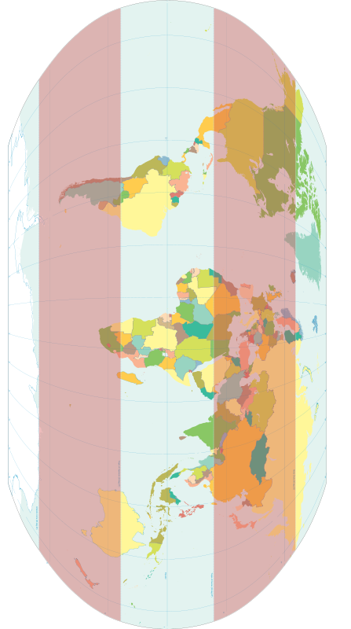

Appendix T: Climate Zones Teacher Notes

The Tropic of Cancer is located at 23.5 degrees north. It is a parallel that runs through Mexico, the Bahamas, Egypt, Saudi Arabia, India, and Southern China.

The Tropic of Capricorn is located at 23.5 degrees south. It is a parallel that runs through Australia, China, Chile, southern Brazil, and northern South Africa.

The area between the two tropics is known as “the tropics” or “low latitudes.” Each tropic rotates on its on axis and at the same time, it revolves around the sun.

There are three main categories of climate ~ arctic (also known as polar), tropical, and temperate.

Arctic ~ included both the Arctic and Antarctic areas. It has cool to cold summers and cold to very cold winters. The temperature averages below 32°F year-round on the Antarctic and Greenland ice caps, and drop to well below 0°F during the long, dark winter months.

Tropical ~ includes some belts of climate with hot, wet weather year-round and some with hot weather that is dry part of the year and wet part of the year. Areas with wet weather all year are typically rainforests. Temperatures average above 68°F throughout the year in the tropics. Tropical rainforests thrive around the Equator in Africa and in South America, Southeast Asia, Indonesia, Borneo, and New Guinea.

Temperate ~ found in the middle latitudes, between the tropics and the polar areas. It is characterized by warm to hot summers and cool to cold winters, with variations depending on latitude. Temperatures rise above 100°F in the summer and drop well below freezing in the winter. It experiences dramatic changes in seasons, with pronounced periods of spring and fall. Temperate zones are found in the northeastern and north United States, western Europe, and eastern Asia.
Appendix U: Map of Climate Zones

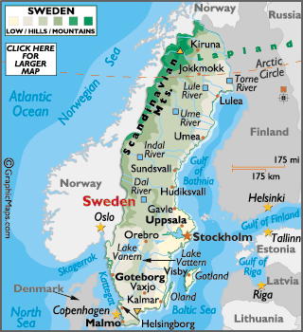
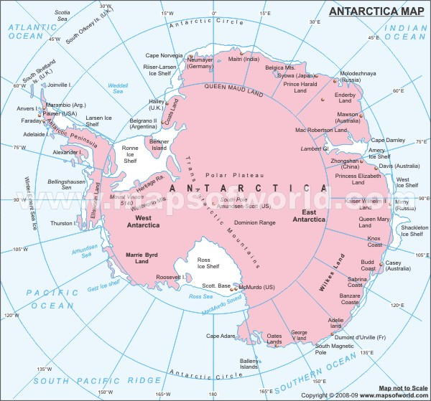

Sweden and the Arctic Circle Antarctica and the Antarctic Circle

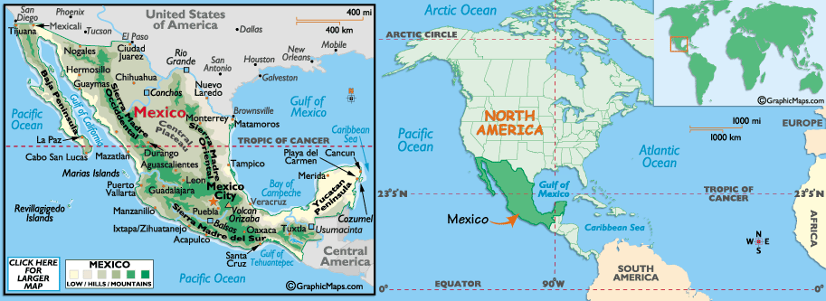
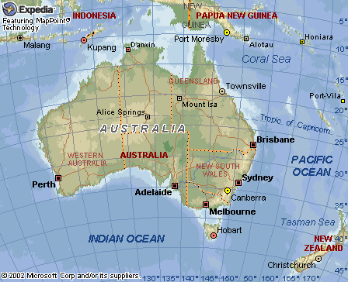
Australia and the Tropic of Capricorn Mexico and the Tropic of Cancer

http://www.worldatlas.com/aatlas/imageg.htm

Appendix V: Map of Time Zones

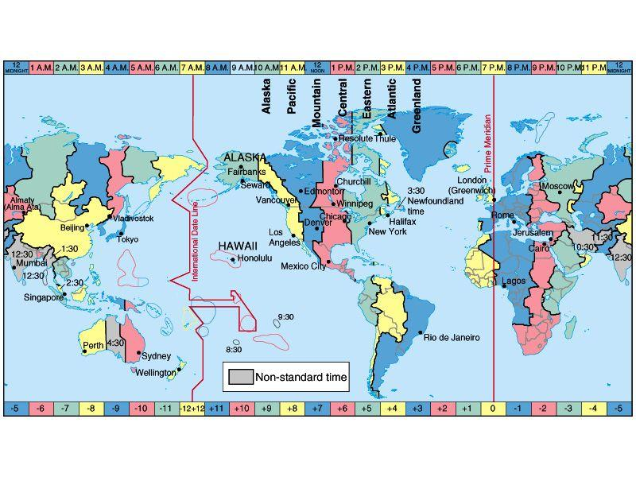
Appendix W: Traveling Through the Time Zones

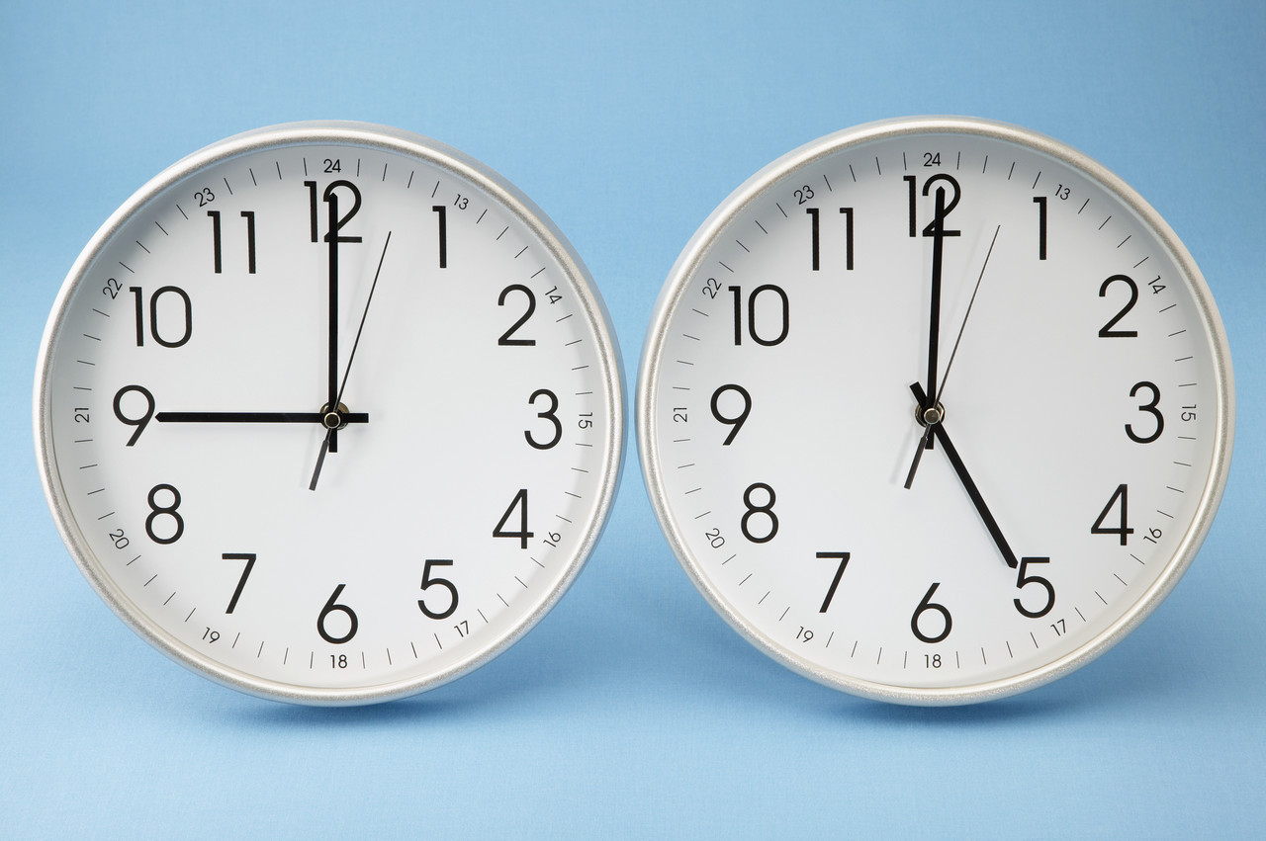
As you travel from place to place, you become confused at all the different time zones. What is going on? One minute it is 3:00 PM and then you travel around the world and it is the next day!
To help with this confusion, you are to create a brochure about the World Time Zones.
Be creative and accurate in your product.
You can use any sources that you may have (just make sure to cite them in your brochure).

Include the following criteria as you create your brochure:

- Use a computer publishing program (such as Microsoft Publisher) OR 8 ½ X 14 paper folded into a tri-fold pamphlet.
- Make sure your content is accurate.
- Writing needs to be organized with correct grammar and use of vocabulary (Greenwich, England, International Date Line, Prime Meridian, Time Zone).
- Use graphics/pictures that go with text.
- Be able to accurately answer questions about time zones and how you created your brochure.
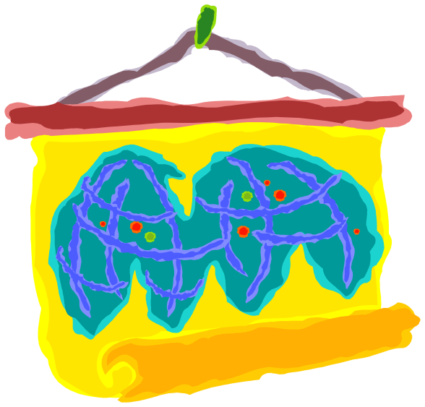
- Cite sources on brochure.
Appendix X: Brochure Rubric


