“Measurement Matters”
Grade Level or Special Area: Kindergarten
Written by: (Kristi Shoemake and Tammy Peacock, College Lane Elementary)
Length of Unit: (12 lessons) (approximately 3 weeks)

ABSTRACT

Measure this and measure that? Do children need to learn the importance of how to measure things and why we measure things? In this unit, young learners will be introduced to various measurement tools and strategies in both standard and non-standard forms. Children will be exposed to music that will help them to learn about measurement and they will be exposed to numerous hands-on activities that also help them to understand measurement. They will enjoy the numerous books that teach them about measurement in a fun and creative way.

OVERVIEW
  - Concept Objectives
    - Understand measurable attributes of object and units, systems, and processes of measurement. (K.4 Benchmark 1)
    - Apply appropriate techniques, tools, and formulas to determine measurements (K.4 Benchmark 2)
  - Content from the Core Knowledge Sequence (List specific content from the Core Knowledge Sequence that will be covered in the unit.)
    - Measurement
      - Identify familiar instruments of measurement, such as ruler, scale, and thermometer.
      - Compare objects according :
Linear measure
Long and short: longer than, shorter than
Measure length using non-standard units
Begin to measure length in inches
Height: taller than, shorter than
Weight (mass)
Heavy, light
Heavier than, lighter than
Capacity (volume)
Full and empty
Less full than, as full as, fuller than
Temperature: hotter and colder
- Time
Sequence events: before and after; first, next last,
Compare duration of events: which takes more or less time.
Read a clock face and tell time to the hour.
Know the days of the week and the months of the year.
Orientation in time: today, yesterday, tomorrow, morning, afternoon; this morning vs. yesterday morning, etc.

  - Skill Objectives (List specific skills to be taught in each lesson – and use the same ones from your lessons.)
    - Describe and compare, using appropriate concepts and vocabulary, the measurable properties of length (shorter, longer, taller) volume (full, empty) weight (heavy, light) and time (before, after, morning, afternoon, days week) (K-4 Benchmark 1)
    - Use tools to make predictions (using a balance scale, predicting how many cups a container will hold and then filling it to check the prediction) (K-4 Benchmark 1)
    - Measure using non-standard units of measurement (sue pencils to measure desk top, use different lengths of rope to measure distance in classroom) (K-4 Benchmark 1)
    - Use digital and analog (face) clocks to tell time to the hour. (K-4 Benchmark 1)
    - Explore measuring objects using a repeating non-standard unit of measure (paper clips, cubes etc..) (K-4 Benchmark 2)

BACKGROUND KNOWLEDGE
  - For Teachers (Cite up to three resources to increase the teacher’s knowledge for teaching this unit.)
    - Core Knowledge Sequence
    - Core Knowledge Kindergarten Teacher Handbook
    - What you Kindergartener Should Know
    - Math Investigations teacher handbooks
  - For Students (Identify topics introduced in previous units or grade levels that provide students with necessary prior knowledge.)
    - (none due to age of students)

RESOURCES (Provide a list of key resources-literature selections, activity books, AV materials, etc.-that are critical in teaching this unit.)
- LESSONS
Lesson One: Title (Days of the Week)
  - Daily Objectives (Lesson content, concept objectives, and skill objectives should all be
listed in the Overview section as well.)
  - Concept Objectives (List the same ones used within the individual lessons.)
    - Understand measurable attributes of object and units, systems, and processes of measurement. (K.4 Benchmark 1)
    - Apply appropriate techniques, tools, and formulas to determine measurements (K.4 Benchmark 2)
    - Lesson Content
      - Measurement (page # 18 In Core Knowledge Sequence)
Know the Days of the week and the months of the year.
    - Skill Objective(s)
    - a. Describe and compare, using appropriate concepts and vocabulary, the measurable properties of length (shorter, longer, taller) volume (full, empty) weight (heavy, light) and time (before, after, morning, afternoon, days week) (K-4 Benchmark 1)

  - Materials (List the materials a teacher must have in order to teach this lesson. Itemize the list and reference the item if it is included in the handouts i.e., (Appendix A, B, etc.)
    - Core Knowledge Sequence
    - calendar (month)
    - days of the week chart
    - copy of song “Days of the week” (sung to the tune of the Adams Family)
    - copy of Eric Carles Today is Monday
    - copy of Cookies Week by Tomie dePoala.
    - pocket chart with days of the week cards to use in pockets
    - puzzle worksheet (appendix 1)
    - Venn diagram (appendix 2)
  - Key Vocabulary (List and define Core Knowledge vocabulary (and sayings) that will be introduced in the lesson.)
    - calendar- a system of time keeping that defines the beginning and length and divisions of a year.
    - day- a unit of measure that is defined by hours.
    - week- a unit of measure that is comprised of 7 days.
    - month- a unit of time that consists of 30 or 31 days and defines 1/12 of a year.

  - Procedures/Activities (List the steps in how the teacher proceeds when teaching this lesson. Include procedures for integrating subjects—where appropriate—motivating activity to introduce the lesson, additional activities and assignments that will lead to student learning. Provide step-by-step directions through the use of brief action statements i.e., Brainstorm possibilities; read (book title); record responses.)
    - Teacher introduces the lesson by reading Today is Monday by Eric Carle
    - Using pocket charts and cards that have the days of the week on each card, students will take turns placing the days in the correct order. Teacher directed as needed to identify each day correctly.
    - Sing together the Days of the Week song written the to tune of the Adams Family song
    - Discuss the order of the days of the week and talk about the first day, last day and so on. Read Cookies Week by Tomie dePaola.
    - Discuss the consistent pattern of the days of the week that occurs every single day.
Teacher directed discussion Students will be encouraged to tell what happened yesterday, today and tomorrow. This discussion will continue as they discuss what events will happen tomorrow and what happened yesterday.
    - Encourage students to write the names of each day of the week copied from the board using markers and white boards. Teacher assistance as needed.
    - Allow students to color and cut out a puzzle that contains the days of the week. Recreate the puzzle in the correct order.
    - Students will give each student 3 strips of paper with “today”, “tomorrow” and “yesterday” on each strip. Students will be asked to sort pictures to each category of time.
    - Using the overhead or Elmo teacher and students will complete a Venn diagram that demonstrates the differences between, today, yesterday and tomorrow.

  - Assessment/Evaluation (Identify the method used (or provide the actual assessment used) to assess learning in this lesson. Provide any follow-up activity by which the children can demonstrate their mastery of the lesson.)
    - Teacher will do on-going assessment of observation as students complete the calendar chart.
    - Teacher will allow each student to demonstrate understanding of sequence of the days of the week as they put the days of the week cards in correct sequence.
    - Students will be encouraged to pair up and play a game putting them in order.
    - Students will be encouraged to color, cut out and re-create the puzzle of the days of the week to show understanding of the concept. (Appendix A)
    - Students will share with the class the posters created to display “today, “tomorrow” and “yesterday”

- LESSONS
(Organize each day into a lesson incorporating the following):
Lesson Two: Title (More Time, Less Time)
- Daily Objectives (Lesson content, concept objectives, and skill objectives should all be
listed in the Overview section as well.)
B. Concept Objectives (List the same ones used within the individual lessons.)
    - Understand measurable attributes of object and units, systems, and processes of measurement. (K.4 Benchmark 1)
    - Apply appropriate techniques, tools, and formulas to determine measurements (K.4 Benchmark 2)
    - Lesson Content
      - Measurement (page # 18 In Core Knowledge Sequence)
Compare duration of events: which takes more or less time
    - Skill Objective(s)
Describe and compare, using appropriate concepts and vocabulary, the measurable properties of length (shorter, longer, taller) volume (full, empty) weight (heavy, light) and time (before, after, morning, afternoon, days week) (K-4 Benchmark 1)

C. Materials (List the materials a teacher must have in order to teach this lesson. Itemize the
list and reference the item if it is included in the handouts i.e., (Appendix A, B, etc.)
    - Montgomery’s Time Zone by C.A. Nobens
    - chart paper with three headings to include: morning, noon and night.
    - items to represent each time of day such as a box of cereal for morning, tennis shoes for recess for afternoon and pajamas for evening.
    - markers, crayons and pencils
    - pre- made three flap books for each student.
    - collection of items to compare time, such as: two books(one thick and one thin) two jackets(one slip-on and one jip up)
    - students can be given lollipop and M&M’s. Have class decide which would take more time to eat. Allow them to eat the M&M’s, timing them. Then time the class as they eat the lollipops. You may want to have them completing another activity as you do this.

D. Key Vocabulary (List and define Core Knowledge vocabulary (and sayings)

that will be introduced in the lesson.)
    - more- greater in number
    - less- less in number
    - morning-the early part of the day, ending at noon
    - afternoon-the part of the day between noon and evening
    - evening-time between sunset and bedtime
    - today-the present time or age
    - tomorrow-the day after today
    - yesterday-the day before today

  - Procedures/Activities (List the steps in how the teacher proceeds when teaching this lesson. Include procedures for integrating subjects—where appropriate—motivating activity to introduce the lesson, additional activities and assignments that will lead to student learning. Provide step-by-step directions through the use of brief action statements i.e., Brainstorm possibilities; read (book title); record responses.)
    - During morning circle and calendar time, teacher will discuss with the students what day it is and what day yesterday was and what day tomorrow will be. Teacher will discuss with the students what events happened yesterday, what will happen tomorrow, what event takes longer and what event takes less time etc….
    - Students will be given numerous items that the teacher collected earlier. They will look at these objects and predict what items will take less time to complete or more time to complete.
    - Next, they will be told that it is a race and will then be encouraged to begin the race. Set the timer! Students will complete the activity that is assigned to them and will compete with their neighbor to see whose activity took more time and which activity took less time.
    - Discuss with the class which activity took more time and the possibilities of why.
    - Teacher directed Venn diagram to show which activities show which activities took more time and which ones took less time.
  - Assessment/Evaluation (Identify the method used (or provide the actual assessment used) to assess learning in this lesson. Provide any follow-up activity by which the children can demonstrate their mastery of the lesson.)
    - Observation of activities by teacher

- LESSONS
(Organize each day into a lesson incorporating the following):
Lesson Three: Title (Months of the Year)
  - Daily Objectives (Lesson content, concept objectives, and skill objectives should all be listed in the Overview section as well.)
  - Concept Objectives (List the same ones used within the individual lessons.)
    - Understand measurable attributes of object and units, systems, and processes of measurement. (K.4 Benchmark 1)
    - Apply appropriate techniques, tools, and formulas to determine measurements (K.4 Benchmark 2)
    - Lesson Content
      - Measurement (page 18 in Core Knowledge Sequence)
Know the Days of the week and the months of the year.
    - Skill Objective(s)
Describe and compare, using appropriate concepts and vocabulary, the measurable properties of length (shorter, longer, taller) volume (full, empty) weight (heavy, light) and time (before, after, morning, afternoon, days week) (K-4 Benchmark 1)
  - Materials (List the materials a teacher must have in order to teach this lesson. Itemize the list and reference the item if it is included in the handouts i.e., (Appendix A, B, etc.)
    - Core Knowledge Sequence
    - Calendar journal for each student (this will be an ongoing activity throughout the year that includes weather, counting, sequencing)
    - materials to create hats for each month (pre-cut hats with pre-cut decorations for each month)
  - Key Vocabulary (List and define Core Knowledge vocabulary (and sayings) that will be introduced in the lesson.)
    - month-a unit of time that consists of 30 or 31 days and defines 1/12 of a year.
    - journal-an ongoing daily log of events in the classroom
    - sequence-a continuous pattern of events
    - pattern-events that follow a particular order
  - Procedures/Activities (List the steps in how the teacher proceeds when teaching this lesson. Include procedures for integrating subjects—where appropriate—motivating activity to introduce the lesson, additional activities and assignments that will lead to student learning. Provide step-by-step directions through the use of brief action statements i.e., Brainstorm possibilities; read (book title); record responses.)
    - Introduce the lesson by reading Month by Month the Year Goes Round by Carol Shields (discuss the story and the sequence of the story)
    - Teacher will introduce the concept of the daily journal to include: weather, counting and sequencing activities. Instruct students to begin their journals. Give examples.
    - Read the poem Months and Seasons to the students
    - Show calendar and discuss how each month is in a specific season and that a group of months make up a season and that each year is comprised of 4 seasons.
    - Using cards printed with months of the year, picture and the number of the month included, divide the students into groups and have them put the months into the correct order. First, give students an example to follow, gradually reducing the teacher assistance.
    - Read Twelve Hats for Lena by Karen Katz (discuss story)
    - Students will create hats to represent each month of the year. Encourage students to create a hat to represent the assigned month using teacher provided materials.
    - Students will review the 12 months of the year using technology. (song and puzzle) (www.britishcouncil.org/kids-songs-months-popup.htm)
    - Review the months by allowing each student to stand in the correct order of the months of the year in front of the classroom. Allow students to help as the students get into the correct order.
    - As an extension activity, students will continue to discuss the concept of: today, yesterday and tomorrow.
  - Assessment/Evaluation (Identify the method used (or provide the actual assessment used) to assess learning in this lesson. Provide any follow-up activity by which the children can demonstrate their mastery of the lesson.)
    - Teacher observation
    - Use objects and pictures as visual aids and students will identify the month of the year that goes with each object.
    - Question/Answer session
    - Songs to teach and re-enforce the months of the year
- LESSONS
(Organize each day into a lesson incorporating the following):
Lesson Four: Title (What time is it?)
  - Daily Objectives (Lesson content, concept objectives, and skill objectives should all be listed in the Overview section as well.)
  - Concept Objectives (List the same ones used within the individual lessons.)
    - Understand measurable attributes of object and units, systems, and processes of measurement. (K.4 Benchmark 1)
    - Apply appropriate techniques, tools, and formulas to determine measurements (K.4 Benchmark 2)
    - Lesson Content
      - Measurement (page # 18 In Core Knowledge Sequence)
Read a clock face and tell time on the hour
    - Skill Objective(s)
    - Use digital and analog (face) clocks to tell time to the hour. (K-4 Benchmark 1)
  - Materials (List the materials a teacher must have in order to teach this lesson. Itemize the list and reference the item if it is included in the handouts i.e., (Appendix A, B, etc.)
    - Judy-E Clocks One large for teacher and one small one for each child
    - Copy of book My First Book of Time by Claire Llewellyn
    - two paper cups
    - sand
    - sharp pencil
    - Copy of book Grouchy Ladybug by Eric Carle
    - Lima Beans
    - red spray paint
    - black sharpie
  - Key Vocabulary (List and define Core Knowledge vocabulary (and sayings) that will be introduced in the lesson.)
    - time-past, present and future
    - hour-a frame of time that consists of 60 minutes
    - clock-an instrument for telling time
    - minute-a frame of time that consists of 60 seconds
  - Procedures/Activities (List the steps in how the teacher proceeds when teaching this lesson. Include procedures for integrating subjects—where appropriate—motivating activity to introduce the lesson, additional activities and assignments that will lead to student learning. Provide step-by-step directions through the use of brief action statements i.e., Brainstorm possibilities; read (book title); record responses.)
    - Introduce the lesson by reading My First Book of Time by Claire Llewellyn
    - Create a sand clock by filling a paper cup with sand. Use a sharp pencil to poke a hole in the bottom of a second paper cup. Cover the hole with your finger and pour the sand into the cup with the hole. Move you finger and show your child how the sand runs through the hole into the other cup.
    - Discuss the importance of time and explain how events are based on time and that we have to wait until a set time for events
    - Use Judy-E clocks to show students how to tell time on the hour. Using the large teacher clock, students will follow teacher’s example and practice with classmates on telling time on the hour.
    - Read the Grouchy Ladybug by Eric Carle
    - Review what time on the hour means and have students to practice telling time with small Judy-e clocks.
    - As an extended activity, create lima bean ladybugs. Lay out a small amount of lima beans on a piece of paper. Spray each bean with read spray paint, wait for them to dry and turn them over and spray the other side red also. After beans are completely dry, draw spots and eyes on each bean to create ladybugs.
    - Using ladybug markers, measure using ladybug markers. Children will learn to align ladybug rulers, bead counters, and single non-standard units (ladybug lima beans) at the beginning and ending points, and focus on the length of the object according to units rather than only numbers.
    - Discuss with students the comparison of time on the clock to measurement and that time is a form of measurement similar to measurement on a ruler.
    - As a final activity, the students will create their own clock with an hour hand and a minute hand. Students will cut out and create a clock. Print the clock on cardstock paper. Students will cut out the clock face and the hands. Attach the hands with a brad. Students will practice moving the hands and telling time on the hour.
    - Encourage the students to practice telling time on the hour with their classmates.
    - As a homework assignment, encourage the students to take home the clock and practice telling time on the hour with family members.
  - Assessment/Evaluation (Identify the method used (or provide the actual assessment used) to assess learning in this lesson. Provide any follow-up activity by which the children can demonstrate their mastery of the lesson.)
    - Teacher observes students as they work with classmates to tell time on the hour.
    - Students will complete a worksheet on how to tell time on the hour. Teacher will check for understanding of concept of time on the hour. (Appendix B)
- LESSONS
(Organize each day into a lesson incorporating the following):
Lesson Five: Title (Temperature Rising and Falling)
  - Daily Objectives (Lesson content, concept objectives, and skill objectives should all be listed in the Overview section as well.)
  - Concept Objectives (List the same ones used within the individual lessons.)
    - Understand measurable attributes of object and units, systems, and processes of measurement. (K.4 Benchmark 1)
    - Apply appropriate techniques, tools, and formulas to determine measurements (K.4 Benchmark 2)
    - Lesson Content
      - Measurement (page # 18 In Core Knowledge Sequence)
Read a clock face and tell time on the hour
    - Skill Objective(s)
    - Use digital and analog (face) clocks to tell time to the hour. (K-4 Benchmark 1)
  - Materials (List the materials a teacher must have in order to teach this lesson. Itemize the list and reference the item if it is included in the handouts i.e., (Appendix A, B, etc.)
    - Big thermometer
    - Seasons (Pre-made with cardboard, cotton, grass, flowers, leaves, and paper bags for trees)
    - 8 two liter pop bottles ( scissors needed)
    - 8- thermometers (tape needed)
    - paper thermometers
    - season worksheets
    - glue sticks
    - crayons
  - Key Vocabulary
    - temperature-a measure of warmth or coldness of an object or substance with reference to some standard value.
    - thermometer- an instrument for measuring temperature.
    - degrees- a unit of measurement for temperature on a scale such as Celsius or Fahrenheit.
    - seasons- one of the four periods of the year
2. cool- neither warm nor cold
    - damp- slightly wet
    - humid- containing a large amount of water or water vapor
    - heat- a hot condition of the atmosphere or physical environment; hot season or weather
  - Procedures/Activities
    - Introduce a thermometer in a whole groups setting. Do some counting drills with the big thermometer.
    - Move the thermometer and have the children read it; introduce the word degrees.
    - Ask what temperatures are hot and which ones are cold.
    - Introduce seasons and have students repeat the four seasons in order; do it continuously several times to allow students to comprehend the idea that seasons cycle.
    - Explain that today we are going to investigate the different temperatures of water in different seasons.
    - Separate students into groups and explain the activity.
    - Distribute paper thermometers and a season worksheet.
    - When at the stations, allow students several minutes to complete their task and then have them rotate.
          - find the temperature to the close degree. (remind students that they are allowed to look at the big thermometer for help)
          - Next, the students are to take their paper thermometers and color it so it looks like the real thermometers.
          - Finally, the student will glue his or her thermometer to the season worksheet.
          - Students will color their worksheet until their teacher has them move to the next station.

    - Call everyone back into a whole group setting once everyone has been to each of the four season centers.
10. Tell students to sit next to the people in their groups. Start out by asking one of the children to share something about what they found out about the Summer station. Ask the child to put up a "sun sticker" on the big thermometer so that it looks like their thermometer for the summer. Then go to another child within the same group and have that child share a different season, (each season will have a different sticker appropriate to the season). Do this until each person in the group has gone, (depending on group size, each group will not get to put up a full four seasons.) Continue doing this until each person in each group has gotten a turn at the big thermometer.
11. Now it is time for questions:
a. "How many suns are up on the big thermometer?"
b. "Are all of the suns on the same temperature?"
c. "What does this mean?"
d. "Where does the red stuff inside the thermometer like to go when it is summer? Winter? Fall/Spring?
e. "What does it mean when the thermometer goes up high?"
f. "What does it mean when the thermometer goes down really low?"
g. "If I wore a hat, scarf, boots, a heavy coat, a pair of paints, and gloves, what do you think the thermometer would look like? What season would it be?
h. "If I put the thermometer way up here, what kind of cloths would I wear?"
i. "If I put the thermometer right here (at 60 degrees), what season do you think it is? What would you wear?"
12. Count off children 1,2,3,4 and then assign them where to stand. Let children feel the water for each of the four seasons. Have them go back to their desk and finish coloring the seasons worksheet until everyone has gotten a turn to feel the water. Also tell them to put their names on their papers.
13. Finally, have them turn in their papers once everyone is finished feeling the water. They may finish coloring the paper once the teacher has had a chance to look them over.
· EVALUATION:
Directions: Color your thermometers so that each one would read an appropriate temperature for each one of the four seasons. Then paste them in the correct box. Finally, you may color in the rest of the picture.
Name: ______________________________________
SUMMER FALL

WINTER SPRING

  - Assessment/Evaluation
1. Children will be evaluated on the following.
a. Did they put up a sensible answer for the graphing portion of circle time?
b. When we asked all of the questions at the end of circle time, was the child's answer sensible?
c. Did the child color a temperature that makes sense on their paper thermometer? Did they place it in the correct season?
d. How did they act in their groups? (not related to science, but is an important part of kindergarten; sharing, getting along with others)?
(Appendix C)

- LESSONS
(Organize each day into a lesson incorporating the following):
Lesson Six: Title (Measure Once, Measure Twice)
  - Daily Objectives (Lesson content, concept objectives, and skill objectives should all be listed in the Overview section as well.)
  - Concept Objectives (List the same ones used within the individual lessons.)
    - Understand measurable attributes of object and units, systems, and processes of measurement. (K.4 Benchmark 1)
    - Apply appropriate techniques, tools, and formulas to determine measurements (K.4 Benchmark 2)
    - Lesson Content
      - Measurement (page # 18 In Core Knowledge Sequence)
Read a clock face and tell time on the hour
    - Skill Objective(s)
    - Use digital and analog (face) clocks to tell time to the hour. (K-4 Benchmark 1)
  - Materials
    - Core Knowledge Kindergarten Teacher Handbook
    - Measuring Penny book
    - ruler
    - yardstick
    - tape measure
    - scale
    - thermometer
    - clock
    - calendar
    - measuring spoons,
    - cups
    - containers
    - Available objects such as; school box, glue, Kleenex box, crayons, bowl of sand, water, pennies, paperclips, hot and cold liquid, and rice (objects may vary)
    - Pencil
    - paper
    - checklist
  - Key Vocabulary
    - measurement- is the estimation of a physical quantity such as length, temperature, or time.
    - ruler- an instrument used to measure distances and/or to rule strait lines.
    - yardstick- is a tool to physically measure lengths of up to three feet. ( a yard)
    - scale- an instrument used for weighing,
    - clock- an instrument for measuring and recording time.
    - thermometer- an instrument used for measuring temperature.
    - standard- items commonly used to measure.
    - non-standard- items not commonly used as a form of measurement.
  - Procedures/Activities
    - Read and discuss the book Measuring Penny.
    - Discuss vocabulary words associated with the story such as; measuring, ruler, yardstick, scale, clock, thermometer,
    - ruler
    - yardstick
    - tape measure
    - scale
    - clock
    - thermometer
    - measuring spoons
    - cups
    - containers
    - Demonstrate a range of items and discuss which instrument would be used to measure these items.
    - Arrange students in groups of four to six.
    - Present a collection of items, and have each group determine which instrument would be used to measure each substance.
    - Discuss the findings of each group and what they used to measure each item.
    - Watch a short movie on Brain Pop Jr. called Measurement.

  - Assessment/Evaluation
1. Students will match the correct measuring tool with the item that needs to be
measured.
(Appendix D)

- LESSONS
(Organize each day into a lesson incorporating the following):
Lesson Seven: Title (High, Low, High, Low)
  - Daily Objectives (Lesson content, concept objectives, and skill objectives should all be listed in the Overview section as well.)
  - Concept Objectives (List the same ones used within the individual lessons.)
    - Understand measurable attributes of object and units, systems, and processes of measurement. (K.4 Benchmark 1)
    - Apply appropriate techniques, tools, and formulas to determine measurements (K.4 Benchmark 2)
    - Lesson Content
      - Measurement (page # 18 In Core Knowledge Sequence)
    - Linear Measurement
Height: taller than, shorter than
    - Skill Objective(s)
    - Describe and compare, using appropriate concepts and vocabulary, the measurable properties of length (shorter, longer, taller) volume (full, empty) weight (heavy, light) and time (before, after, morning, afternoon, days week) (K-4 Benchmark 1)

  - Materials (List the materials a teacher must have in order to teach this lesson. Itemize the list and reference the item if it is included in the handouts i.e., (Appendix A, B, etc.)
    - Copy of Snow White and the Seven Dwarfs
    - various sizes of straws in Ziploc bags
    - paper
    - glue
  - Key Vocabulary (List and define Core Knowledge vocabulary (and sayings) that will be introduced in the lesson.)
    - tall/taller-higher than the average
    - short/shorter-shorter than the average
    - long/longest-measuring much or more than usual
    - length-a thing’s measurement from end to end
  - Procedures/Activities (List the steps in how the teacher proceeds when teaching this lesson. Include procedures for integrating subjects—where appropriate—motivating activity to introduce the lesson, additional activities and assignments that will lead to student learning. Provide step-by-step directions through the use of brief action statements i.e., Brainstorm possibilities; read (book title); record responses.)
    - Introduce the lesson by reading the story Snow White and the Seven Dwarfs to the students.
    - Ask the students to think about this story and what might be the connection to measurement in this story.
    - Review book recalling favorite events of the story. Name and recall names of the seven dwarfs.
    - Select seven students to represent the seven dwarfs.
    - Ask remaining students to determine which of the seven classmates is the shortest. Which is the tallest? Students assist in lining remaining “dwarfs” from shortest to tallest.
    - The first group of “dwarfs” selects another child to take his/her place and march back to his/her seated place. Continue sorting students by size, this time tallest to shortest. Continue playing until everyone has had a turn.
    - (Straw activity) Give each student a bag of straws of various lengths. Give them a piece of paper and some glue and ask the students to line the straws up from shortest to tallest and to glue them onto a piece of paper. Next, ask them to line them up from tallest to shortest and to glue them onto a piece of paper. Teacher assists as needed.
    - Whole group activity: Review with students the concepts that have been taught throughout this lesson. Review tallest, shortest, and same length.
  - Assessment/Evaluation (Identify the method used (or provide the actual assessment used) to assess learning in this lesson. Provide any follow-up activity by which the children can demonstrate their mastery of the lesson.)
    - Observation of activities as student’s line up classmates from shortest to tallest and from tallest to shortest.
    - Assess each student’s straw activity to check for understanding.
(Appendix E)
- LESSONS
(Organize each day into a lesson incorporating the following):
Lesson Eight: Title (Building Blocks)
  - Daily Objectives (Lesson content, concept objectives, and skill objectives should all be listed in the Overview section as well.)
  - Concept Objectives (List the same ones used within the individual lessons.)
    - Understand measurable attributes of object and units, systems, and processes of measurement. (K.4 Benchmark 1)
    - Apply appropriate techniques, tools, and formulas to determine measurements (K.4 Benchmark 2)
    - Lesson Content
      - Measurement (page # 18 In Core Knowledge Sequence)
Linear Measurement
Measure length using non-standard units
    - Skill Objective(s)
    - Measure using non-standard units of measurement (sue pencils to measure desk top, use different lengths of rope to measure distance in classroom) (K-4 Benchmark 1)

  - Materials (List the materials a teacher must have in order to teach this lesson. Itemize the list and reference the item if it is included in the handouts i.e., (Appendix A, B, etc.)
    - Various sizes of blocks
    - Jack the Builder by Stuart J. Murphy
    - popsicle sticks
    - paper
    - markers or crayons
    - ruler
  - Key Vocabulary (List and define Core Knowledge vocabulary (and sayings) that will be introduced in the lesson.)
    - numbers-a word or symbol used in counting
    - length-how long a thing is
    - width-how wide a thing is
    - height-how tall a thing is

  - Procedures/Activities (List the steps in how the teacher proceeds when teaching this lesson. Include procedures for integrating subjects—where appropriate—motivating activity to introduce the lesson, additional activities and assignments that will lead to student learning. Provide step-by-step directions through the use of brief action statements i.e., Brainstorm possibilities; read (book title); record responses.)
    - To introduce the lesson, teacher will read Jack the Builder to the class.
    - Discuss the story and talk about Jack and how he built things using blocks.
    - Encourage the students to think about how they would build a house and what items must be considered when building their house using blocks. Ask questions such as:
      - What will your house look like?
      - What colors will you use?
      - How many blocks will you need?
      - Will you need to use various sizes of blocks?
      - What might you build next?
    - Create groups of 2 or 3 students and have them to work together to build a house using blocks.
    - After each group has their house constructed, go to each group and ask questions such as:
      - Tell me about your house?
      - What colors did you use?
      - How many blocks did you use?
      - Did you use various sizes of blocks?
    - Have the students draw a picture of their house. Encourage them to focus on numbers, length, width and height. Allow time for each student or group to share their pictures with the class.
    - As a follow up activity and an assessment, encourage students to build a different type of house using popsicle sticks. This can be glued on a flat paper surface or it can be created 3 dimensional in shape.
    - Encourage the students to share with family members how they have learned to “build” a house today at school and encourage them to share terms about measurement that they have been introduced to.
    - Introduce the students to standard forms of measurement such as a ruler. This should be an introduction that focuses on a ruler but does not focus as much on the numbers on the ruler. Children should be come familiar with measurement tools for further lessons on standard forms of measurement.
  - Assessment/Evaluation (Identify the method used (or provide the actual assessment used) to assess learning in this lesson. Provide any follow-up activity by which the children can demonstrate their mastery of the lesson.)
    - Teacher observation of construction of houses
    - Checklist of concepts taught. Teacher will use this checklist to ensure that students are familiar with the concepts introduced in this lesson.

- LESSONS
(Organize each day into a lesson incorporating the following):
Lesson Nine: Title (Chocolate Anyone?????)
  - Daily Objectives (Lesson content, concept objectives, and skill objectives should all be listed in the Overview section as well.)
  - Concept Objectives (List the same ones used within the individual lessons.)
    - Understand measurable attributes of object and units, systems, and processes of measurement. (K.4 Benchmark 1)
    - Apply appropriate techniques, tools, and formulas to determine measurements (K.4 Benchmark 2)
    - Lesson Content
      - Measurement (page # 18 In Core Knowledge Sequence)
Linear Measurement
Measure length using non-standard units
    - Skill Objective(s)
    - Measure using non-standard units of measurement (sue pencils to measure desk top, use different lengths of rope to measure distance in classroom) (K-4 Benchmark 1)

  - Materials (List the materials a teacher must have in order to teach this lesson. Itemize the list and reference the item if it is included in the handouts i.e., (Appendix A, B, etc.)
    - wig
    - oversized flowery dress
    - various sizes of chocolate candy bars

  - Key Vocabulary (List and define Core Knowledge vocabulary (and sayings) that will be introduced in the lesson.)
    - measure-to find out the extent, size quantity of something
    - ruler-a straight strip of wood used to measure things
    - inch-the smallest unit of linear measurement
    - square-a shape with 4 equal sides
    - rectangle-a shape with 2 equal sides on one side and 2 longer yet equal sides on the other side
  - Procedures/Activities (List the steps in how the teacher proceeds when teaching this lesson. Include procedures for integrating subjects—where appropriate—motivating activity to introduce the lesson, additional activities and assignments that will lead to student learning. Provide step-by-step directions through the use of brief action statements i.e., Brainstorm possibilities; read (book title); record responses.)
    - Teacher comes in the classroom dressed as a substitute teacher named “Mrs. McNosh” (she is wearing an oversized flowery dress and a big curly wig)
    - She introduces herself to the class
    - She announces to the class that she needs to measure something, but she can’t find anything to measure with. “I do have some candy bars” says the teacher.
    - The class discusses how to use various sizes of candy bars to measure things in the classroom. (small, medium, large sizes)
    - Students are given a tally sheet to record their findings on.
    - Students come back together and discuss their findings.
    - Teacher discusses how measurement using standard and non-standard measurement is different and that non-standard measurements are a way to gain an understanding but are not an accurate way to form a specific measurement.
    - Next the students are given cards with pictures on them. Students are asked to go around the room and find an item that is the same length as the item on the picture, longer than the item on the picture and shorter than the item on the picture.
    - Students are encouraged to take this idea home and talk to family about measurement and find things at home to measure using standard and non-standard methods of measuring.
  - Assessment/Evaluation (Identify the method used (or provide the actual assessment used) to assess learning in this lesson. Provide any follow-up activity by which the children can demonstrate their mastery of the lesson.)
    - Teacher observes as the students go around the room to measure items.
    - Teacher assesses during large group time to gage understanding in her group.
    - Teacher checks tally sheet of each student to check for understanding.
- LESSONS
(Organize each day into a lesson incorporating the following):
Lesson Ten: Title (Heavy as an Elephant, or Light as a Feather)
  - Daily Objectives (Lesson content, concept objectives, and skill objectives should all be listed in the Overview section as well.)
  - Concept Objectives (List the same ones used within the individual lessons.)
    - Understand measurable attributes of object and units, systems, and processes of measurement. (K.4 Benchmark 1)
    - Apply appropriate techniques, tools, and formulas to determine measurements (K.4 Benchmark 2)
    - Lesson Content
      - Measurement (page # 18 In Core Knowledge Sequence)
Read a clock face and tell time on the hour
    - Skill Objective(s)
    - Use digital and analog (face) clocks to tell time to the hour. (K-4 Benchmark 1)
  - Materials
    - You will need the books Big and Little on the Farm, The Very Small, and Dragon Scales.
    - Chart paper
    - Markers
    - Items that are vary in weight.
    - scale
  - Key Vocabualary
    - weight- he heaviness of a particular object or person, especially as measured by a particular system of weight.
    - mass- a body of matter that forms a whole but has no definable shape.
    - heavy- weighing a relatively large amount and thus difficult to lift, carry, or move.
    - light- weighing comparatively little.
    - scale- an instrument used for weighing.
    - balance- a simple mechanical device for weighing objects.
  - Procedures/Activities
    - Read and discuss Big and Little on the Farm.
    - Read and discuss The Very Small.
3. Have a discussion about items that are large and small.
    - Students will play a game that involves naming things that are big and little. The class will be divided into two groups. One team will represent little and one team will represent big. The first person on the big team will name something big, and the next person has to name something bigger. The little team must name an item that is small and the next person will have to come up with something that is increasingly smaller. Each team will take turns naming items thus enabling the other team to come up with an additional answer. Each team will receive a point if they give an answer that is larger or smaller than the given answer. The team with the most points is the winner.
    - Read and discuss The Dragons Scales
    - Discuss and describe the different kinds of scales.
    - Make a chart and list items from the story that were heavy, and the items that were light.
    - Present various items to the class and have them make estimations about which items are light and which ones are heavy. Use a scale to determine if their estimations were correct.
    - Split the class into groups of four. Present each group with an array of items. Have each group arrange the items from the lightest to the heaviest. Have a group discussion about his or her findings.

  - Assessment/Evaluation
    - Teacher Observation
    - Written Assessment- circle objects that are lighter, and objects that are heavier
(Appendix F)

- LESSONS
(Organize each day into a lesson incorporating the following):
Lesson Eleven: Title (Capacity Comparison)
  - Daily Objectives (Lesson content, concept objectives, and skill objectives should all be listed in the Overview section as well.)
  - Concept Objectives (List the same ones used within the individual lessons.)
    - Understand measurable attributes of object and units, systems, and processes of measurement. (K.4 Benchmark 1)
    - Apply appropriate techniques, tools, and formulas to determine measurements (K.4 Benchmark 2)
    - Lesson Content
      - Measurement (page # 18 In Core Knowledge Sequence)
Read a clock face and tell time on the hour
    - Skill Objective(s)
    - Use digital and analog (face) clocks to tell time to the hour. (K-4 Benchmark 1)
  - Materials
    - Core Knowledge Kindergarten Teacher Handbook
    - Plastic container
    - jars
    - measuring cups
    - and spoons
    - sand
    - water
    - rice
    - paper
    - pencil
    - crayons
    - Chart and markers
    - milk
    - vanilla
    - sugar
    - crushed ice
    - salt
    - quart size Zip-lock bags (2 for each student)
    - gallon size Zip-lock freezer bag (1 for each child)
    - paper towels.
  - Key Vocabulary
    - capacity- a measure of the amount that can be held or contained.
    - weight- the heaviness of somebody or something
    - length- the distance along something
    - height- the distance between somebody or something’s lowest point and highest point.
    - volume- the amount of space that an object or substance occupies.
  - Procedures/Activities
    - introduce measurement tools that are used to measure Capacity (mass) such as containers, measuring cups and spoons
    - discuss vocabulary words such as capacity, weight, length, height, and volume
    - discuss concepts such as full and empty, less full than, and fuller than
    - present an array of different size containers and have a class discussion about the containers
    - have students discuss which container holds the most or the least
    - divide students into groups of four to five students
    - provide each group with various containers, measuring cups and spoons
    - provide them with items such as sand, water, rice, paper, pencils, and crayons
    - Discuss the findings of each group, and recording the findings as a group on a chart.
    - Have a class discussion about recipes and why we measure ingredients when making something
    - To demonstrate student understanding of capacity students will make ice cream
    - Each group will be provided with ingredients such as ; milk, vanilla, sugar, ice, salt, two quart size zip-lock bags, 1 gallon size zip lock bag, measuring spoons and cups, and paper towels.
    - The teacher will instruct one group at a time, as he or she discuss the ice cream recipe and how to measure the correct amount of ingredients. (this activity works well with extra help such as student aids or parent volunteers)
    - Discuss the importance of measuring the ingredients, and what would happen if the ingredients were not measured the correct way. What would the ice cream taste like?
  - Assessment/Evaluation
    - Teacher observation
    - Written observation- circle the container that holds less, and circle the container that holds the most.
(Appendix G)

- LESSONS
(Organize each day into a lesson incorporating the following):
Lesson Twelve: Title (Standard Units of Measure)
  - Daily Objectives (Lesson content, concept objectives, and skill objectives should all be listed in the Overview section as well.)
  - Concept Objectives (List the same ones used within the individual lessons.)
    - Understand measurable attributes of object and units, systems, and processes of measurement. (K.4 Benchmark 1)
    - Apply appropriate techniques, tools, and formulas to determine measurements (K.4 Benchmark 2)
    - Lesson Content
      - Measurement (page # 18 In Core Knowledge Sequence)
Read a clock face and tell time on the hour
    - Skill Objective(s)
    - Use digital and analog (face) clocks to tell time to the hour. (K-4 Benchmark 1)
  - Materials
    - A copy of the book “Jack and the Beanstalk”
    - five foot strips of bulletin board paper for each child
    - yardsticks for each child
    - record paper for each child

  - Key Vocabulary
    - measurement-The dimension, quantity, or capacity determined by measuring
    - ruler-a strip of wood, metal, or other material having a straight edge and usually marked off in inches or centimeters, used for drawing lines, measuring
    - inch-a very small amount, degree, or distance
    - yard-a unit of length equal to 0.9144 m/3 ft
    - Centimeter-a metric unit of length equal to one hundredth of a meter.
    - Estimation- a judgment or opinion about somebody or something.
  - Procedures/Activities (List the steps in how the teacher proceeds when teaching this lesson. Include procedures for integrating subjects—where appropriate—motivating activity to introduce the lesson, additional activities and assignments that will lead to student learning. Provide step-by-step directions through the use of brief action statements i.e., Brainstorm possibilities; read (book title); record responses.)
    - Read and discuss Attack of the 50-Foot Teacher
    - Read and discuss Jim and the Beanstalk
    - Have the students recall how large the giant was. Was he larger that a house? Was he larger than the beanstalk? Ask the students if there are really such things as giants. Explain that the book is fiction which means it is not real, it is made up. Show the children a yardstick. Explain that a yardstick is 36 inches or three feet long. Explain that most adults are five to six feet tall. Six feet tall would be two yard sticks put together. Lay two yardsticks end to end on the floor. Explain that the two yardsticks together represent the average size of adults. Ask children to predict how many yardsticks it would take to show how big the giant may have been. Write the predictions on chart.
    - After predictions have been recorded. Explain to the children that they estimated how large the giant was using yardsticks. However, now they are going to estimate how tall they are using inches. Review how big inches are and show them an inch on the yardstick. After this has been done, ask the children to think about how many inches it may be from their feet to their head. While they are thinking pass out their record sheets.
    - Once the children have their record sheets, discuss estimation using inches. Show the children an inch on the yardstick again. Ask them if anyone in the room is that small? Show them the two yardsticks and tell them that the two yardsticks equal 72 inches. Ask them if any child in the room is that tall. The answer to both of these questions should be no. Talk with the children about realistic estimations. Show them 42 inches using two yardsticks. Ask them if they thing someone in the room could be about that tall. Explain that no one in the room is one inch tall and no child in the room is seventy-two inches tall (six feet). After discussing this, ask children to write their height estimations in the appropriate blank.
    - After students have recorded their estimations, explain to them that now they will work with a partner to measure their actual height. Demonstrate this by asking a child to come up front. Lay the five foot piece of bulletin paper on the floor. Have the child lay on the paper. Make sure the child’s feet are at the bottom of the paper. Show the children how to draw a line at the top of the students head. Ask the student to get up. Proceed to show the students how to measure from the bottom of the paper to the line that was drawn. Assign each student a partner and give them the yardsticks and tow pieces of bulletin board paper. Tell them after they have their actual measurements, to write that number on the appropriate line on their record sheet. Walk around the room and assist students as needed.
    - After everyone has been measured have the class come back together as a group and discuss their findings. Which partner was the shortest? Which partner was the longest or tallest? Were your actual heights longer or shorter than your estimated height?

  - Assessment/Evaluation (Identify the method used (or provide the actual assessment used) to assess learning in this lesson. Provide any follow-up activity by which the children can demonstrate their mastery of the lesson.)
    - Students will be able to use a variety of measurement tools to measure items in the classroom.
    - Students will be able to decide the correct tool needed to measure items correctly
    - Students will be able to name measurement tools being used

- (CULMINATING ACTIVITY (Optional)
  - We would take a field trip to our local pizza store and the students would be allowed to make and bake their own pizza. They would be encouraged to use their new skills to measure the ingredients for their pizza as they create it. This should be a fun way to show the students how measurement is used in our every day lives. They could see measurement and the importance of it in ways other than ruler, pencil and paper forms. This could prove to be a very fun and meaningful event for the students.

HANDOUTS/WORKSHEETS (Please include copies of all handouts, worksheets, teacher-made tests, etc., needed to teach this unit.)
IMPORTANT: Copyrighted material should only be cited by source, not photocopied.
Directions for Appendices
- Any handout should be labeled as an Appendix.
- Position all appendices at the end of the unit.
- Appendices should be labeled in alphabetical order according to their position in the unit. Don’t forget to include the title of your unit too!
- If a handout consists of more than one page, each page should be labeled with the same letter.
- “Appendix” should be centered at the top of each page, allowing for a one inch margin.

BIBLIOGRAPHY
  - Briggs, Raymond, Jim and the Beanstalk Canada, The Puttman and Grosset Group, 1970 ISBN 0-698-11577-5

  - Carle, Eric, Today is Monday, New York, Putnam and Grosset Group, 1993 ISBN 0-698-11563-5

  - Donohue, Dorothy, Big and Little on the Farm, New York, Golden Books 1999 ISBN 0-307-10225-4

  - Gliori, Debi, The Very Small New York, Harcourt, Inc. 2000 ISNB0-15-202346-1

Hirsch, Jr. E.D. What Your Kindergartener Needs to Know. New York: Dell Publishing, 1991, ISBN 0-385-31026-9

  - Lionni, Leo, Inch by Inch, New York, Mulberry Paper Book 1960 ISBN 0-688-13283-9

  - Llewellyn , Clair, My First Book of Time. New York, Dorling Kindersley, Inc, 1992 ISBN 1-879431-78-5

  - Loreen Leedy, Measuring Penny, New York, Henry Holt and Company, 1997 ISNB 0-8050-6572-5

  - Murphy, Stuart, Jack the Builder, China, Harper Collins Publishers, 2006, ISBN 13-978-0-06-055114

  - Myller, Rolf, How Big is a Foot? New York, Random House 1990 ISBN 0-440-40495-9

  - Nobens, C.A., Montgomery’s Time Zone Minneapolis, Carolrhoda Books, 1990 ISNB 0-87614-398-2

  - (?)Passen, Lisa, Attach of the 50-Foot Teacher (?)New York, Henry Holt and Company 2000 ISBN 0-08050-6100-2

  - Sarah Albee, The Dragon’s Scales New York, Random House, 1998 ISBN 0-679-88381-9

(Appendix A-1)
Lesson #1 “Days of the Week”
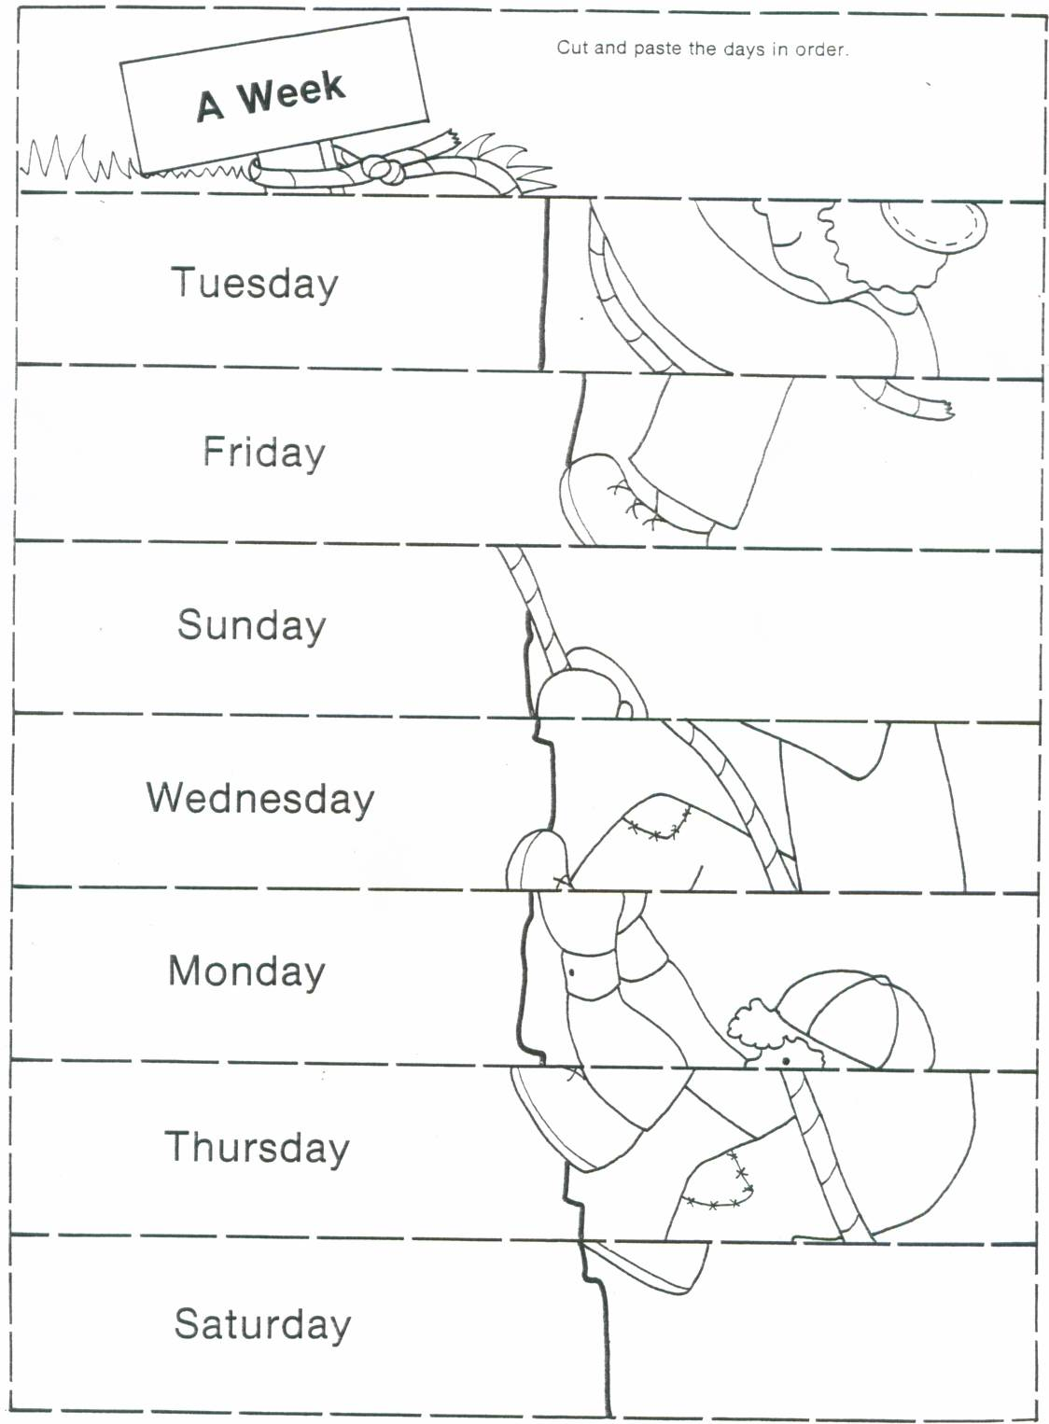

(Appendix A-2)
Lesson #1 “Days of the Week”

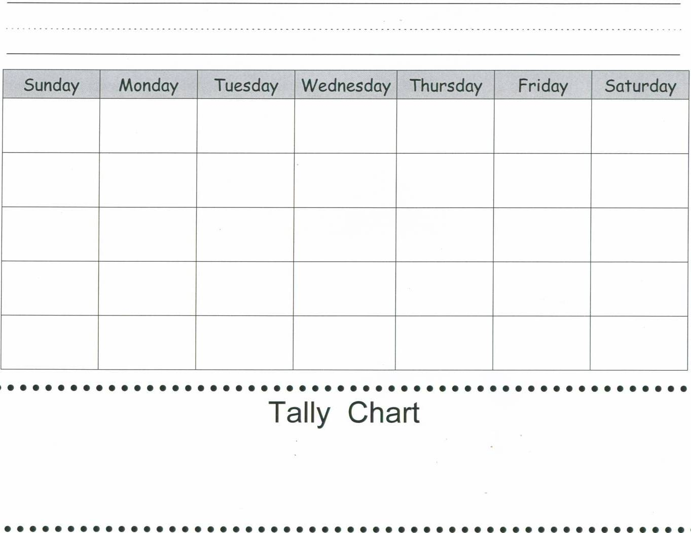

(Appendix B-1)
Lesson # 4 “What Time is It?”

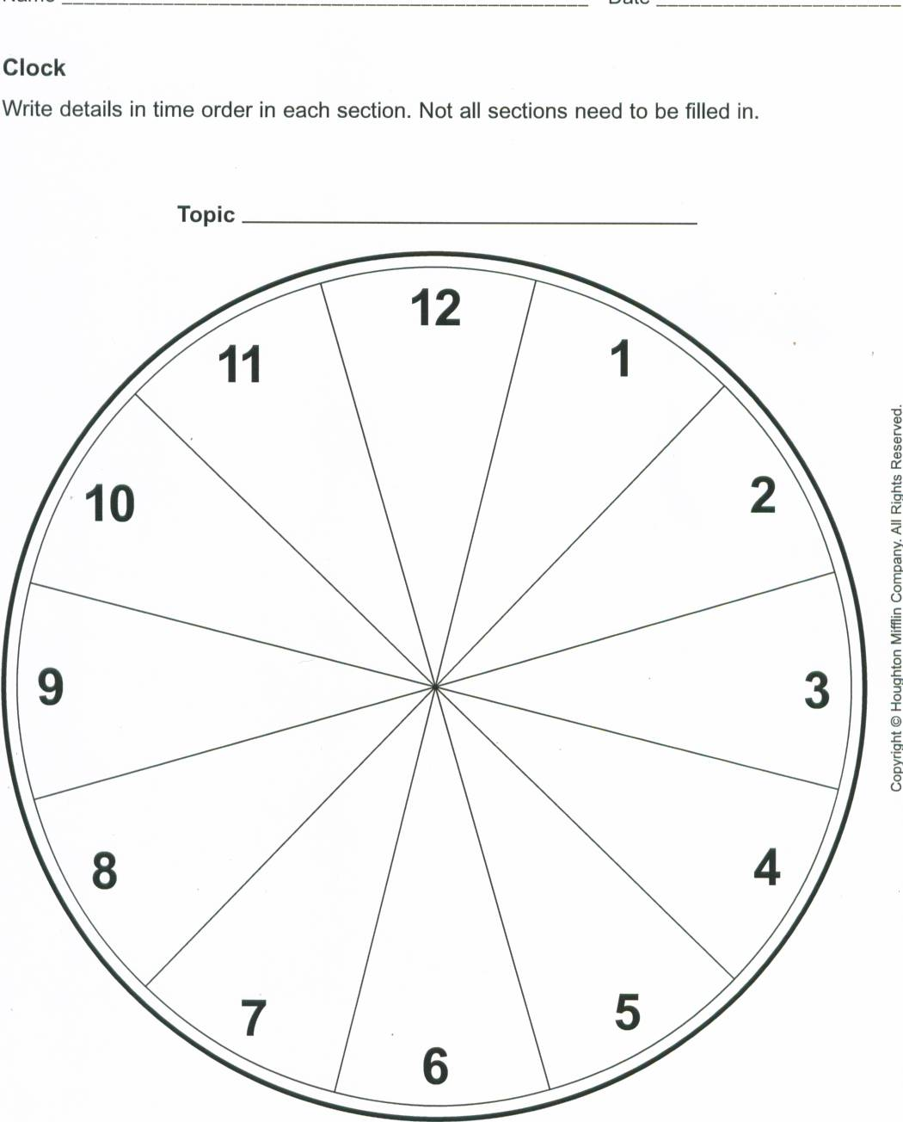

(Appendix B-2)
Lesson # 4 “What Time is It?”

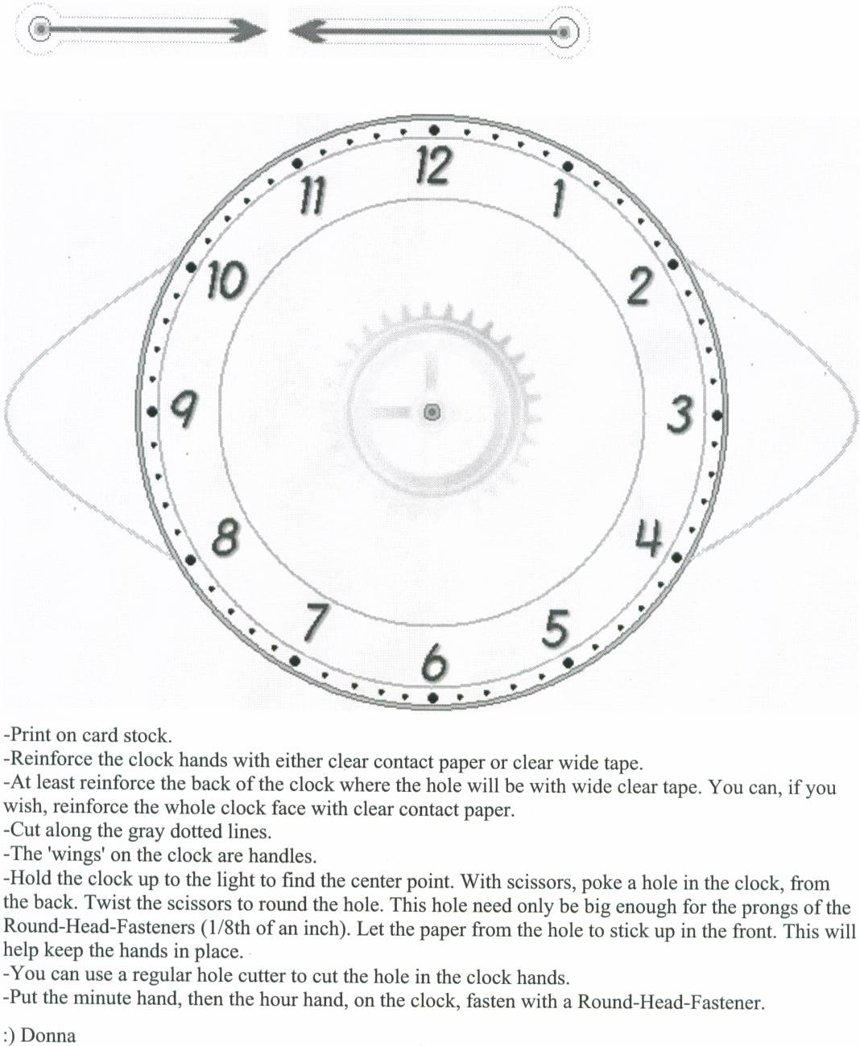

(Appendix C-1)
Lesson # 5 “Temperature Rising and Falling”

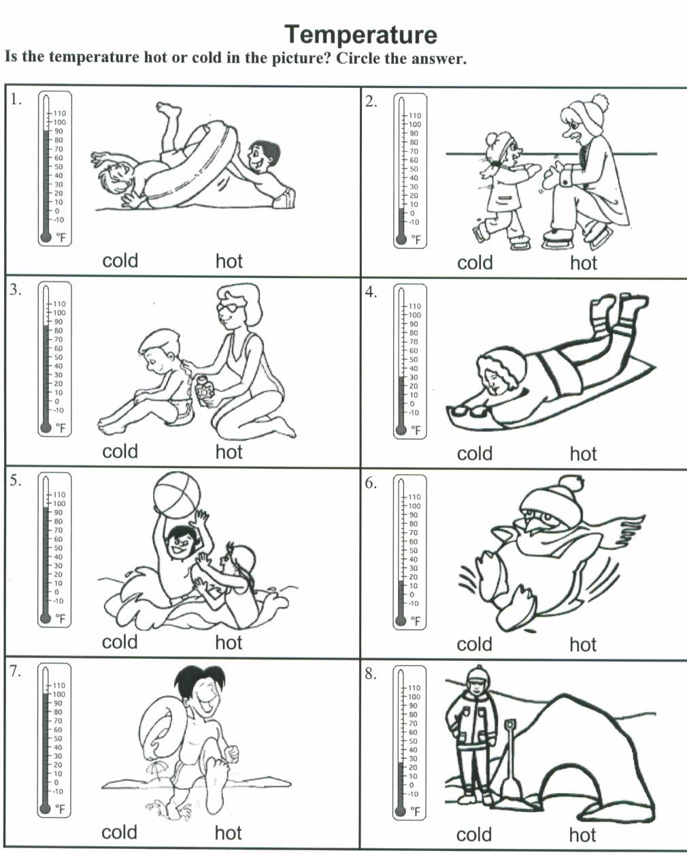
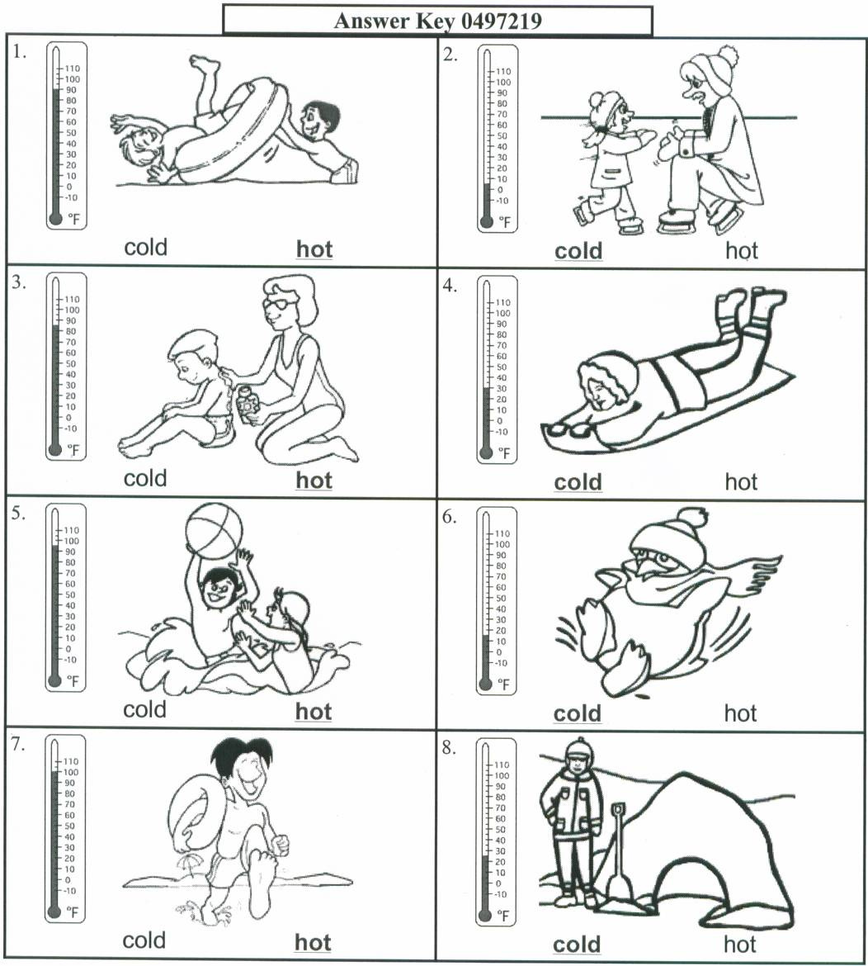

(Appendix C-2)
Lesson # 5 “Temperature Rising and Falling”

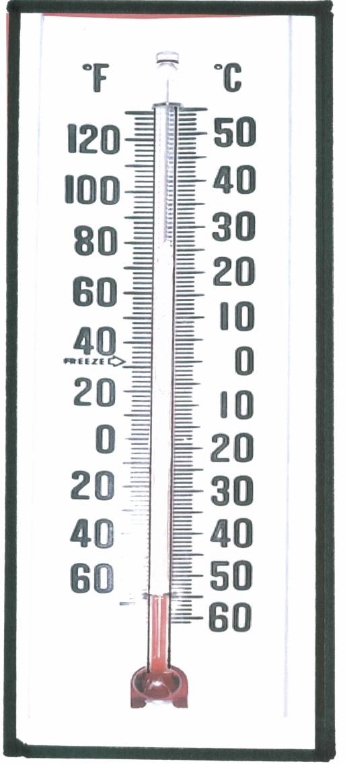

(Appendix C-3)
Lesson # 5 “Temperature Rising and Falling”

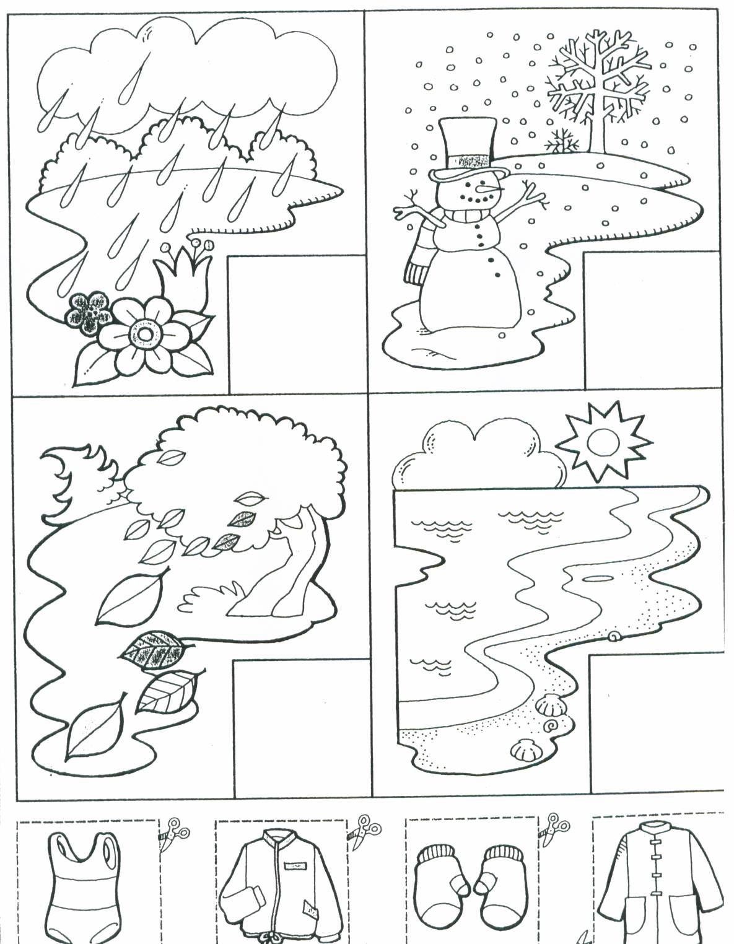

(Appendix D-1)
Lesson # 6 “Measure Once, Measure Twice”

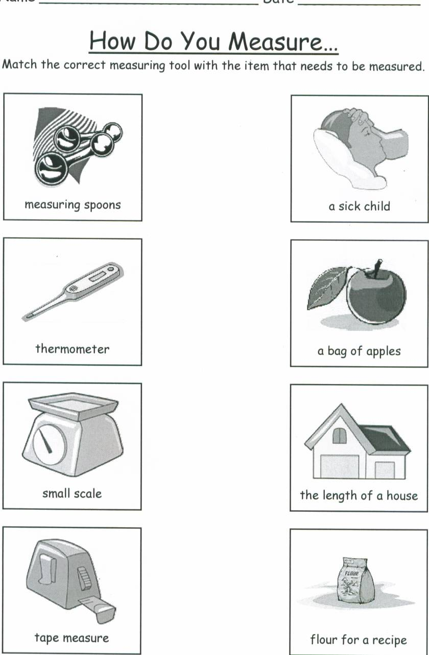

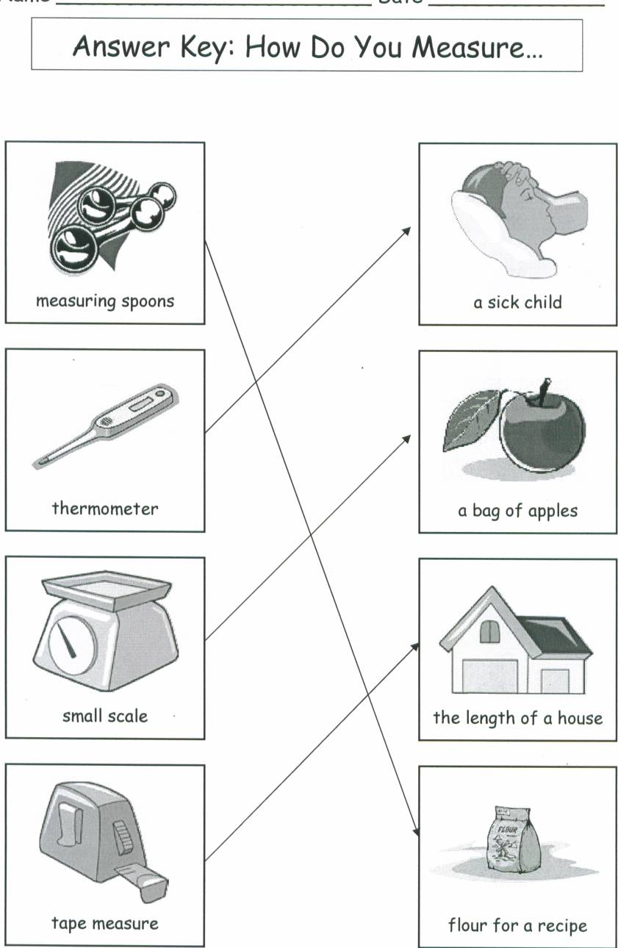

(Appendix D-2)
Lesson # 6 “Measure Once, Measure Twice”

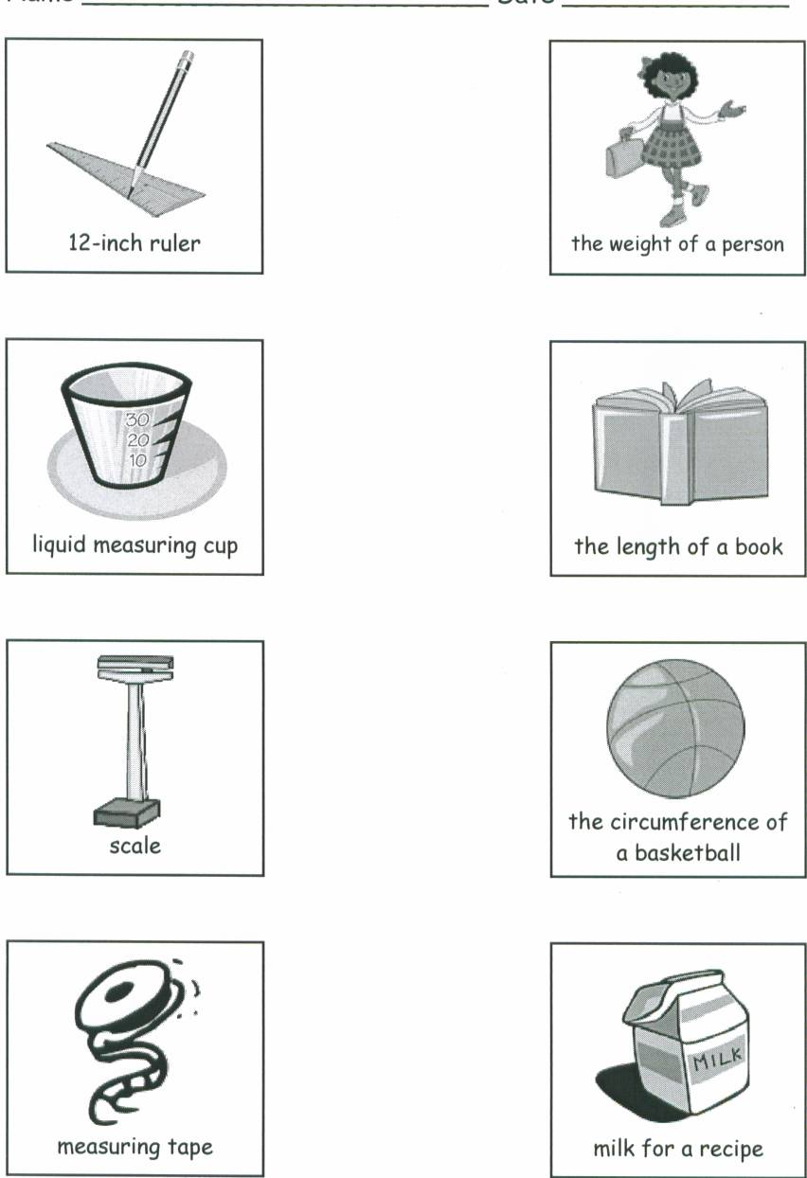

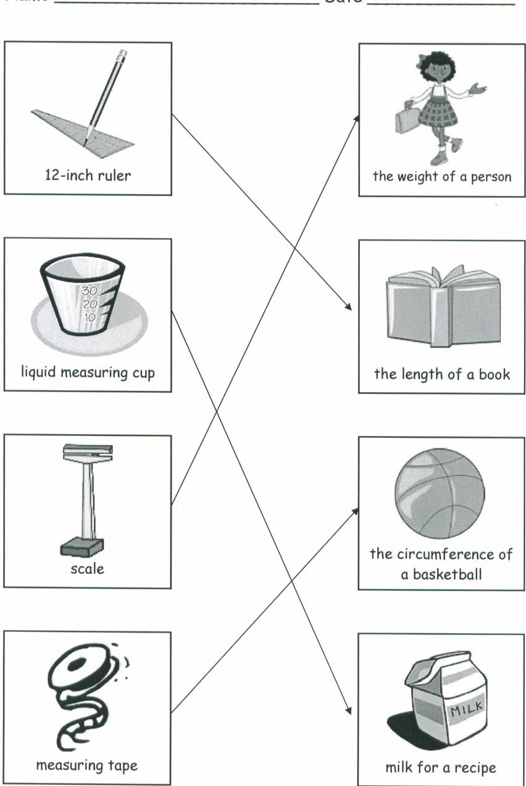

(Appendix E-1)
Lesson # 7 “High Low, High Low”

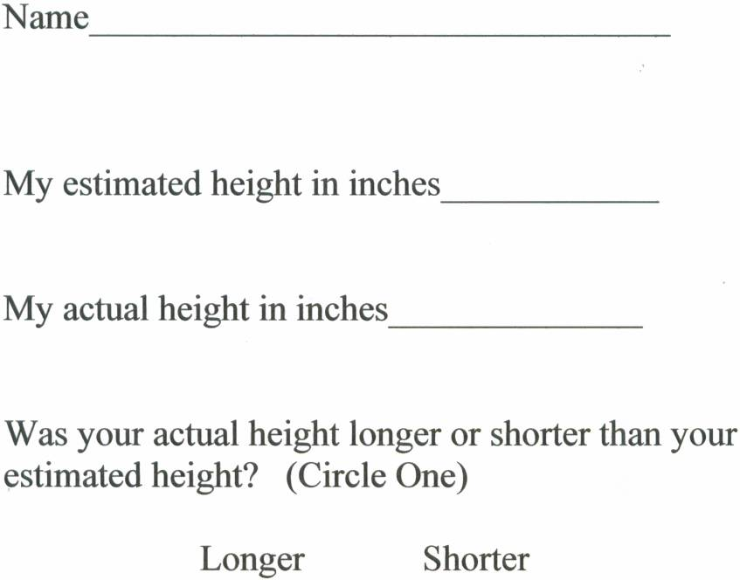

(Appendix E-2)
Lesson # 7 “High Low, High Low”

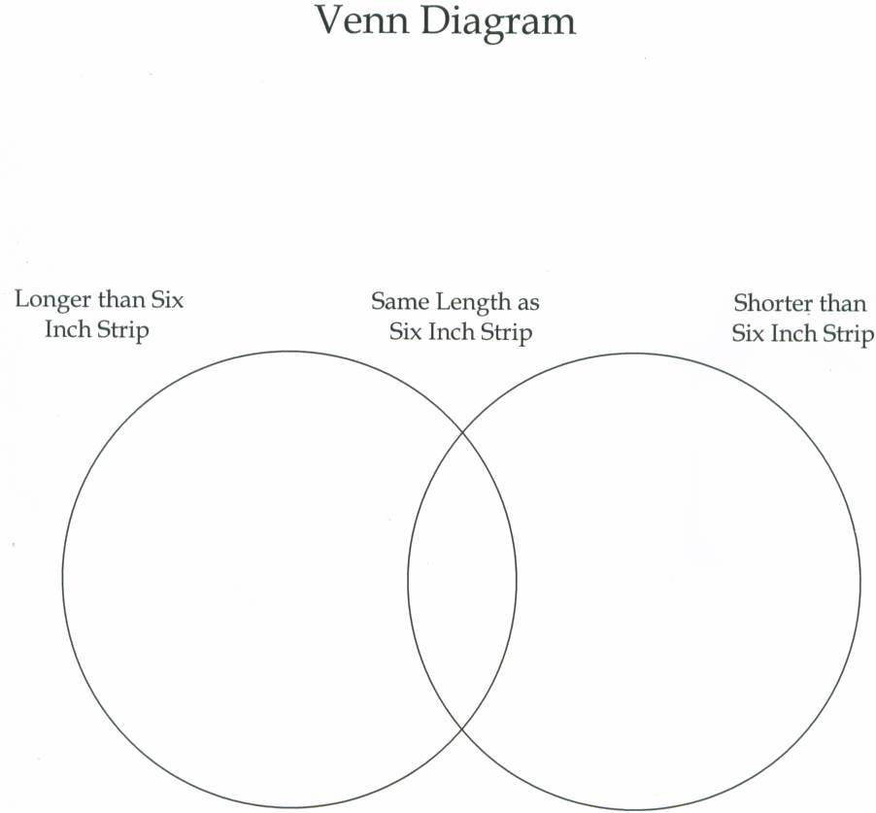

(Appendix F-1)
Lesson # 10 “Heavy as an Elephant, Light as a Feather”

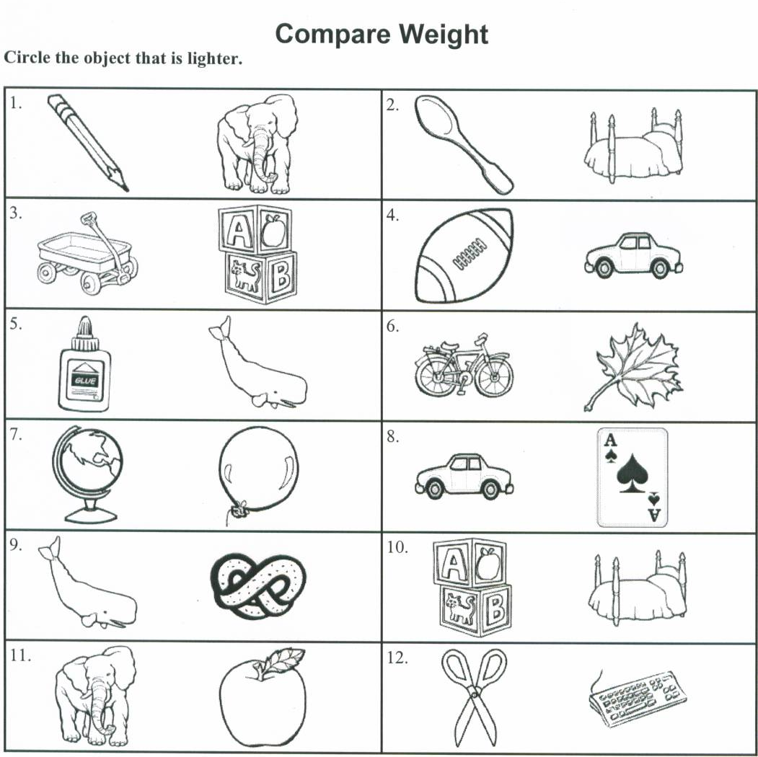

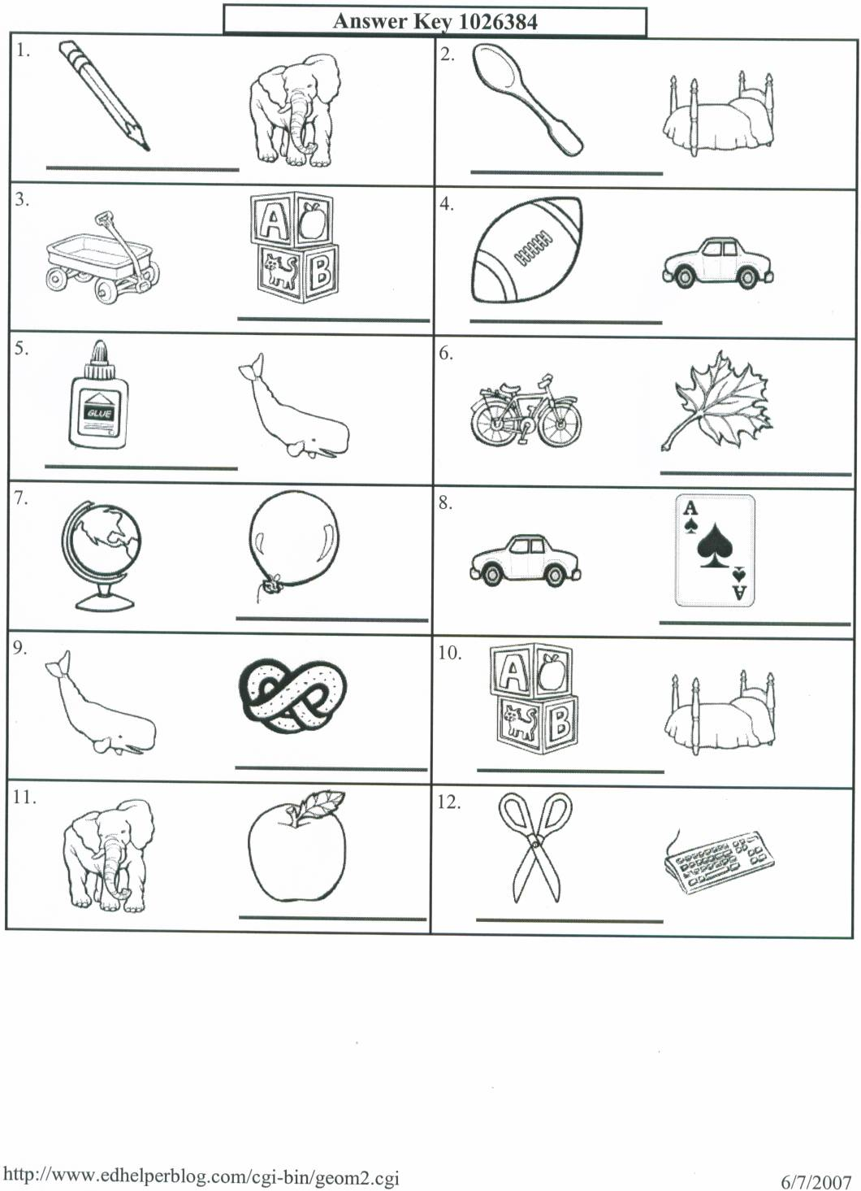

(Appendix F-2)
Lesson # 10 “Heavy as an Elephant, Light as a Feather”

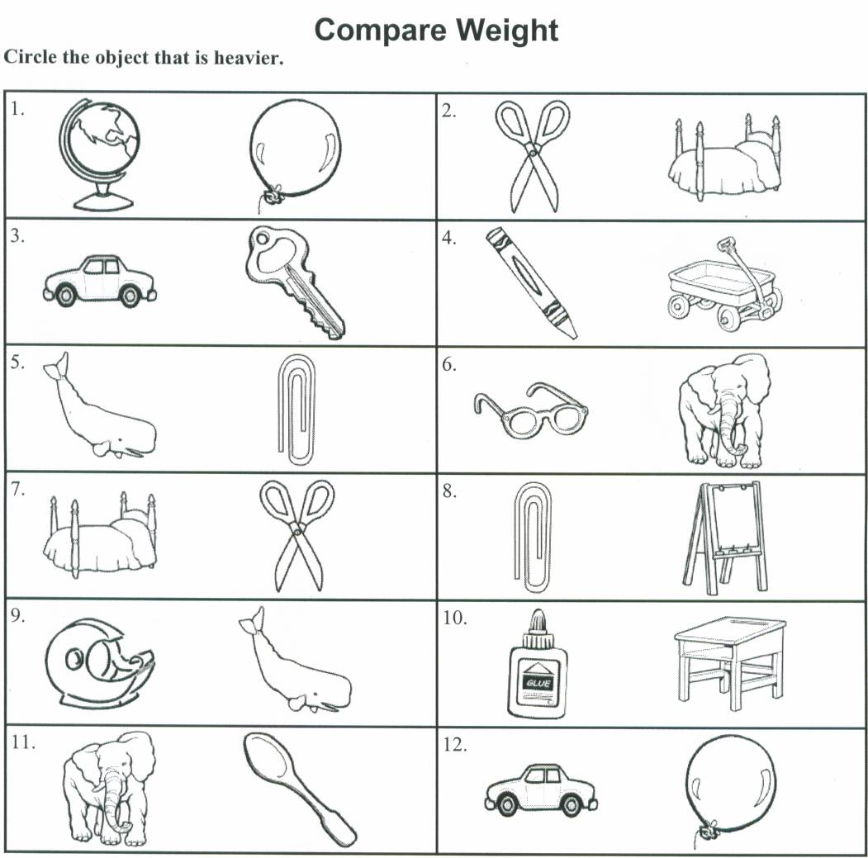

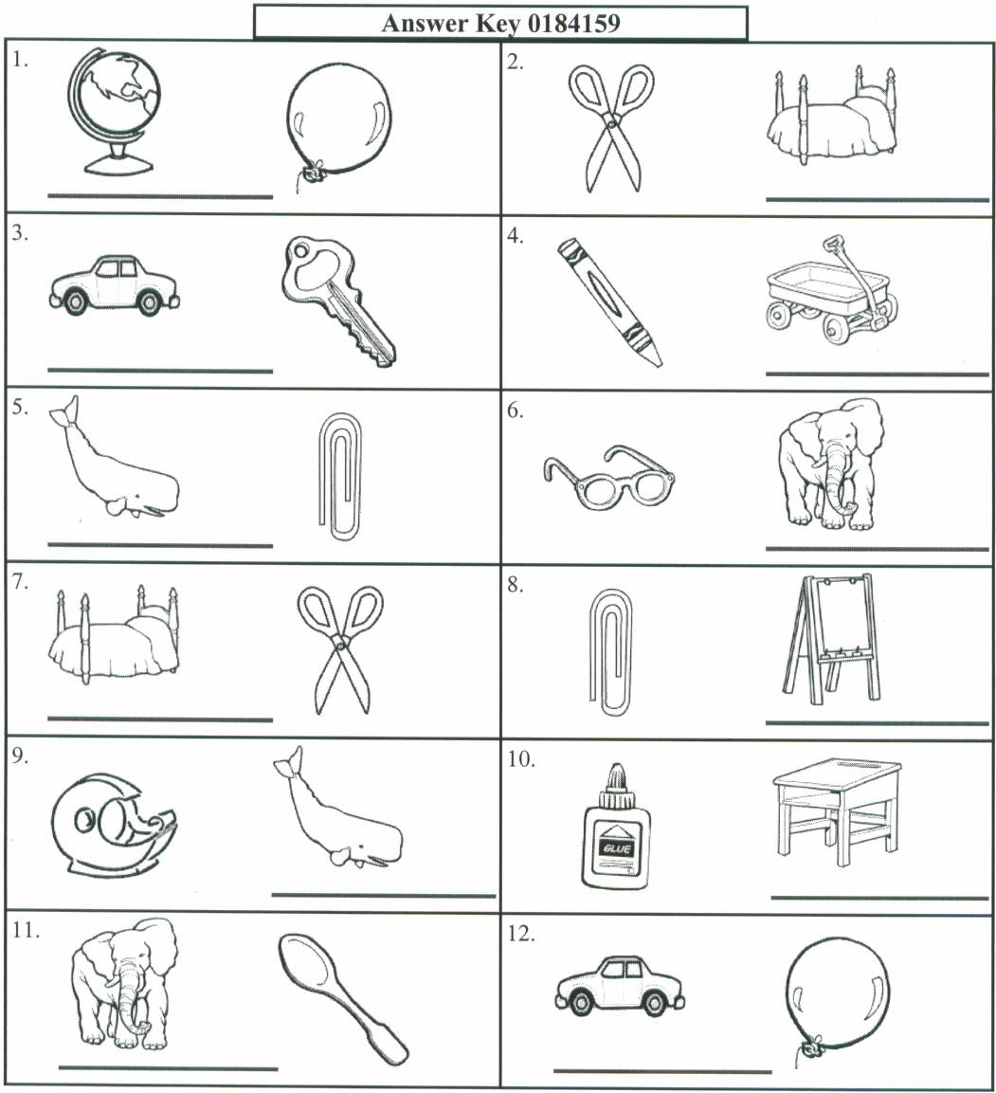

(Appendix F-3)
Lesson # 10 “Heavy as an Elephant, Light as a Feather”

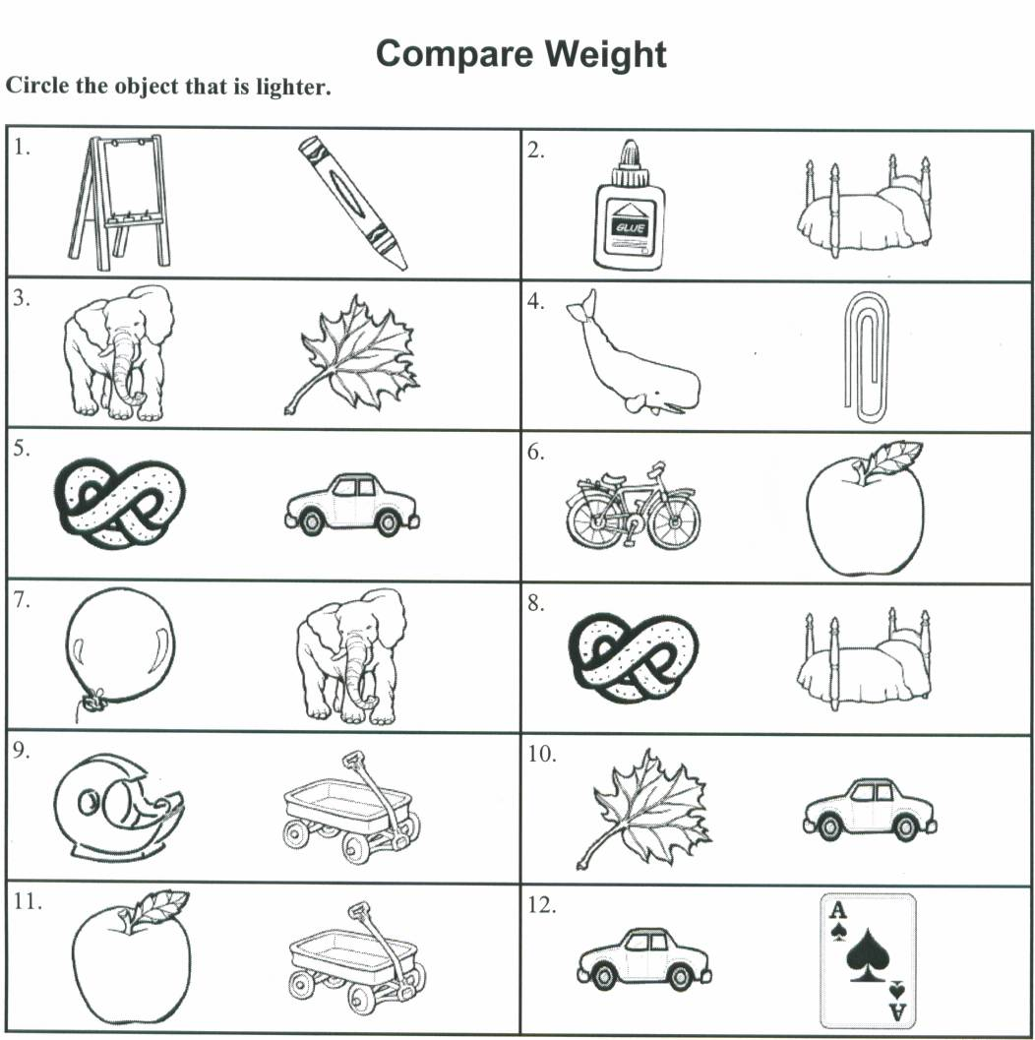

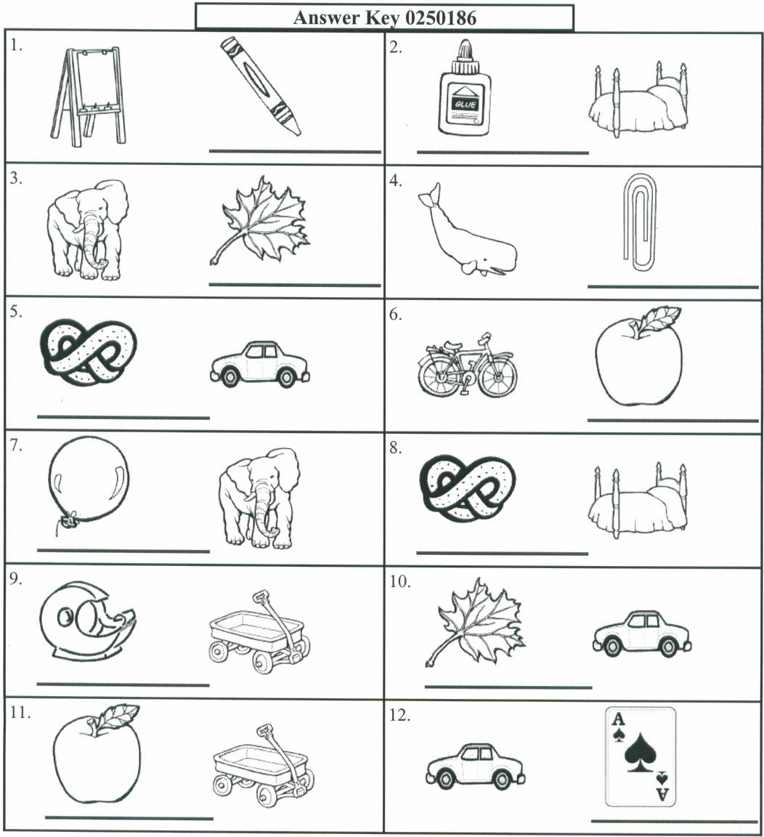

(Appendix G-1)
Lesson # 11 “Capacity Comparison”

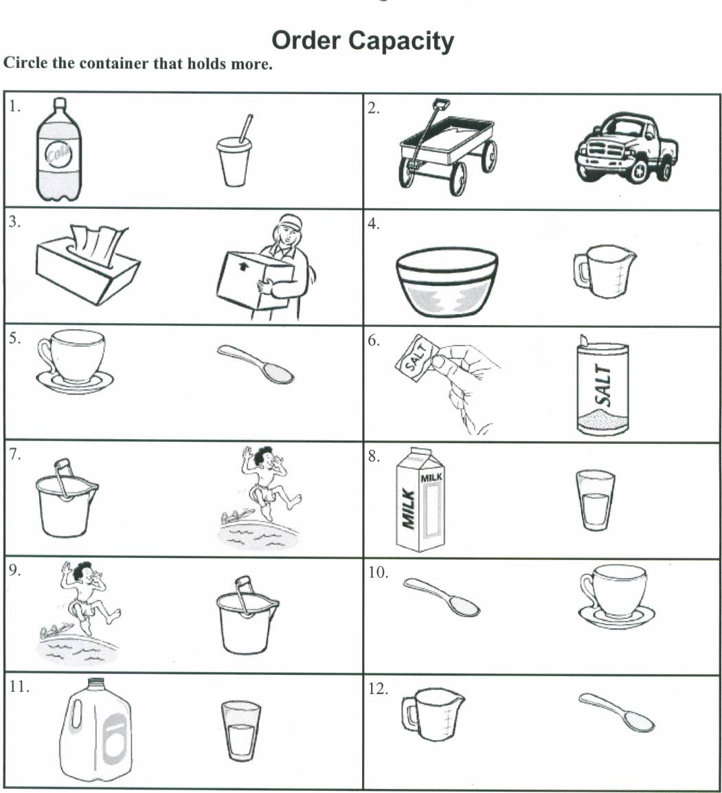
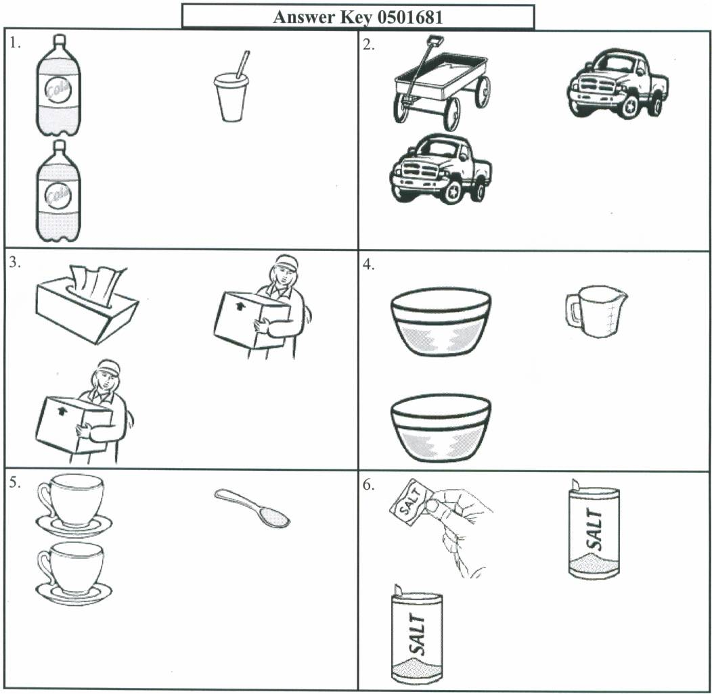

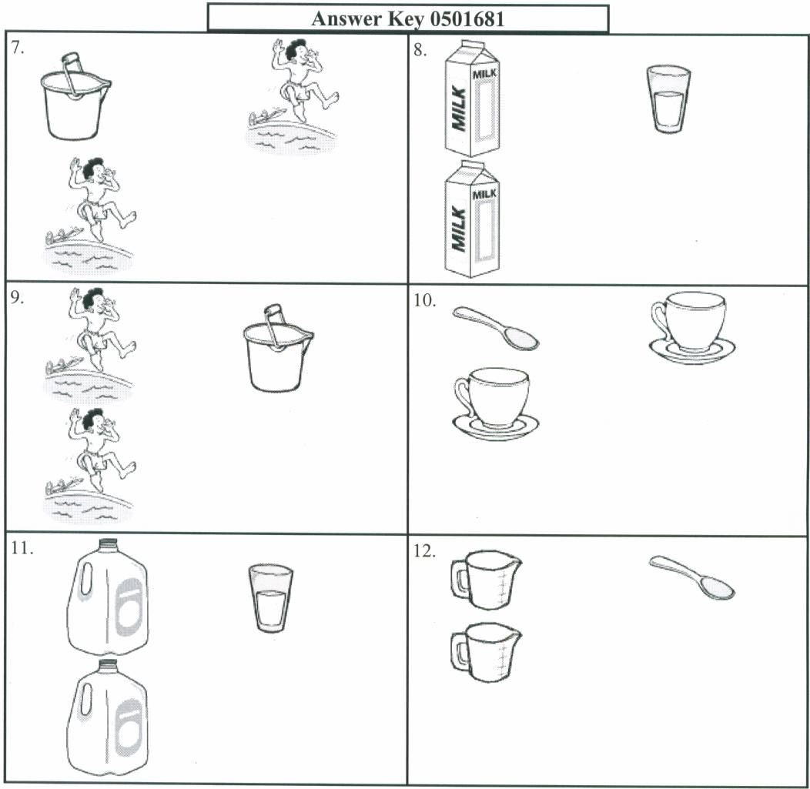

(Appendix G-2)
Lesson # 11 “Capacity Comparison”

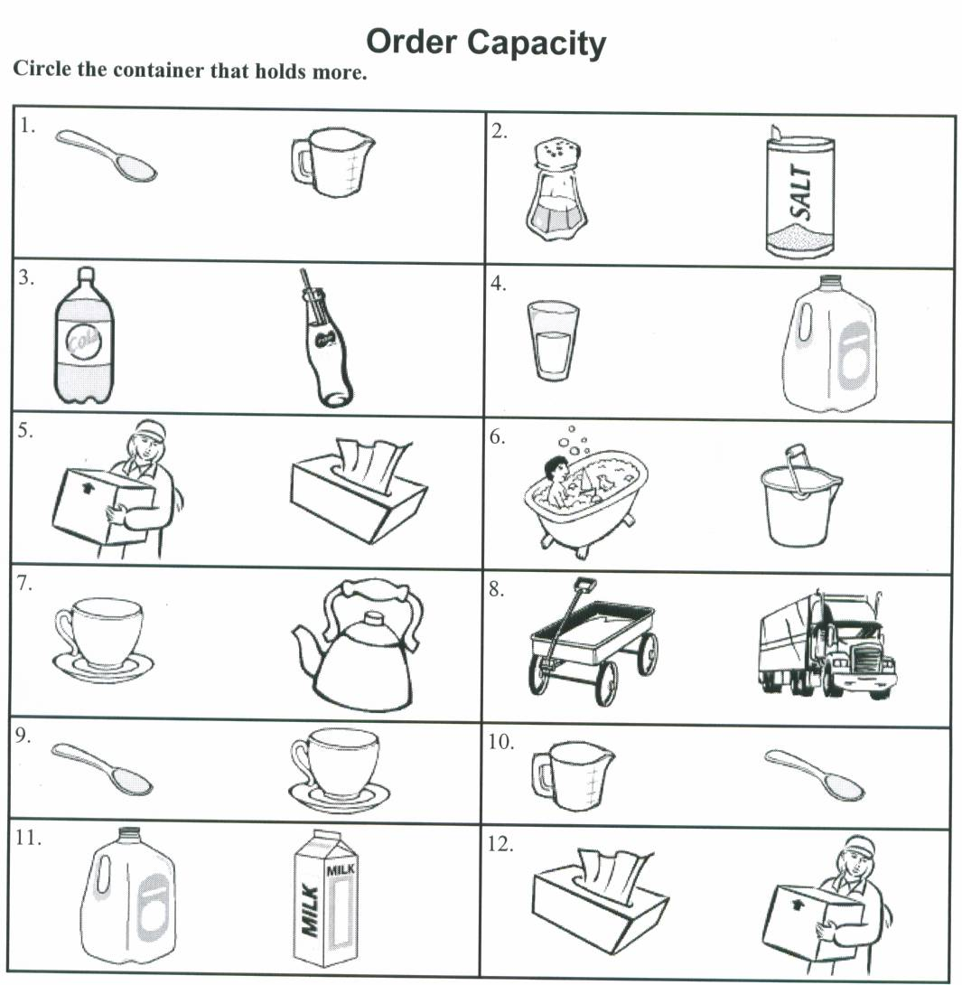

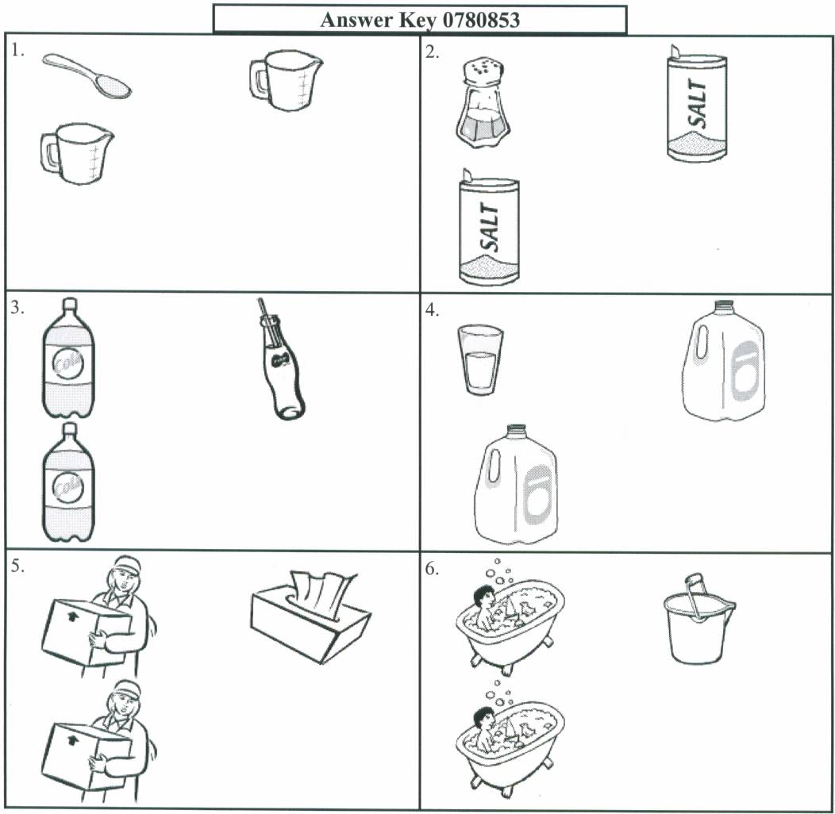

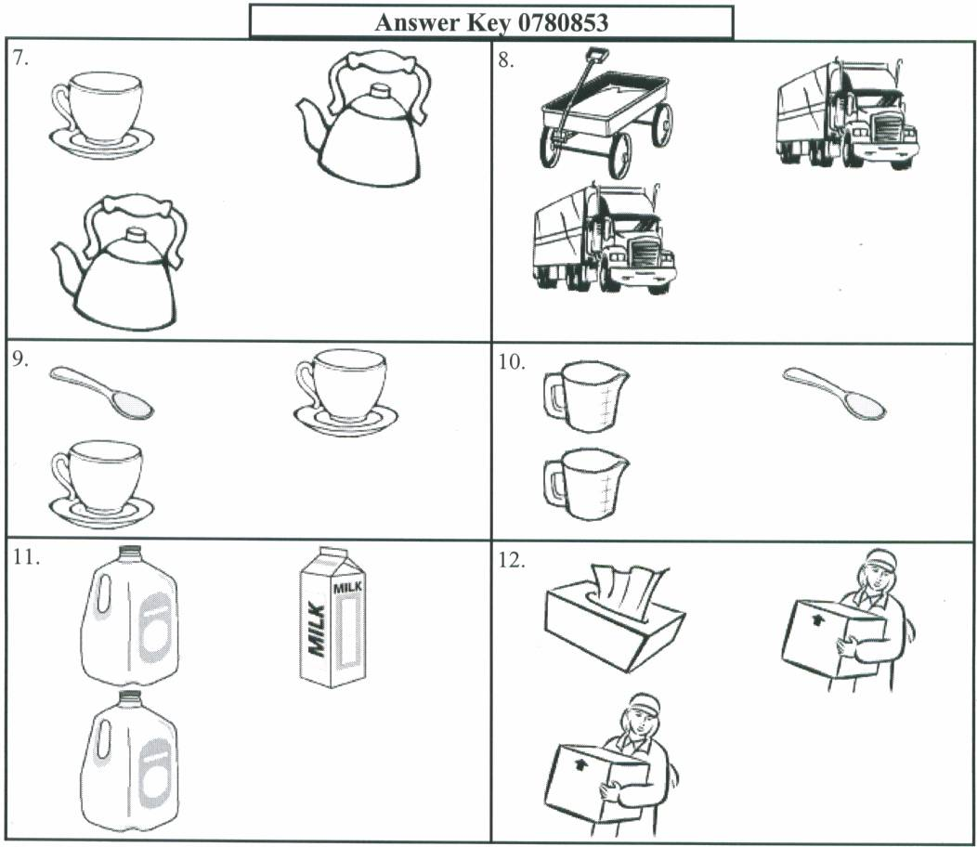

(Appendix G-3)
Lesson # 11 “Capacity Comparison”



