Plate Tectonics
Grade Level or Special Area: Science/6th grade
Written by: Wendy Haggerton, Mills Elementary; Heather Chavez, Coronado Elementary; Glenda Bearden, Southern Heights Elementary
Length of Unit: Eight lessons

ABSTRACT
  - This unit focuses on the Plate Tectonics section from the 6th grade Core Knowledge Sequence. It explores earth’s structure and the effect on its surface while providing hands-on activities. Students will investigate earth’s surface in constant movement, the layers of the earth, convection currents, earthquakes and volcanoes.

OVERVIEW
  - Concept Objectives
    - Understand the structure of the earth and the processes and interactions of Earth’s systems (NM strand II, standard III Earth and Space Science)
  - Content from the Core Knowledge Sequence page 152
    - The surface of the earth
- in constant movement
- continents were once joined (Pangaea)
    - Layered structure of the earth
- crust
- mantle
- outer core
- inner core
    - Crust movements
- surface in constant motion
- convection currents
- earthquakes
    - Formation of volcanoes
    - Evidence for long-term movement of plates
  - Skill Objectives
    - Identify and label the earth’s plates
    - Draw and label plate movement
    - Explain Wegener’s theory that the continents were once joined
    - Piece together the continents to make Pangaea
    - Identify the layers of the earth and describe their properties
    - Predict how the mantle moves
    - Draw a diagram showing convection currents
    - Compare and contrast prediction to outcome
    - Illustrate and label the types of fault movement
    - Explain the types of stress that cause earthquakes
    - Draw and label the parts of an earthquake
    - Explain the three types of Seismic waves
    - Research types of volcanoes
    - Compare and Contrast types of volcanoes

BACKGROUND KNOWLEDGE
  - For Teachers
    - Donald M. Silver & Patricia J. Wynne, The Amazing Earth Model Book
    - Dinah Zike, The Earth Science Book
    - Anne Zeman & Kate Kelly, Everything You Need to Know About Science Homework
  - For Students
    - First Grade: What’s Inside the Earth, Volcanoes
    - Fourth grade: Earth’s Layers

RESOURCES
  - Donald M. Silver & Patricia J. Wynne, The Amazing Earth Model Book
  - Dinah Zike, The Earth Science Book
  - Hirsh, E.D. What Your 6th Grader Needs to Know
  - http://volcano.und.nodak.edu/vwdocs/vwlessons/lessons/Plates/Plates1.html
  - http://www.oceanoasis.org/teachersguide/activity3.html
  - http://www.cotf.edu/ete/modules/msese/earthsysflr/plates1.html
  - http://www.enchantedlearning.com/subjects/dinosaurs/glossary/Pangaea.shtml
  - http://volcano.und.nodak.edu/vwdocs/vwlessons/lessons/Earths_layers/Earths_layers1.html
  - http://www.scarborough.k12.me.us/wis/teachers/dtewhey/webquest/nature/earthquakes.htm
  - http://interactive2.usgs.gov/learningweb/teachers/volcanoes.htm

- LESSONS
Lesson One: The Earth’s Cracked Crust
  - Daily Objectives
    - Concept Objective(s)
a. Understand the structure of the earth and the processes and interactions of Earth’s systems (NM strand II, standard III Earth and Space Science)
    - Lesson Content
- The surface of the earth is in constant movement
    - Skill Objective(s)
a. Identify and label the Earth’s plates.
  - Materials
    - Hard-boiled egg (1 per group of 4)
    - Black felt tip marker (1 per group of 4)
    - Appendix A: Earth’s Plates (blank copy 1 per student)
    - Appendix B: Earth’s Plates (Teacher Copy)
  - Key Vocabulary
    - plate – a large section of Earth’s crust and upper mantle that moves around on the plastic-like layer within the mantle
    - crust – surface layer of mainly basalt or granite, 5-25 miles thick; temperature 930 F
    - mantle – thickest layer inside earth located beneath the crust with a semi-molten consistency; it can flow like maple syrup or be stretchy like putty; temperature 4,000 F
  - Procedures/Activities
    - Have students close their eyes and imagine standing on pieces of plywood that are lying in a muddy field. Ask the students to predict what would happen if they tried to walk across the pieces of wood. Possible answers: They would slip and bump into the pieces next to them; as they move to the next piece the other piece will be pushed away; etc.
    - Ask students: What is the Earth’s crust?(The outer most layer of rock that surrounds earth). Is the crust a single solid piece? (No, It is made up of moving plates).
    - Review with students prior knowledge of the crust and mantle.
    - Divide students into groups and distribute the eggs.
    - Discuss with the students how the earth’s crust is like an egg shell, very thin and brittle.
    - Have students crack the shell by lightly tapping on the desk, being very careful not to peel the shell off.
    - Ask the students to look at the egg and relate it to the earth’s plates. Students should notice that some of the pieces are overlapping others, and in other places there are spaces where pieces have pulled apart.
    - Have students use the marker to carefully outline the edges of the cracked pieces.
    - Have the students carefully move one of the broken pieces along the egg. Have the students discuss with each other what is happening to the other pieces as one moves slowly across the mantle (white of the egg).
    - Ask students: How do you think giant moving plates change Earth’s surface? (They can create mountains, volcanoes, earthquakes).
    - Explain to the students that this is just like the earth’s crust. Each of these broken pieces are sections of the crust referred to as plates (vocabulary).
    - Pass out Appendix A: Earth’s plates (student copy)
    - Using Appendix B: Earth’s plates (teacher copy) discuss with students the major plates and their names. (teacher copy can be made into a transparency)
  - Assessment/Evaluation
    - Have students label Appendix A: Earth’s Plates (student copy) to be turned in for a grade.

Lesson Two: Plates on the Move
  - Daily Objectives
    - Concept Objective(s)
      - Understand the structure of the earth and the processes and
interactions of Earth’s systems (NM strand II, standard III Earth
and Space Science)
    - Lesson Content
        - The surface of the Earth is in constant movement.
    - Skill Objective(s)
      - Draw and label plate movement
  - Materials
    - Appendix C: How Plates Move (teacher copy)
    - Appendix D: Plate Movement Activity (teacher copy)
    - Internet access
    - Square cardboard 4 x 4 inches (1 per group of 4)
    - Scissors
    - Chocolate pudding cup (1 per group of 4)
    - Tape
    - Cookie wafers (6 per group)
    - Frosting (small decorating tub, 1 per group)
    - Piece of paper (1 per group)
    - Pencil
  - Key Vocabulary
    - divergent plate boundary – a plate boundary at which the plates are moving away from each other
    - convergent plate boundary – a plate boundary at which the plates are moving towards each other
    - transform/lateral plate boundary – a plate boundary at which the plates are sliding past each other
  - Procedures/Activities
    - Teachers review Plate Tectonics Theory: http://volcano.und.nodak.edu/vwdocs/vwlessons/lessons/Plates/Plates1.html (This website gives information about how plates move)
    - Introduce the three ways plates can move. (Refer to Appendix C: How Plates Move)
    - Discuss how each movement type is similar and different.
    - Pass out materials for activity for each group. (Appendix D: Plate Movement Activity)
    - Position two of the cookie wafers end to end so they are lying horizontally.
    - Push them together so that one overlaps the other.
    - Ask question: What does this represent?
    - Cut a hole in the center of the cardboard about 1" x 1/2". Poke a small hole in the top of the pudding cup. Tape the cardboard to the top of the pudding cup, centering the slit in the board over the hole in the cup. The pudding represents magma.
    - Center cookie wafers plates, lengthwise, over the hole in the cardboard.
    - Keep the set-up on the table. One student steadies the cardboard with the cookies, while another student gently squeezes the pudding cup. Observe the results.
    - Mark directional points (north, south, east, west) on a piece of paper. On the paper, line up two cookie wafers side by side, lengthwise in a northwesterly direction. The cookies represent the Pacific Plate and the North American Plate. Spread a line of frosting horizontally across the cookies to represent a road.
    - One student gently pushes the cookie on the west side (Pacific Plate) in a northwesterly direction while a second student presses the other cookie (North American Plate) in a westerly direction. Do the plates stick? Is there sideways motion? What happens to the road? Do the edges crumble?
    - Discuss your results. (This activity from: http://www.oceanoasis.org/teachersguide/activity3.html )
    - Extension Activity: This activity gives students a visual example that they create to demonstrate the moving plates. “Plates on the Move” pages 110-117 from The Amazing Earth Model Book
  - Assessment/Evaluation
    - Students will draw the ways that plates can move and label the movement. (Teachers can use http://www.cotf.edu/ete/modules/msese/earthsysflr/plates1.html
to give students a visual reference for drawing)

Lesson Three: Puzzling Pangaea
  - Daily Objectives
    - Concept Objective(s)
      - Understand the structure of the earth and the processes and
interactions of Earth’s systems (NM strand II, standard III Earth
and Space Science)
    - Lesson Content
- The continents were once joined (Pangaea)
- Evidence for long-term movement of plates
    - Skill Objective(s)
      - Explain Wegener’s theory that the continents were once joined
      - Piece together the continents to make Pangaea
  - Materials
    - Appendix E: Continental Drift/Pangaea (teacher)
    - Appendix F: Puzzling Pangaea (1 per student)
    - Appendix F: Puzzling Pangaea continued (answer key)
    - Internet access
    - Crayons
    - Scissors
    - Glue
    - 11x14 blue construction paper (1 per student)
  - Key Vocabulary

Continental Drift Theory – a theory proposed by Wegener to explain the movement of the continents over millions of years from Pangaea to their present-day positions

Pangaea – the super continent made up of all the continents joined

together about 250 million years ago, before they broke apart and

slowly moved to their present positions
  - Procedures/Activities
    - Teacher can use Appendix E: Continental Drift/Pangaea or other resources to discuss Alfred Wegener’s theory of Continental Drift and Pangaea.
    - Using a map of teacher’s choice and website: http://www.enchantedlearning.com/subjects/dinosaurs/glossary/Pangaea.shtml Teachers can show the present day continents and the theory of them being joined.
    - Pass out Appendix F: Puzzling Pangaea
    - Have the students color pieces and then cut out.
    - On a sheet of 11x14 blue construction paper, have the students paste the pieces together to make the super-continent of Pangaea. (Appendix F: continued – answer key)
    - Extension Activity: Students can model how moving plates spread continents apart. “Moving Continents” pages 120-121 from The Amazing Earth Model Book
  - Assessment/Evaluation
    - Teacher will collect the Puzzling Pangaea activity and check to see if the continents are in the correct place.
    - Write a paragraph explaining the Theory of Continental Drift.

Lesson Four: Layers of the Earth
  - Daily Objectives
    - Concept Objective(s)
      - Understand the structure of the earth and the processes and
interactions of Earth’s systems (NM strand II, standard III Earth
and Space Science)
    - Lesson Content
- Layered structure of the earth
    - Skill Objective(s)
      - Identify the layers of the earth and describe their properties.
  - Materials
    - Apple
    - Knife
    - Appendix G: Layers of the Earth (teacher copy)
    - Appendix H: Layers of the Earth Activity (answer key) (use as transparency)
    - Appendix I: Layers of the Earth Activity (1 per student)
    - Internet access
    - Crayons
    - Scissors
    - Glue
    - Appendix J: Layers of the Earth Quiz (1 per student)
    - Appendix J: Layers of the Earth Quiz continued (answer key)
  - Key Vocabulary
Review crust and mantle from previous lesson
    - outer core – surrounds the inner core; made of liquid iron and nickel; about 1400 miles (2270 km) thick; temperature 9,000 F
    - inner core – made of solid iron and nickel, 800 miles(1216 km) thick, about 7,000 degrees C; inner most layer of the Earth; 12,600 F
  - Procedures/Activities
    - Teacher Demonstration: Ask the students what they know about the layers of the earth. Hold up the apple and explain how it is like a model of the earth. Cut the apple in half. Discuss each part of the apple and what layer it represents. Skin ~ crust; Meat/Flesh ~ mantle; Seed casing ~ outer core; Seed ~ inner core.
    - Teacher can use Appendix G: Layers of the Earth or other resources to discuss the different layers of the earth and their properties.
    - Review this website prior to teaching or with students: http://volcano.und.nodak.edu/vwdocs/vwlessons/lessons/Earths_layers/Earths_layers1.html (This website reviews the earth’s layers)
    - Present details about each layer using Appendix H: Layers of the Earth Activity: answer key.
    - Students will use Appendix I: Layers of the Earth Activity to transfer information from Appendix H: Layers of the Earth Activity (answer key)
    - Students will need to color and cut the circles from Appendix I: Layers of the Earth Activity. Do not cut the dotted lines. Cut only the solid lines. The mantle circle is glued inside the crust circle following the dotted lines provided inside the crust circle. The outer core circle is glued inside the mantle circle following the dotted lines provided inside the mantle circle. The inner core circle is glued inside the outer core circle following the dotted lines inside the outer core circle. The map circle should be colored (according to teacher’s preference) and glued onto the other side of the layers of the earth circle.
  - Assessment/Evaluation
    - Quiz on layers of the earth and its properties (Appendix J: Layers of the Earth Quiz)

Lesson Five: Convection Currents
  - Daily Objectives
    - Concept Objective(s)
      - Understand the structure of the earth and the processes and
interactions of Earth’s systems (NM strand II, standard III Earth
and Space Science)
    - Lesson Content
- Crust Movements- Convection Currents
    - Skill Objective(s)
      - Predict how the mantle moves
      - Draw a diagram showing convection currents
      - Compare and contrast prediction to outcome
  - Materials
    - Appendix K: Convection Currents
    - Clear plastic tray/pan
    - 4 Styrofoam cups
    - Red food coloring
    - Parsley flakes
    - Eyedropper
    - Hot water (from tap or heated from a hot plate)
    - White construction paper (for drawing predictions and outcome, 1 per student)
    - Crayons
    - Paper
    - Pencil
  - Key Vocabulary
    - convection currents – circular currents or movement within a liquid (or gas) due to different densities of the hotter and cooler parts; when heated the liquid/gas spreads out, when cooled the liquid/gas sinks. Once heated again, the liquid/gas rises
  - Procedures/Activities
    - Ask question: How does a hot air balloon rise and fall? Discuss possible reasons.
    - Draw a diagram of how air rises when it is heated, then expands, spreads out, sinks, and rises again. (Appendix K: Convection Currents)
    - Teacher can use Appendix K: Convection Currents or other resources to discuss convection currents.
    - Discuss predictions of how students think molten rock in the mantle moves.

The following activity can be done as a whole class or in groups;
Adapted from Lawrence Hall of Science, A Current Event, GEM Series, University of California, 1988

    - Fill tray with cool water. Place tray on top of 3 evenly spaced, upside- down Styrofoam cups. (This should support your display)
    - Sprinkle parsley flakes on the water.
    - Fill the 4th cup with hot water and slide under the center of the tray.
    - Using the eyedropper, gently place several drops of food color inside the tray, on the bottom directly over the heat source (cup of hot water).
    - Observe 5 minutes
    - Ask Questions: What does the hot water represent? (heat rising from the center of the earth) What does the tray of cool water represent? (mantle) What does the parsley represent? (plates moving) Is warmer water heavier or lighter than cooler water? (lighter) More or less dense? (less dense) Are the water molecules moving faster or slower in warmer water? (faster)
  - Assessment/Evaluation
    - Draw and label a diagram of how convection currents move using activity.
    - Write a paragraph comparing prediction to actual outcome. Assess paragraph according to teacher’s preference (grammar, punctuation, accuracy of information).

Lesson Six: Earthquakes
  - Daily Objectives
    - Concept Objective(s)
      - Understand the structure of the earth and the processes and
interactions of Earth’s systems (NM strand II, standard III Earth
and Space Science)
    - Lesson Content
- Crust Movements - Earthquakes
    - Skill Objective(s)
      - Illustrate and label the types of fault movement
      - Explain the types of stress that cause earthquakes
  - Materials
    - Rubber band ( 1 per student)
    - Appendix L: Earthquake Faults
    - Internet access
    - 2 foam rubber pieces
    - Wheat bread (3 slices for every two students)
    - Grape jelly
    - Chunky peanut butter
    - Chocolate syrup
    - Plastic knife (1 per group of 2 students)
    - Waxed paper
    - Napkins/paper towels
    - Appendix M: Fault Movements (make transparency or give to each student)
  - Key Vocabulary
    - earthquake – sudden, violent shifting movements in the Earth’s crust
    - fault- a feature of Earth’s crust where plates rub against each other and build up energy that is released in waves during an earthquake
    - normal fault – rock above the fault surface moves downward in relation to rock below the fault surface
    - reverse fault – the rocks above the fault surface are forced up and over the rocks below the fault surface
    - strike-slip fault – created when two plates move side ways past each other
    - tension stress – pulls rocks apart
    - compression stress – occurs when rocks are pushed on from opposite directions
    - shear stress – as the rocks move past each other, their irregular surfaces snag each other, and the rocks are twisted and strained. The snagging also hinders the movement of the plates
  - Procedures/Activities
    - Pass out rubber bands to each student.
    - Have students twist and stretch the rubber band in a variety of ways and then stretch it as far as they can until it breaks (Relate this to how a fault is under stress and can stretch and eventually snap like a rubber band).
    - Explain to the students that along the plate boundaries there are fault zones where the earth slips.
    - Teachers can use Appendix L: Earthquake Faults or any resources available to discuss the ways stress is built up along the plate boundaries and cause earthquakes.
    - Review this website prior to teaching or with the students: http://www.scarborough.k12.me.us/wis/teachers/dtewhey/webquest/nature/earthquakes.htm (This website gives an abundance of information on earthquakes).
    - Teacher Demonstration: adapted from The Earth Science. Use the foam rubber to pretend that each one is a piece of the earth’s lithospshere. Press the two pieces of foam slowly towards each other. Ask students: What happens when plates come together? (the run into each other; example of compressional stress) Place the two pieces of foam together on a table so that the sides are touching. Slowly move them apart. Ask students: How does the surface of the earth change as plates move? (plates/continents move apart and cause gaps; example of tensional stress) Place the two pieces of foam together on a table so that the sides are touching. Move the plates in opposite directions as their sides touch. Ask students: What happens when the plates move against each other? (scrape each other and could buckle in some places; example of shear stress)
    - Pass out materials for activity (work in groups of 2).
    - Have students spread the waxed paper in the work area and put the bread on the paper.
    - Spread a thin layer of chocolate on one slice of the bread.
    - Spread a layer of peanut butter on the chocolate.
    - On a second slice, spread a thin layer of chocolate.
    - Spread a layer of grape jelly over the chocolate.
    - Explain to students that each ingredient represents a layer of rock.
    - Have students put the bread together with the bottom layer being the one with the peanut butter on it. The third slice of bread needs to go between the slices with the ingredients.
    - Cut the sandwich into fourths so that each student gets two small slices.
    - Using their pieces, have the students demonstrate the three types of faults and the types of stress associated with each one
    - After demonstrating the students may eat the sandwich.
    - Extension Activity: Students build blocks and demonstrate the ways they move. “Earthquakes” pgs. 100-105, The Amazing Earth Model Book
  - Assessment/Evaluation
    - Have students draw and label each fault movement and explain the type of stress that is occurring.

Lesson Seven: Seismic Waves
  - Daily Objectives
    - Concept Objective(s)
      - Understand the structure of the earth and the processes and interactions of Earth’s systems (NM strand II, standard III Earth and Space Science)
    - Lesson Content
      - Crust Movements - Earthquakes
    - Skill Objective(s)
      - Draw and label the parts of an earthquake
      - Explain the three types of Seismic waves
  - Materials
    - Slinky
    - Large bowl of water
    - Small stone
    - Small pan of prepared Gelatin dessert(whole class or groups)
    - Mini marshmallows
    - Clear plastic wrap (to cover gelatin)
    - Appendix M: Seismic waves
    - Appendix N: Parts of an earthquake
  - Key Vocabulary
    - seismic waves – relating to or caused by an earthquake or earth tremor
    - epicenter – the point at which the waves of an earthquake hit the surface of Earth, directly over the focus
    - focus – the exact spot inside Earth where an earthquake starts
  - Procedures/Activities
    - Teacher demonstration: Ask students if they know how earthquake waves travel. Tell the students that the energy of an earthquake is released in the form of waves. Select a student to assist. Take one end of the slinky and teacher take the other and stretch the slinky out about 2-3 meters on a table top. Move the slinky in a back and forth motion. Explain that this motion simulates a P wave or primary wave (this wave moves in back and forth motions). Then have the assistant hold his/her end still as you the teacher move the slinky from side to side (like a snake moving). Explain that these type of waves are called S waves or secondary waves. (these waves vibrate perpendicular to the direction of movement). Hold the stone about two feet above the bowl of water. Drop the stone into the water. Ask the students what they observe. L waves travel on Earth’s surface away from the epicenter, similar to what the students just observed.
    - Pass out or set up materials for activity.
    - Tell the students they are going to simulate the release of earthquake energy.
    - Gently tap the side of the pan of gelatin while holding the pan firmly with the other hand. Students should be able to see the waves traveling through the gelatin.
    - Ask question: What do you think will happen if we tap the pan with more force? Tap the pan harder. Did their predictions come true?
    - Cover the gelatin with plastic wrap. Be sure the plastic touches the surface of the gelatin.
    - Have the students build a structure or structures out of the marshmallows on top of the gelatin.
    - Tell the students to tap the gelatin at different points around their structures. Have them record what is happening to the structures and the gelatin.
    - Ask question: Does it make a difference how close or how far you are away from the structure(s) when you tap?
    - Teacher can use Appendix M: Seismic Waves or other resources to discuss seismic waves, focus, epicenter, and Richter Scale.
    - Display Appendix N: Parts of an Earthquake and discuss.
    - Extension Activity: Students produce and demonstrate the types of waves. “Earthquake Energy Waves” pgs. 106 – 109. The Amazing Earth Model Book
  - Assessment/Evaluation
    - Draw and label parts of earthquake.
    - Write a paragraph explaining each type of seismic wave. Teacher will check to make sure each wave is explained correctly.

Lesson Eight: Volcanoes
  - Daily Objectives
    - Concept Objective(s)
      - Understand the structure of the earth and the processes and
interactions of Earth’s systems (NM strand II, standard III
Earth and Space Science)
    - Lesson Content
    - a. Formation of volcanoes
    - Skill Objective(s)
      - Research types of volcanoes
      - Compare and contrast types of volcanoes
  - Materials
    - Appendix O: How Volcanoes Occur (teacher copy)
    - Appendix P: Types of Volcanoes (teacher copy)
    - Internet access
    - Tube of toothpaste
    - Pin
    - Video National Geographic Volcano Nature’s Inferno
    - Appendix R: Volcano Nature’s Inferno quiz
  - Key Vocabulary
    - magma – hot, molten rock that flows in the mantle
    - vent – an opening in the surface of the earth
    - lava – magma once it reaches the surface of the earth
    - composite volcano – volcano made of layers of thick, sticky lava and ash that is formed from alternating quiet and explosive eruptions; forms tall, pointed mountains. Also called strato-volcano
    - cinder volcano – a cone-shaped volcano whose steep sides are made up of blocks of solid lava that formed by explosive eruptions
    - shield volcano – volcanoes with long, sloping rock layers formed from quiet eruptions of fluid lava
    - hot spots – areas in the mantle that are away from plate boundaries that are hotter than others
  - Procedures/Activities
    - Teacher demonstration: Ask question: How do you think magma reaches the surface of the Earth? Place a tube of toothpaste on a desk. Invite the students to imagine that the tube represents the Earth’s surface. Ask question: What would the toothpaste represent (Hot melted magma). Distribute the toothpaste evenly in the tube. Use a pen to make a tiny hole in the tube. Ask question: What does this hole represent? (volcano’s opening). Have the students predict what will happen if you press on the tube. (the magma (toothpaste) oozes out of the volcano (tube)). Discuss with students how this demonstration simulates magma under pressure.
    - Teacher can use Appendix O: How Volcanoes Occur and Appendix P: Types of Volcanoes or other resources to discuss and explain volcanoes.
    - Watch movie National Geographic Volcano Nature’s Inferno (Quiz Appendix Q)
    - Extension Activities: Students will do various activities with volcanoes and how they are formed “Volcano!” pages 15-31 The Amazing Earth Model Book and http://interactive2.usgs.gov/learningweb/teachers/volcanoes.htm (This website gives you a complete lesson on volcanoes).
  - Assessment/Evaluation
    - Give mini quiz over video Appendix Q: Volcano Nature’s Inferno Quiz
    - In groups, students will research and make a poster of one of the types of volcanoes. Posters can include but are not limited to: diagrams, characteristics of volcano, famous volcanoes, etc.
- CULMINATING ACTIVITY
  - At the end of the unit, students can use a multimedia program (Power Point) or publishing program (Microsoft publisher) to create a slideshow or newsletter that focuses on one of the topics covered in the unit. It can include, but is not limited to vocabulary, diagrams/pictures, explanations of topic, etc. Teachers can assess the project by making sure the criteria they set are met.

HANDOUTS/WORKSHEETS
          - Appendix A: Earth’s Plates
          - Appendix B: Earth’s Plates (teacher copy)
          - Appendix C: How Plates Move
          - Appendix D: Plate Movement Activity
          - Appendix E: Continental Drift/Pangaea
          - Appendix F: Puzzling Pangaea
          - Appendix G: Layers of the Earth (teacher copy)
          - Appendix H: Layers of the Earth Activity: answer key
          - Appendix I: Layers of the Earth Activity
          - Appendix J: Layers of the Earth Quiz
          - Appendix K: Convection Currents
          - Appendix L: Earthquake Faults
          - Appendix M: Seismic Waves
          - Appendix N: Parts of Earthquake
          - Appendix O: How Volcanoes Occur
          - Appendix P: Types of Volcanoes
          - Appendix Q: Volcano quiz

BIBLIOGRAPHY
  - Books:
    - Core Knowledge Foundation. Core Knowledge Sequence. Virginia: Core Knowledge Foundation, 1999. ISBN: 1-890517-20-8
    - Hirsch, E.D. What Your 6th Grader Needs to Know. New York: Delta, 1993. ISBN 0-385-31467-1
    - Silver, D.M. & Wynne, P.J. The Amazing Earth Model Book. New York: Scholastic, Inc., 1997. ISBN: 0-590-93089-3
    - Young, R.N. Ms.Ed. Geology. California: Teacher Created Materials, Inc., 1994. ISBN: 1-55734-641-0
    - Zeman, A. & Kelly, K. Everything You Need to Know About Science Homework. New York: Scholastic, Inc., 1994. ISBN: 0-590-49357-4
    - Zike, D. The Earth Science Book. New York: John Wiley & Sons, Inc., 1993. ISBN: 0-471-57166-0
  - Internet sites:
    - “How Plates Move?” June 2004. http://volcano.und.nodak.edu/vwdocs/vwlessons/lessons/Plates/Plates1.html
    - “Plate Boundaries: Cookie Crust and Pudding Magma” Ocean Oasis Teacher’s Guide. June 2004. http://www.oceanoasis.org/teachersguide/activity3.html
    - “Plate Tectonics” Earth Floor: Plate Tectonics. June 2004. http://www.cotf.edu/ete/modules/msese/earthsysflr/plates1.html
    - “Pangaea” Enchanted Learning. June 2004. http://www.enchantedlearning.com/subjects/dinosaurs/glossary/Pangaea.shtml
    - “The Earth’s Layers” June 2004. http://volcano.und.nodak.edu/vwdocs/vwlessons/lessons/Earths_layers/Earths_layers1.html
    - “Earthquakes” Forces of Nature. June 2004. http://www.scarborough.k12.me.us/wis/teachers/dtewhey/webquest/nature/earthquakes.htm
    - “Volcanoes!” USGS Learning Web. June 2004. http://interactive2.usgs.gov/learningweb/teachers/volcanoes.htm
  - Video:
    - Volcano: Nature’s Inferno. National Geographic. Washington: 1997. ISBN: 0-7922-5201-2

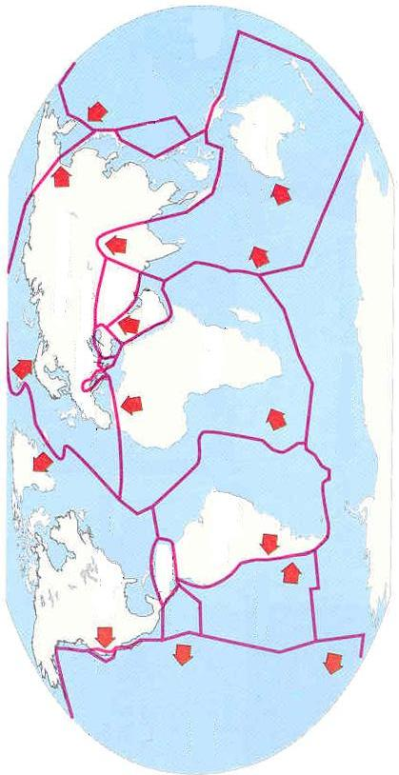
Appendix A: Earth’s Plates
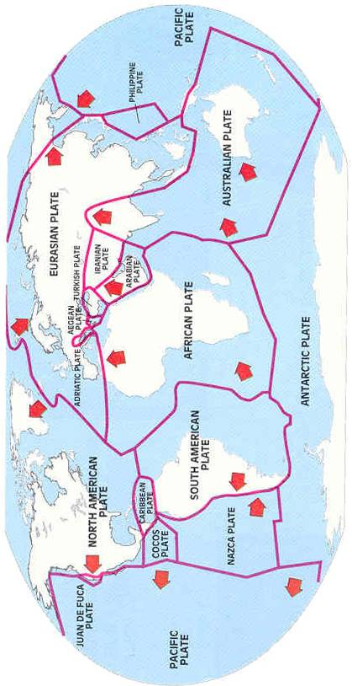
Appendix B: Earth’s Plates

Appendix C
How Plates Move

A convergent plate boundary occurs when collisions take place along the boundary. When this happens, one of the plates may descend beneath the other one, with pieces breaking off and becoming part of the molten asthenosphere. This motion causes the upper plate to be lifted and folded, forming mountain ranges. India is presently going under Asia, creating the earth’s greatest mountain range, the Himalayas.

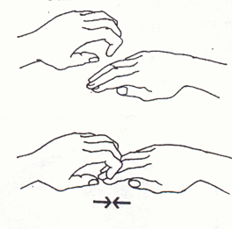

Mid-ocean ridges, where the crust is thinner than on the continents, tend to have plate boundaries that are separating or spreading apart. This is called a divergent plate boundary. The gaps are filled with partially molten rock rising from the asthenosphere. The hot material spreads and slowly cools. The Mid-Atlantic Ridge, a mountain range rising about 3,000 meters above the ocean floor, is one place where sea-floor spreading is occurring.
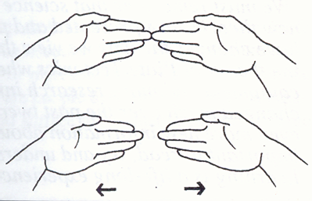

At other boundaries, plates move by sliding past each other. This is called a transform or lateral plate boundary. The Pacific Plate is moving northward in this fashion along the San Andreas Fault.
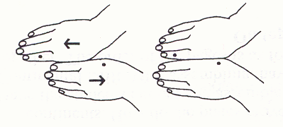

Appendix D
Plate Movement Activity

Steps 8-10 (from lesson)
- Cut a hole in the center of the cardboard about 1" x 1/2". Poke a small hole in the top of the pudding cup. Tape the cardboard to the top of the pudding cup, centering the slit in the board over the hole in the cup. The pudding represents magma.
- Center cookie wafers plates, lengthwise, over the hole in the cardboard.
- Keep the set-up on the table. One student steadies the cardboard with the cookies, while another student gently squeezes the pudding cup. Observe the results.

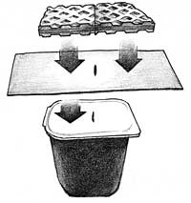

Steps 11-12 (from lesson)
    - Mark directional points (north, south, east, west) on a piece of paper. On the paper, line up two cookie wafers side by side, lengthwise in a northwesterly direction. The cookies represent the Pacific Plate and the North American Plate. Spread a line of frosting horizontally across the cookies to represent a road.
    - One student gently pushes the cookie on the west side (Pacific Plate) in a northwesterly direction while a second student presses the other cookie (North American Plate) in a westerly direction. Do the plates stick? Is there sideways motion? What happens to the road? Do the edges crumble?

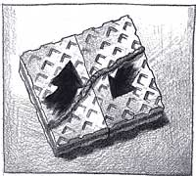

Appendix E
Continental Drift/Pangaea

Continental Drift Theory
A theory proposed by Alfred Wegener to explain the movement of the continents over millions of years from Pangaea to their present-day positions.

Alfred Wegener
German meteorologist and explorer
In 1912, he presented the theory the continents were once joined together.
He named the big land mass Pangaea.
He based this theory on the evidence that came from studying rocks, fossils, and the climate of various continents.

Pangaea
The name of the super-continent that scientists believe was once made up of all the continents combined.

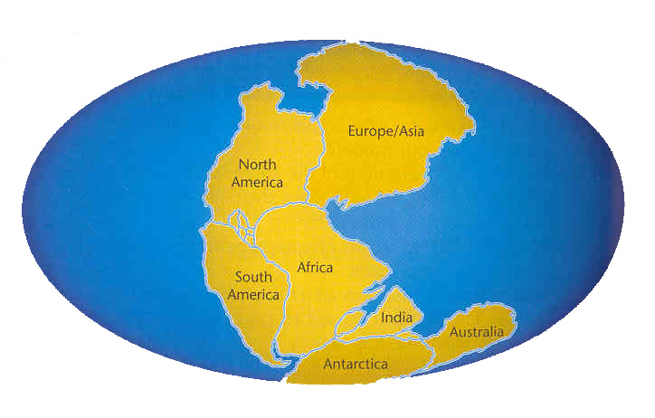

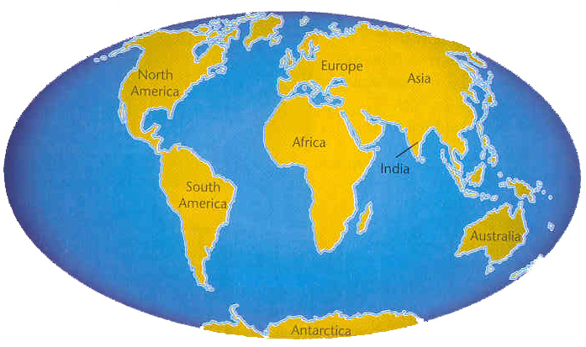
Appendix F
Puzzling Pangaea

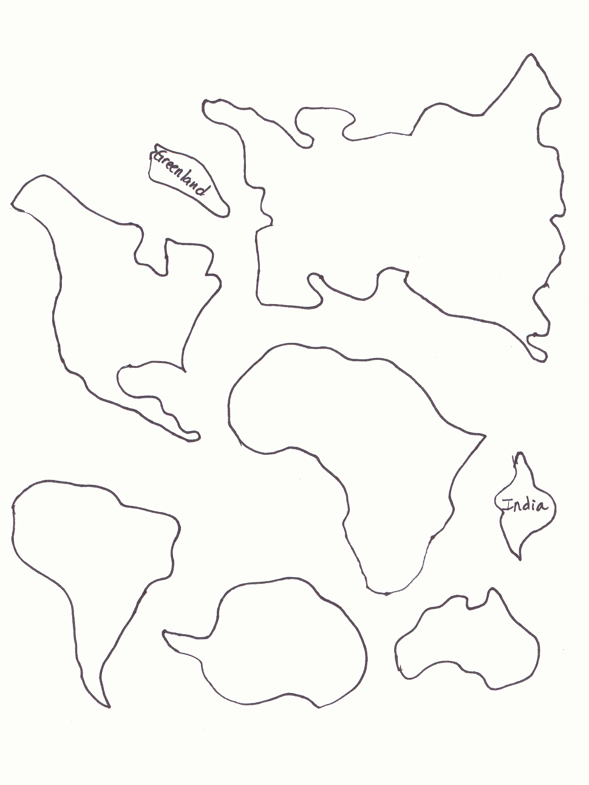

Appendix F
continued
Puzzling Pangaea
answer key (approximate)

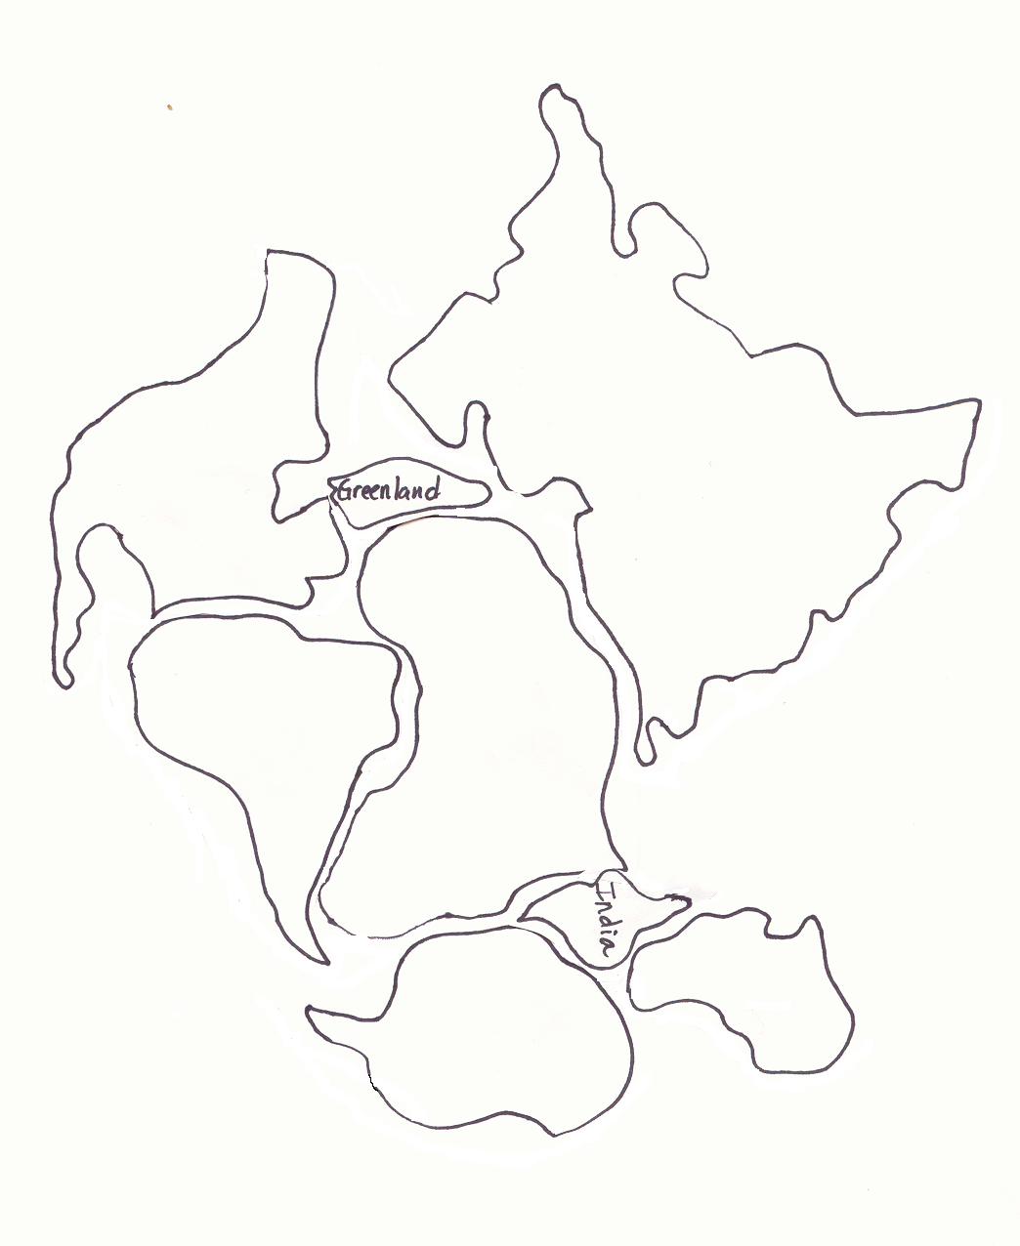

Appendix G
Layers of the Earth

CRUST
The earth's crust is like the skin of an apple.
Surface layer of the earth made up of solid rock ~ mainly basalt or granite
0 - 60 miles thick (0-100 km)
Much of the crust is covered by oceans, lakes, rivers, sediments, plants, and soil.
The lithosphere is the rigid outer most layer of the earth composed of the crust and the upper part of the mantle.
The crust of the earth is broken into many pieces called plates.
MANTLE
The thickest layer inside the earth
1,800 miles thick (2900 km)
Formed mostly of silicon, oxygen, magnesium, and iron
Below the rigid lithosphere is the asthenosphere. It can flow like maple syrup or be stretched out like putty.
OUTER CORE
The core of the earth is like a ball of very hot metals.
The outer core is so hot that the metals in it are all in the liquid state.
Made of molten iron and nickel
Surrounds the inner core
2270 km thick
INNER CORE
The inner core of the earth has temperatures and pressures so great that the metals are squeezed together and are not able to move about like a liquid, but are forced to vibrate in place as a solid.
Made of solid iron and nickel
It is the inner most layer of the earth
800 miles thick (1216 km)

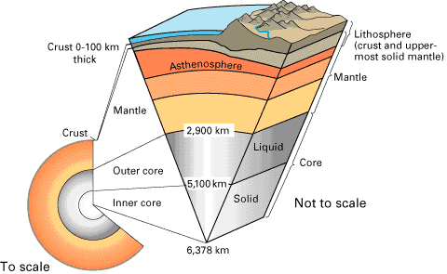
Crust- 930 degrees-5 to 25 miles
Basalt and granite
Mantle- 4,000 degrees-
1800 miles
Molten silicon, oxygen, magnesium, and iron
outer core
9,000 degrees
L
I
Q
U
I
d
i
r
o
n
N
I
C
K
L
E

Inner core
12,600 degrees
solid iron and nickel
Appendix H
Layers of the Earth Activity Key

crust
Appendix I
Layers of the Earth Activity

Mantle
Appendix I continued
Layers of the Earth Activity

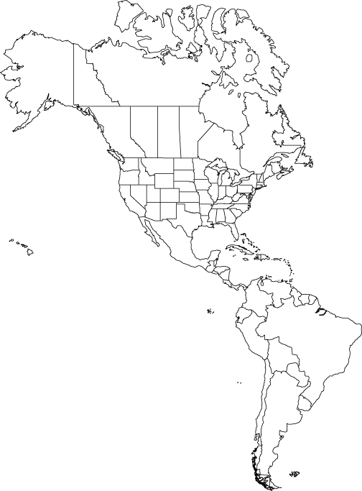
Appendix I continued
Layers of the Earth Activity

Inner core
Outer core
Appendix I continued
Layers of the Earth Activity

Appendix J
Layers of the Earth Quiz

Name: ___________________________________

Earth Layers | Temperature | Thickness | Composition
Crust | 930 degrees  Fahrenheit
Mantle |  | 1800 miles
Outer Core |  |  | Liquid nickel and iron
Inner Core | 12,600 degrees  Fahrenheit

Appendix J contiued
Layers of the Earth Quiz

Name: ___________________________________

Earth Layers | Temperature | Thickness | Composition
Crust | 930 degrees  Fahrenheit | 5-25 miles | Basalt and granite
Mantle | 4,000 degrees  Fahrenheit | 1800 miles | Molten silicon, oxygen, magnesium, and iron
Outer Core | 9,000 degrees  Fahrenheit | 1400 miles | Liquid nickel and iron
Inner Core | 12,600 degrees  Fahrenheit | 800 miles | Solid nickel and iron

Appendix K
Convection Currents

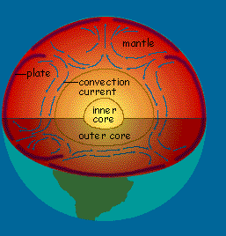

Scientists believe that the unequal distribution of heat causes convection currents in the mantle.

The semi-molten asthenosphere rises with heat, causing the plates to separate (divergent), collide (convergent), or slide past (transform/lateral) each other.

The convection currents in the mantle continually move the plates about 1/2 to 4 inches per year.

Appendix L
Earthquake Faults

Normal Faults/ Tension
Forces inside Earth cause plates to move apart, the plates and the rocks that compose them are subjected to the force of tension.
Tension can pull rocks apart and a normal fault is created.
Along a normal fault, rock above the fault surface moves downward in relation to rock below the fault surface.

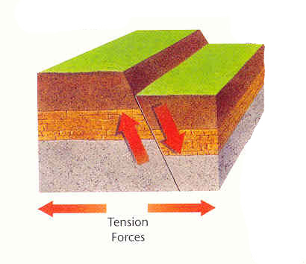

Reverse Faults/Compression

Compression forces are generated where Earth’s plates come together.
Compression pushes on rocks from opposite directions and causes them to bend and sometimes break.
Once they break, the rocks continue to move along the reverse fault surface.
At a reverse fault, the rocks above the fault surface are forced up and over the rocks below the fault surface.

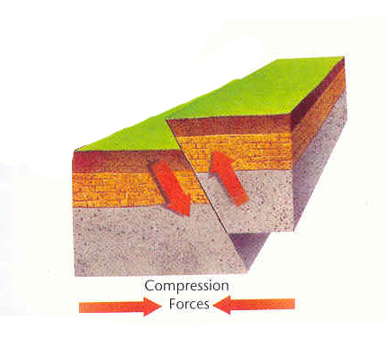

Appendix L
continued

Strike-slip/Shear
When two plates move sideways past each other with shear force, a transform, or strike-slip fault is created.
At a strike-slip fault, rocks on either side of the fault surface are moving past each other without much upward or downward movement.
As the rocks move past each other, their irregular surfaces snag each other, and the rocks are twisted and strained. The snagging also hinders the movement of the plates.
The stress builds up and the rocks reach their elastic limit and break.
The San Andreas Fault is an example of a transform/strike-slip fault.

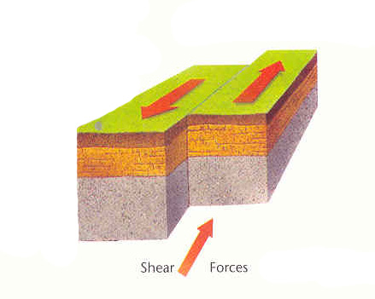

Appendix M
Seismic Waves

Earthquakes are sudden, violent shifting movements in the Earth’s crust.
They are caused when the tectonic plates collide, separate, or scrape against each other.
Earthquakes take place along faults (break’s in Earth’s crust).
Pressure builds up and stored energy is released (can be stronger than a nuclear bomb).
Focus ~ The point in the Earth’s interior where earthquake energy is released.
Epicenter ~ The point on Earth’s surface directly above an earthquake’s focus.

Primary (P) Waves ~ Waves that move through Earth by causing particles in rocks to move back and forth in the same direction the wave is moving. They are the fastest.
Secondary (S) Waves ~ Waves that move through Earth by causing particles in rocks to move at right angles to the direction of the wave. They are the slowest.
Surface (L) Waves ~ Waves that reach the surface and travel outward from the epicenter in all directions. These waves are the ones that cause damage and are felt.

The Richter scale is a scale used to describe the intensity or force of an earthquake. The instrument used to measure this force is called a seismograph.

Richter Number | Description of Earthquake | Number per Year
2.0-3.4 | Mostly unnoticeable | 800,000
3.5-4.2 | Barely felt | 30,000
4.3-4.8 | Felt by most humans | 4,800
4.9-5.4 | Felt by all | 1,400
5.5-6.1 | Damaging | 500
6.2-6.9 | Serious damage | 100
7.0-7.3 | Very serious damage | 15
7.4-8.0 | Catastrophic | 4
8.0 + | Near total damage | 1

Appendix N
Parts of an Earthquake

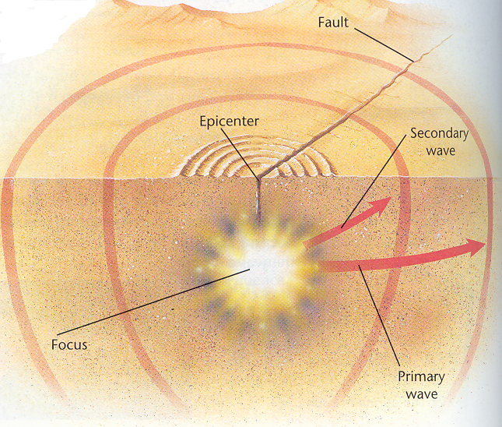

Appendix O
How Volcanoes Occur

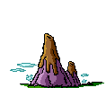

- Hot magma under the surface of the Earth is boiling.
- The magma collects in a chamber just under the surface.
- It begins to rise slowly through cracks and weak spots in the Earth’s surface.
- The ground above the magma grows slowly from the expansion of the heated rocks.
- Pressure begins to build up and an eruption occurs through and opening called a vent.
- This eruption shoots lava (which is what magma is called once it reaches the Earth’s surface), blocks of rock, cinders, ash, and hot gases into the air.
- These fall down around the vent, forming a small mound.
- As this happens over and over, a cone builds up around the opening, and a volcano is born.
- They are most common along the edges of the Earth’s convergent and divergent plate boundaries.

Appendix P
Types of Volcanoes

A composite volcano (also called strato-volcano) is made of layers of thick, sticky lava and ash that is formed from alternating quiet and explosive eruptions in layers much like layers of cake and frosting; forms tall, pointed mountains with symmetrical cones and steep sides.

A cinder cone volcano is cone-shaped volcano whose steep sides are made up of erupting lava that breaks into small pieces as it blasts into the air. As the lava pieces fall back to the ground, they cool and harden into cinders that pile up around the volcano's vent.

A shield volcano has long, sloping rock layers formed from quiet eruptions of fluid lava. The lava spreads out and builds up volcanoes with broad, gently sloping sides. The shape resembles a warrior's shield.

Appendix Q
Volcano: Nature’s Inferno Mini Quiz

Name: ________________________

- Is the gray lava seen in the video hot or cold?

- At night what is odd about the gray lava?

- What is a pyroclastic cloud?

- Where are the volcanoes located that the volcanologist can study in action all the time? What type of volcanoes are these?

- Where is the ring of fire located?

- After the eruptions of Mount Pinatubo in the Philippines what new natural disaster did the people face?

Appendix Q continued
Volcano: Nature’s Inferno Mini Quiz

Name: ________________________

- Is the gray lava seen in the video hot or cold?
hot

- At night what is odd about the gray lava?
It turns red

- What is a pyroclastic cloud?

Is a cloud that is composed of ash (fragments of rock) and gases that erupt from the volcano
- Where are the volcanoes located that the volcanologist can study in action all the time? What type of volcanoes are these?
Hawaii, Shield

- Where is the ring of fire located?
Along the coasts of the Pacific Ocean

- After the eruptions of Mount Pinatubo in the Philippines what other natural disaster did the people face?
Flooding

